

Alameda County Schools Insurance Group (ACSIG)
Po Box 2487 Dublin, CA 94568

MINUTES
Executive Committee

Date: Thursday, February 12, 2026
Time: 9:30AM
Location: The Atrium
5776 Stoneridge Mall Road
Pleasanton, CA 94588

- Danielle Krueger called the meeting to order at 9:34 AM

- Roll call

Executive Committee Members
Danielle Krueger President Alameda USD
Chris Hobbs Vice President Dublin USD
Bryan Wakefield Secretary Mission Valley ROP
Ruth Alahydoian Board Member Piedmont USD
Ahmad Sheikholeslami Board Member Pleasanton USD

Jackie Kim Executive Director Alameda County Schools Insurance
Celina Flotte Executive Assistant Alameda County Schools Insurance

Patrice Grant Guest Keenan & Associates
Kyle Mckibbin Guest Keenan & Associates
Bridgett Jordan Guest Keenan & Associates
Rowena Cowan Guest Keenan & Associates
Julio Villegas Guest Keenan & Associates
Mark Payne Guest Morgan Stanley
Dan Tichenor Guest Morgan Stanley
Laurena Grabert Guest SETECH

- Acceptance of the Agenda
It was moved by Ruth Alahydoian and seconded by Chris Hobbs to approve the agenda as presented.
Ayes: Krueger, Hobbs, Wakefield, Alahydoian, Sheikholeslami
Nays: None
Abstain: None

- Public Comment on Closed Session Agenda Items

No public present to comment.

Closed Session
Closed session began at 9:37am

- Settlement Authorization

- Claim Numbers: None

- Settlement Notification

- Claim Numbers:

490387 Matera | 601817 Watson | 621324 Del Toro | 637187 Rajendran | 647826 Trujillo
509670 Matera | 612616 Gallegos | 623959 Srinivasan | 638909 Jones | 650024 Tenney
549267 Flores | 617493 Crisologo | 625874 Merchant | 639944 Yousfi | 655856 Murray
572340 Leal | 621194 Stevens | 628066 Hashimoto | 646462 Stout | 590690 Wilson
573464 Stoneham | 629930 Hansen | 646588 Sharma

Open Session
Open session began at 9:44am

- Public Comment on Open Session Agenda Items
No public present to comment

- Report of Action Taken in Closed Session
There was no action taken in closed session

- Approval of Minutes
It was moved by Ruth Alahydoian and seconded by Bryan Wakefield to approve the meeting minutes from the November 13, 2025 Executive Committee Meetings and November 13, 2025 Full Board Meeting.
Ayes: Krueger, Hobbs, Wakefield, Alahydoian, Sheikholeslami
Nays: None
Abstain: None

General Business I

- Second Quarter Investment Report
Mark Payne and Dan Tichenor presented the 2025/26 Second Quarter Investment Report.
It was moved by Ahmad Sheikholeslami and seconded by Bryan Wakefield to approve the second quarter investment report.
Ayes: Krueger, Hobbs, Wakefield, Alahydoian, Sheikholeslami
Nays: None
Abstain: None

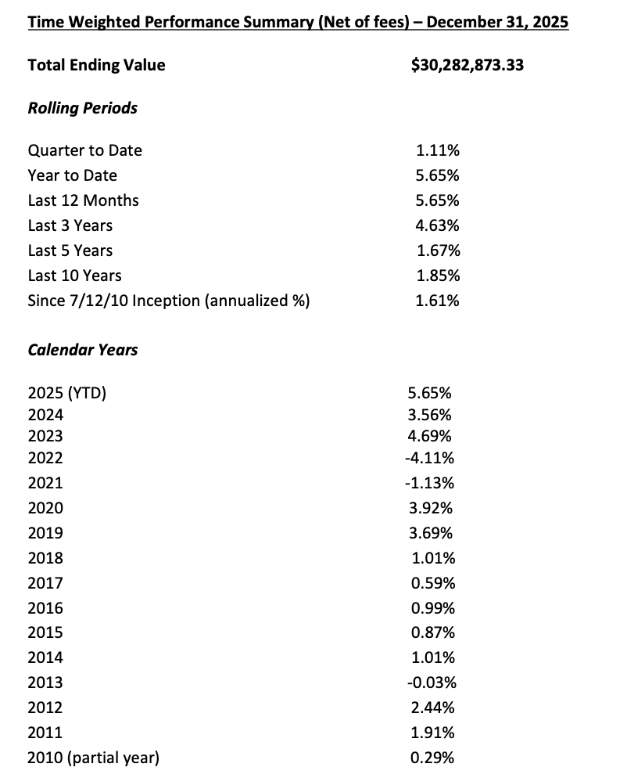
- Second Quarter Financial Report
Laurena Grabert from SETECH presented the 2025/2026 Second Quarter Financial Report.
It was moved by Chris Hobbs and seconded by Ahmad Sheikholeslami to approve the second quarter financial report.
Ayes: Krueger, Hobbs, Wakefield, Alahydoian, Sheikholeslami
Nays: None
Abstain: None

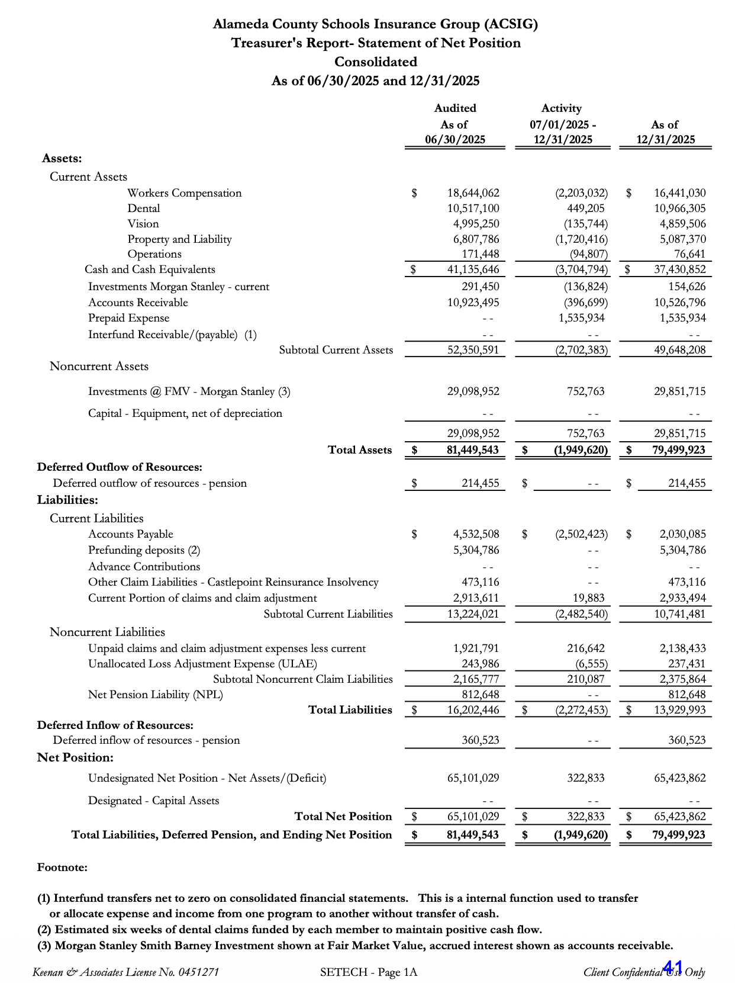
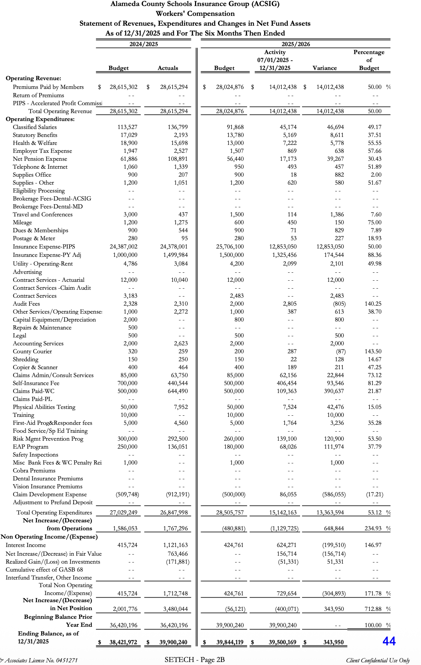
Workers Compensation

- Actuarial Study – Ex Mods
The Executive Director presented the Ex-Mods as determined by the Actuarial by Jack Joyce.
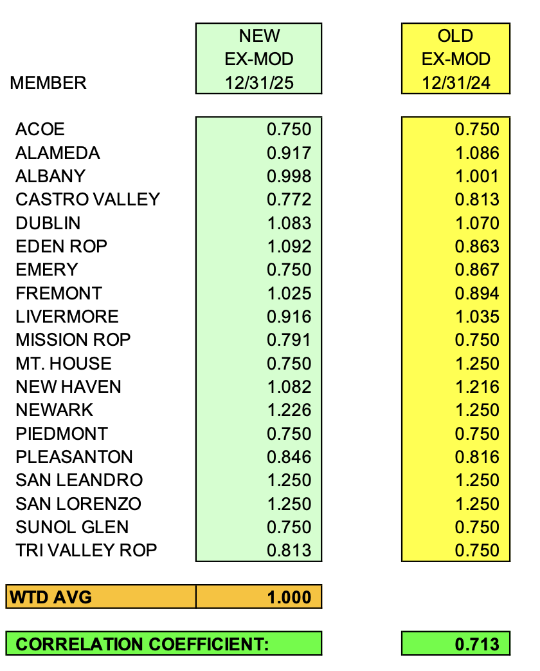

It was moved by Ruth Alahydoian and seconded by Bryan Wakefield to approve the Ex-Mods as presented.
Ayes: Krueger, Hobbs, Wakefield, Alahydoian, Sheikholeslami
Nays: None
Abstain: None

- Actuarial Study – Ultimate Loss
The Executive Director presented Actuarial study of the ultimate loss of the self-insured portion of the ACSIG Workers Compensation program. Bay Actuarial estimates that ACSIG’s liability for unpaid losses were $2.6M on December 31, 2025.
It was moved by Ahmad Sheikholeslami and seconded by Ruth Alahydoian to approve the Ultimate Loss Actuarial Study as presented.
Ayes: Krueger, Hobbs, Wakefield, Alahydoian, Sheikholeslami
Nays: None
Abstain: None

- EAP Update
The Executive Director discussed an update on the EAP Program with the Executive Committee.

- Workers Compensation Program Decisions for 2026-27
The Executive Committee had the opportunity to review existing programs and explore new ones for the 2026-2027 year. The committee has made a motion to approve Shoes for Crews as the new provider for the shoe program.
Ayes: Krueger, Hobbs, Wakefield, Alahydoian, Sheikholeslami
Nays: None
Abstain: None

- Preliminary Workers Compensation Rates 2026-27
The Executive Director reviewed 2026-27 preliminary worker’s compensation rates with the base rate of 2.33. The workers compensation program continues to maintain a positive fund balance, therefore the committee recommends that the base rate be lowered by .23 to 2.10.

It was moved by Ahmad Sheikholeslami and seconded by Chris Hobbs to approve the motion of buying down the WC base rate by $.23.
Ayes: Krueger, Hobbs, Wakefield, Alahydoian, Sheikholeslami
Nays: None
Abstain: None

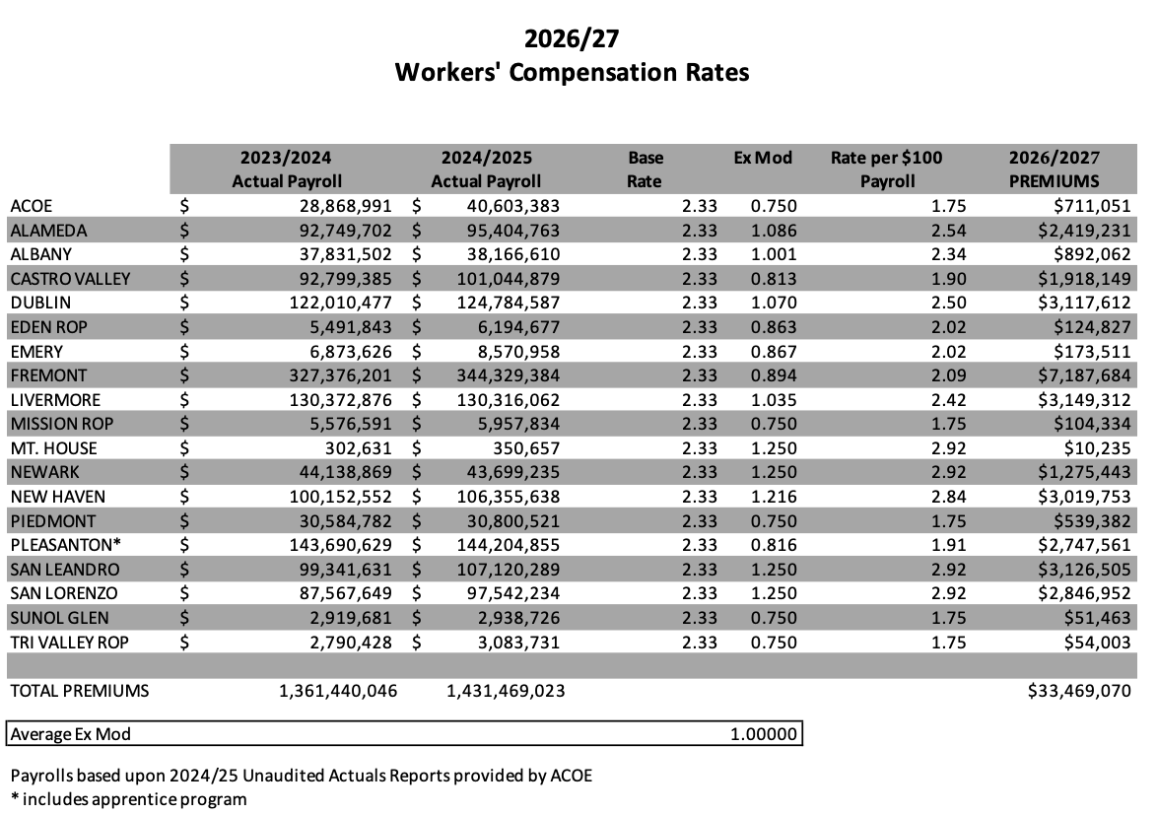

Property & Liability

- Preliminary Property & Liability Rates 2026-27
The Executive Director provided details on the Property & Liability Rates for the 2026-27 year. It’s early in the budget development process, but early indications are that the program is going to see another year of significant increases. This item was to inform the Executive Committee about the market condition and the preliminary Property & Liability rates.

General Business II

- 2026-27 Budget
This budget was developed using year- to-date 2025-26 data and preliminary estimates for 2026-27 rates and costs. Because all rates are not firm at this time, estimates were used for this report.

- Future Planning

- This meeting was adjourned by Danielle Krueger at 11:41 AM

