

Alameda County Schools Insurance Group (ACSIG)
Po Box 2487 Dublin, CA 94568

MINUTES
Executive Committee

Date: Thursday, May 15, 2025
Time: 9:30 AM
Location: Video Meeting
Join Zoom Meeting
https://us02web.zoom.us/j/7358807014?pwd=xQh9bGBXdqrvShyBDg5MCtY07bNlbg.1&omn=81999610238

Meeting ID: 735 880 7014
Passcode: acsig25

- Kevin Collins called the meeting to order 9:31AM

- Roll call

Executive Committee Members
Dr. Kevin Collins President San Leandro USD
Danielle Krueger Vice President Alameda USD
Chris Hobbs Secretary Dublin USD
Leigh Ann Blessing Board Member ACOE
Bryan Wakefield Board Member Mission Valley ROP
Ruth Alahydoian Board Member Piedmont USD
Ahmad Sheikholeslami Board Member Pleasanton USD

Jackie Kim Executive Director ACSIG
Celina Flotte Executive Assistant ACSIG

Ron Martin Guest Keenan & Associates
Patrice Grant Guest Keenan & Associates
Rowena Cowan Guest Keenan & Associates
Bridgett Jordan Guest Keenan & Associates
Laurena Grabert Guest SETECH
Dan Tichenor Guest Morgan Stanley
Ahmad Sheikholeslami and Bridgett Jordan joined the meeting at 9:32am

- Acceptance of the Agenda
It was moved by Chris Hobbs and seconded by Leigh Ann Blessing to approve the agenda as presented.
Ayes: Collins, Krueger, Hobbs, Blessing, Wakefield, Alahydoian, Sheikholeslami
Nays: None
Abstain: None

- Public Comment on Closed Session Agenda Items

No public present to comment.

Closed Session
Closed session began at 9:33am

- Settlement Notification
- Claim Numbers:

Ramos, S | 395115 |  | Johnson, M | 599562 |  | Watson Lum, D | 619460
Flores, A | 487842 |  | Wyckoff, N | 601509 |  | Sowers, V | 621811
Fletcher, H | 534958 |  | Castillo, S | 606271 |  | Lawhun, S | 626587
Brady, J | 555221 |  | Lemas, D | 608777 |  | Berg, J | 627601
Villanueva, E | 593583 |  | Ovalle, A | 612695 |  | Sutton, V | 635008
Zhou, C | 636085 |  | Hayden, D | 638682 |  | Hayden, D | 638688

- Settlement Authorization
- Claims Numbers: None

- Executive Director Evaluation

Open Session
Open session began at 9:49am

- Public Comment on Open Session Agenda Items
No public present to comment.

- Report of Action Taken in Closed Session
No action was taken in closed session.

- Approval of Minutes
It was moved by Dani Krueger and seconded by Ruth Alahydoian to approve the meeting minutes from February 13, 2025.
Ayes: Collins, Krueger, Hobbs, Blessing, Wakefield, Alahydoian, Sheikholeslami
Nays: None
Abstain: None

General

- Executive Committee Membership
The Executive Committee has suggested recruiting San Lorenzo USD and Castro Valley USD to the Executive Committee. Piedmont USD and Pleasanton USD has agreed to continue sitting on the committee.

- Third Quarter Investment Report
Dan Tichenor from Morgan Stanley reviewed the 2024/25 third quarter investment report with the Executive Committee.
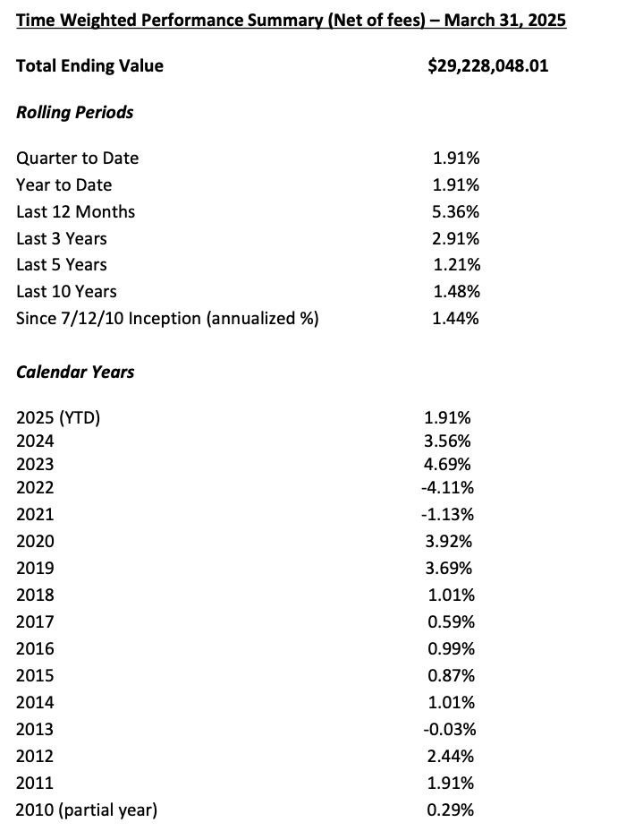
It was moved by Ahmad Sheikholeslami and seconded by Ruth Alahydoian to recommend approval of the third quarter investment report as presented to the Full Board.
Ayes: Collins, Krueger, Hobbs, Blessing, Wakefield, Alahydoian, Sheikholeslami
Nays: None
Abstain: None

- Investment Policy
The Executive Committee conducted the annual review of the written Investment Policy and found no changes necessary.
It was moved by Leigh Ann Blessing and seconded by Chris Hobbs to recommend approval of the Investment Policy as presented to the Full Board.
Ayes: Collins, Krueger, Hobbs, Blessing, Wakefield, Alahydoian, Sheikholeslami
Nays: None
Abstain: None

- Third Quarter Financial Report
Laurena Grabert from SETECH presented the 2024-25 third quarter financial report.
It was moved by Ruth Alahydoian and seconded by Leigh Ann Blessing to recommend approval of the third quarter financial report as presented to the Full Board.
Ayes: Collins, Krueger, Hobbs, Blessing, Wakefield, Alahydoian, Sheikholeslami
Nays: None
Abstain: None

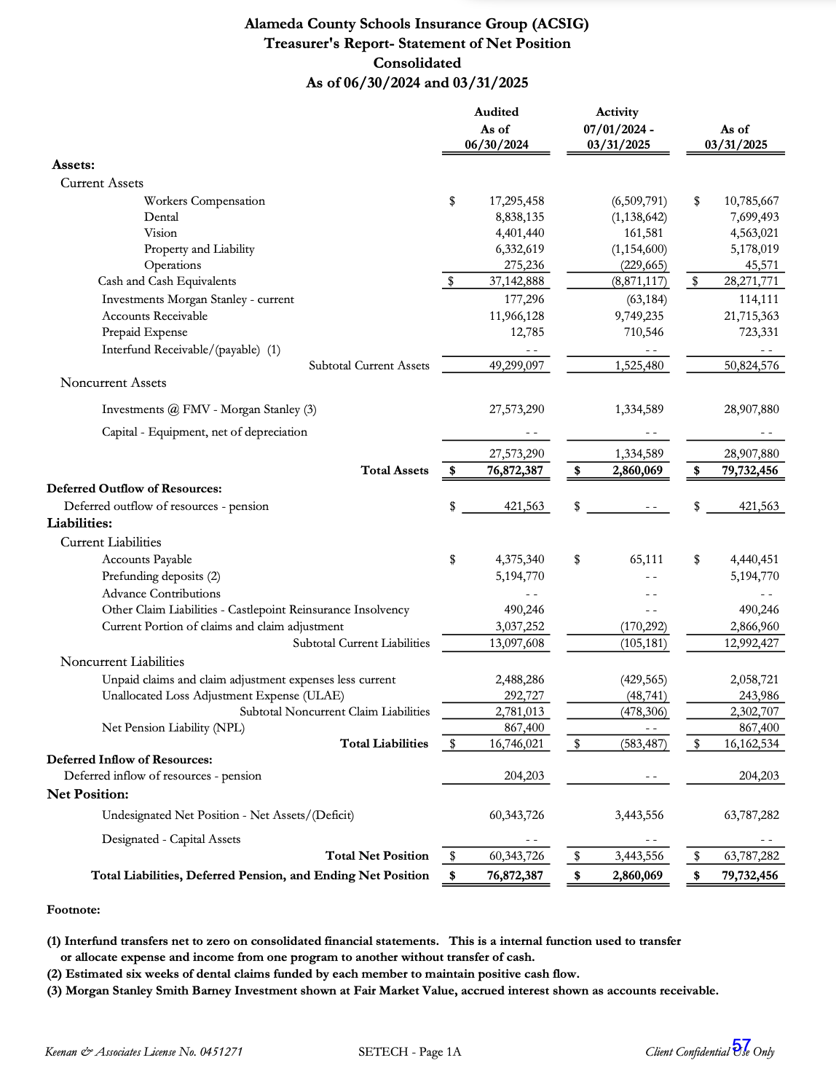

- Budget 2025-26
The Executive Director reviewed the Budget with the Executive Committee. The budget contains a list of major contracts and service providers, assumptions and calculations with a detailed budget for each major program.

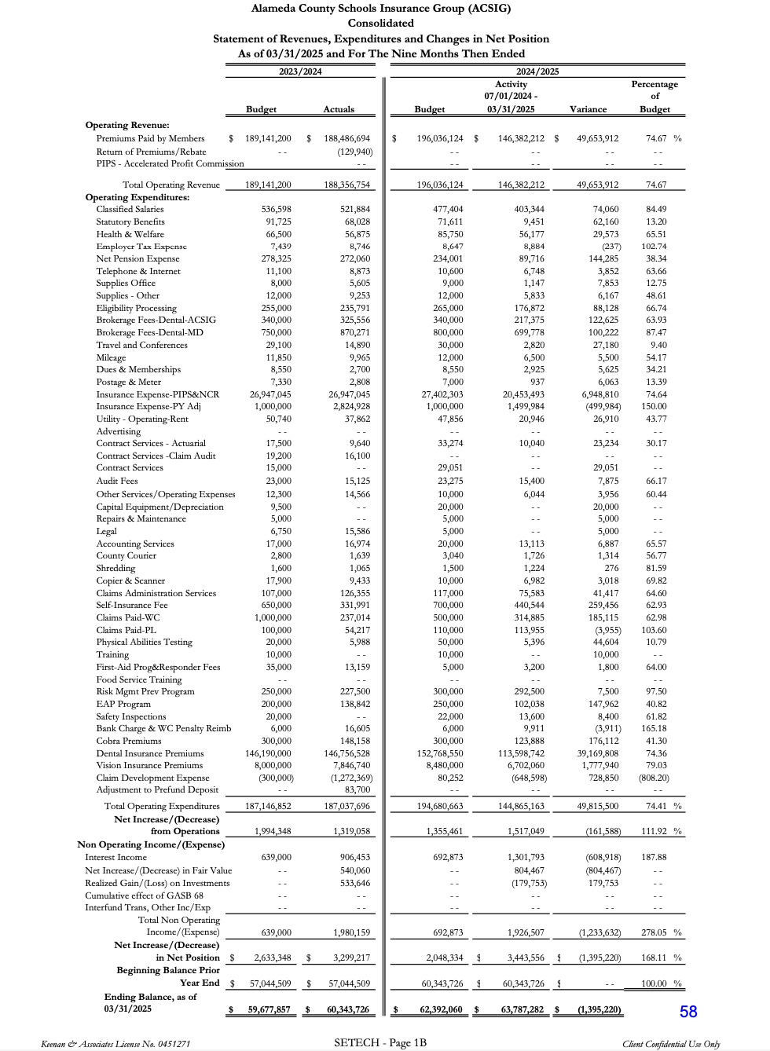
It was moved by Ahmad Sheikholeslami and seconded by Ruth Alahydoian to recommend approval of the budget to the Full Board.
Ayes: Collins, Krueger, Hobbs, Blessing, Wakefield, Alahydoian, Sheikholeslami
Nays: None
Abstain: None

- ACSIG Salaries & Benefits
The Governor’s 2024-25 estimated COLA was 0.76%. ACSIG increased its 2024-2025 salary schedule by 0.38% on July 1, 2024. The member’s weighted average was 5.14% as calculated by the Alameda County Office of Education. Based on those numbers, ACSIG Staff recommends 5.14% increase.
It was moved by Ahmad Sheikholesalmi and seconded by Dani Krueger to recommend approval of the salary increase to the Full Board.
Ayes: Collins, Krueger, Hobbs, Blessing, Wakefield, Alahydoian, Sheikholeslami
Nays: None
Abstain: None

- Executive Director Contract
The Executive Director presented the contract of the role of ACSIG’s Executive Director with the tentative 2024-25 salary schedule upon board approval.
It was moved by Chris Hobbs and seconded by Dani Krueger to recommend approval of the Executive Directors contract to the Full Board.
Ayes: Collins, Krueger, Hobbs, Blessing, Wakefield, Alahydoian, Sheikholeslami
Nays: None
Abstain: None

- New ACSIG Logo
The Executive Committee reviewed three new designs for the new ACSIG logo with reccomendations to add graphics from design #1 to design #2.
No motion was taken and the new logo will be reviewed at the next meeting.

- Meeting Format & Calendar
The Executive Committee reviewed the 2024/25 draft meeting calendar with reccomendations to move the Executive Committee meeting from November to Septemeber and to have a dual Full Board following an Executive Committee meeting in the Fall.

Workers’ Compensation

- Employee Assistance Program Update
The Executive Director reviewed the utilization of the EAP with the Executive Committee. The current overall ACSIG utilization is 2.2%. The top 5 work related problem categories were: 66% work related stress, 25% work/ life balance, 5% performance, 2% conflict with manager, and 2% conflict with coworker.

- Claims Trends – 5 year Point in Time
Bridgett Jordan of Keenan and Associates updated the Committee regarding current claim trends by Job Classification, Age and Month.

- Run Off Claims Agreement
The Executive Director will presented the renewal contract for Run Off Claims Administration.
It was moved by Dani Krueger and seconded by Ahmad Sheikholeslami to recommend approval of the Run off Claims Agreement as presented to the Full Board.
Ayes: Collins, Krueger, Hobbs, Blessing, Wakefield, Alahydoian, Sheikholeslami
Nays: None
Abstain: None

- Tail Claims Report
Patrice Grant from Keenan updated the Committee regarding tail claims report.

- Shoe Program Update
The Executive Director discussed an update regarding the Skechers shoe program. Utilization of the giftcards that were distributed for 2024-25 shows 39% redeemed. Though we have received good feedback from the district employees, the Executive Director plans to find ways to make the show program more effective, including exploring other vendors.

Dental

- Dental Program & Rates 2025-26
The Executive Director presented the Dental Rate recommendations with the Executive Committee. The recommendation is a flat renewal.
It was moved by Chris Hobbs and seconded by Leigh Ann Blessing to recommend approval of Dental Rates to the Full Board.
Ayes: Collins, Krueger, Hobbs, Blessing, Wakefield, Alahydoian, Sheikholeslami
Nays: None
Abstain: None

- Dental & Vision Actuarial Study Agreement
The Executive Director reviewed the actuarial study agreement with Healthcare Actuaries for both the Dental and Vision programs.
It was moved by Ahmad Sheikholeslami and seconded by Ruth Alahydoian to recommend approval of Dental and Vision Actuarial Agreement to the Full Board.
Ayes: Collins, Krueger, Hobbs, Blessing, Wakefield, Alahydoian, Sheikholeslami
Nays: None
Abstain: None

Vision

- Vision Program & Rates 2025-26
The Executive Director presented the Vision Rate recommendations with the Executive Committee. The recommendation is a flat renewal.
It was moved by Ruth Alahydoain and seconded by Dani Krueger to recommend approval of Vision Rates to the Full Board.
Ayes: Collins, Krueger, Hobbs, Blessing, Wakefield, Alahydoian, Sheikholeslami
Nays: None
Abstain: None

Property & Liability

- Property & Liability Actuarial Study
The Executive Director presented the P&L actuarial study.
It was moved by Ruth Alahydoian and seconded by Bryan Wakefield to recommend approval of the P&L Actuarial Study to the Full Board.
Ayes: Collins, Krueger, Hobbs, Blessing, Wakefield, Alahydoian, Sheikholeslami
Nays: None
Abstain: None

- Property & Liability Rates 2025-26
The Executive Director presented the Property and Liability rates.
It was moved by Chris Hobbs and seconded by Bryan Wakefield to recommend approval of the Property & Liability rates as presented to the Full Board.
Ayes: Collins, Krueger, Hobbs, Blessing, Wakefield, Alahydoian, Sheikholeslami
Nays: None
Abstain: None

- AB 218 PLCA Agreement Renewal
The Executive Director presented the renewal contract for AB218 Claims Administrative Services.
It was moved by Ahmad Sheikholeslami and seconded by Ruth Alahydoian to recommend approval of the AB 218 PLCA Amendment to the Full Board.
Ayes: Collins, Krueger, Hobbs, Blessing, Wakefield, Alahydoian, Sheikholeslami
Nays: None
Abstain: None

- PLCA Agreement Amendment No.1
The Executive Director reviewed the amendment for Property and Casualty Claims Administration Services.
It was moved by Ahmad Sheikholeslami and seconded by Ruth Alahydoian to recommend approval of the PLCA Amendment to the Full Board.
Ayes: Collins, Krueger, Hobbs, Blessing, Wakefield, Alahydoian, Sheikholeslami
Nays: None
Abstain: None

- RASP Agreement
The Executive Director reviewed the Rent A Safety Professional contract.
It was moved by Ahmad Sheikholeslami and seconded by Ruth Alahydoian to recommend approval of the RASP Agreement to the Full Board.
Ayes: Collins, Krueger, Hobbs, Blessing, Wakefield, Alahydoian, Sheikholeslami
Nays: None
Abstain: None

Administrative

- Dispute Resolution Policy
The Executive Committee conducted the annual review of the Dispute Resolution policy and found no changes necessary.
It was moved by Ruth Alahydoian and seconded by Dani Krueger to recommend approval the Dispute Resolution policy as presented to the Full Board.
Ayes: Collins, Krueger, Hobbs, Blessing, Wakefield, Alahydoian, Sheikholeslami
Nays: None
Abstain: None

- Underwriting Policy
The Executive Committee conducted the annual review of the Underwriting Policy and found no changes necessary.
It was moved by Ruth Alahydoian and seconded by Dani Krueger to recommend approval the Underwriting Policy as presented to the Full Board.
Ayes: Collins, Krueger, Hobbs, Blessing, Wakefield, Alahydoian, Sheikholeslami
Nays: None
Abstain: None

- Conflict of Interest Code
The Executive Committee conducted the annual review of the Conflict of Interest Code and found no changes necessary.
It was moved by Ruth Alahydoian and seconded by Dani Krueger to recommend approval of the Conflict of Interest Code as presented to the Full Board.
Ayes: Collins, Krueger, Hobbs, Blessing, Wakefield, Alahydoian, Sheikholeslami
Nays: None
Abstain: None

- Posting and Mailing Address
The Executive Committee conducted the annual review of the Authorization of Signatures and found no changes necessary.
It was moved by Ruth Alahydoian and seconded by Dani Krueger to recommend approval the Authorization of Signatures as presented to the Full Board.
Ayes: Collins, Krueger, Hobbs, Blessing, Wakefield, Alahydoian, Sheikholeslami
Nays: None
Abstain: None

- Future Planning

- This meeting was adjourned by Kevin Collins at 11:27AM


LOCATION CALL- IN SHEET
ALAMEDA COUNTY SCHOOLS INSURANCE GROUP
EXECUTIVE COMMITTEE MEETING
May 15, 2025 – 9:30 AM
Join Zoom Meeting
https://us02web.zoom.us/j/7358807014?pwd=xQh9bGBXdqrvShyBDg5MCtY07bNlbg.1&omn=81999610238

Meeting ID: 735 880 7014 Passcode: acsig25

This meeting will be conducted by teleconferencing in accordance with Government Code Section 54953(b). Members of the public may address the Committee from any teleconference location shown below:

Alameda County Office of Education 313 W Winton Ave. Hayward, CA 94544 Leigh Ann Blessing (510) 670-4187

Alameda Unified School District 2060 Challenger Drive #100 Alameda, CA 94501 Danielle Krueger (510) 337-7066

Dublin Unified School District 7471 Lakedale Avenue Dublin, CA 94568 Chris Hobbs (925) 828-2551 ext 8041

Mission Valley ROP 5019 Stevenson Blvd. Fremont, CA 94538 Bryan Wakefield (510) 492-5145

Piedmont Unified School District 760 Magnolia Ave Piedmont, CA 94611 Ruth Alahydoian (510) 594-2608

Pleasanton Unified School District 5758 W Las Positas Blvd Pleasanton, CA 94588 Ahmad Sheikholeslami (925) 426-4307

San Leandro Unified School District 835 E 14th Street, Suite 200
San Leandro, CA 94577 Kevin Collins (510) 667-3504

