

Alameda County Schools Insurance Group (ACSIG)
5776 Stoneridge Mall Rd., Suite 130 Pleasanton, CA 94588

MINUTES
Executive Committee

Date: Thursday, February 13, 2025
Time: 9:30AM
Location: Video Meeting
Join Zoom Meeting:
https://us02web.zoom.us/j/7358807014?pwd=xQh9bGBXdqrvShyBDg5MCtY07bNlbg.1&o mn=81999610238
Meeting ID: 735 880 7014
Passcode: acsig25

- Kevin Collins called the meeting to order at 9:31 AM

- Roll call

Executive Committee Members
Dr. Kevin Collins President San Leandro USD
Danielle Krueger Vice President Alameda USD
Chris Hobbs Secretary Dublin USD
Leigh Ann Blessing Board Member Alameda COE
Bryan Wakefield Board Member Mission Valley ROP
Ruth Alahydoian Board Member Piedmont USD
Ahmad Sheikholelami Board Member Pleasanton USD

Jackie Kim Executive Director Alameda County Schools Insurance
Celina Flotte Executive Assistant Alameda County Schools Insurance

Kyle Mckibbin Guest Keenan & Associates
Julio Villegas Guest Keenan & Associates
Patrice Grant Guest Keenan & Associates
Bridgett Jordan Guest Keenan & Associates

Mark Payne Guest Morgan Stanley
Laurena Grabert Guest SETECH

- Acceptance of the Agenda
It was moved by Ruth Alahydoian and seconded by Ahmad Sheikholeslami to approve the agenda as presented.
Ayes: Collins, Hobbs, Blessing, Wakefield, Alahydoian, Sheikholeslami
Nays: None
Abstain: None

Dani Krueger joined the meeting at 9:34am

- Public Comment on Closed Session Agenda Items
No public present to comment.

Closed Session
Closed session began at 9:34am

- Settlement Authorization
- Claim Numbers: None

- Settlement Notification

- Claim Numbers:
Scheuber, S | 554475 | Rooney-Etheridge, M | 595970 | Doeschot, J | 613274
Noddin, L | 556299 | Lehr, K | 603631 | Schoenthal, T | 615968
Mehta, K | 578567 | Canales, G | 604954 | Escobar, C | 635980
Diebolt, D | 580313 | Cuenca, B | 606186 | Quinn, J | 1002207
Decoy, T | 594866 | Saenz, M | 606232

Open Session
Open session began at 9:39am

- Public Comment on Open Session Agenda Items
No public present to comment

- Report of Action Taken in Closed Session
There was no action taken in closed session

- Approval of Minutes
It was moved by Ruth Alahydoian and seconded by Dani Krueger to approve the meeting minutes from the November 7, 2024 Executive Committee Meeting and November 14, 2024 Full Board Meeting with the correction of spelling Ruth Alahydoian’s name.
Ayes: Collins, Krueger, Hobbs, Blessing, Wakefield, Alahydoian, Sheikholeslami
Nays: None
Abstain: None

Workers Compensation

- Actuarial Study – Ex Mods
The Executive Director presented the Ex-Mods as determined by the Actuarial by Jack Joyce.
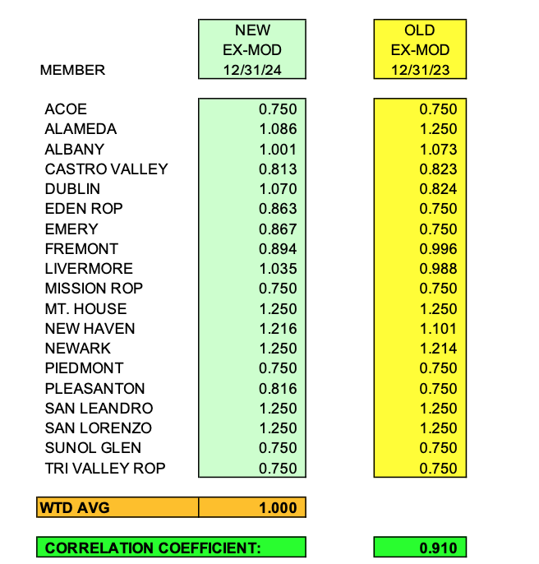

It was moved by Leigh Ann Blessing and seconded by Ahmad Sheikholeslami to approve the Ex-Mods as presented.
Ayes: Collins, Krueger, Hobbs, Blessing, Wakefield, Alahydoian, Sheikholeslami
Nays: None
Abstain: None

- Actuarial Study – Ultimate Loss
The Executive Director presented Actuarial study of the ultimate loss of the self-insured portion of the ACSIG Workers Compensation program. Bay Actuarial estimates that ACSIG’s liability for unpaid losses were $2.8M on December 31, 2024. This report reflects claim payments in the amount of $341,063 and a reduction in reserves of $500,429.
It was moved by Ruth Alahydoian and seconded by Chris Hobbs to approve the Ultimate Loss Actuarial Study as presented.
Ayes: Collins, Hobbs, Blessing, Wakefield, Alahydoian, Sheikholeslami
Nays: None
Abstain: None

- EAP Update
The Executive Director discussed an update on the EAP Program with the Executive Committee. The current overall ACSIG utilization is 2.3%.

- Workers Compensation Program Decisions for 2025-26
ACSIG workers’ compensation program has transitioned into a surplus position, we open the discussion with the Executive Committee to have the opportunity to review existing programs and explore new ones for the 2025-2026 year. The committee has no changes to the Skechers, EAP, post offer-pre placement program or trainings and no action was taken.

- Preliminary Workers Compensation Rates 2025-26
The Executive Director reviewed 2025/26 preliminary worker’s compensation rates with the base rate of 2.29. The workers compensation program continues to maintain a positive fund balance, therefore the committee recommends that the base rate be lowered by .24 to 2.05.

It was moved by Dani Krueger and seconded by Ahmad Sheikholeslami to approve the motion of buying down the WC base rate by $.24.
Ayes: Collins, Krueger, Hobbs, Blessing, Wakefield, Alahydoian, Sheikholeslami
Nays: None
Abstain: None

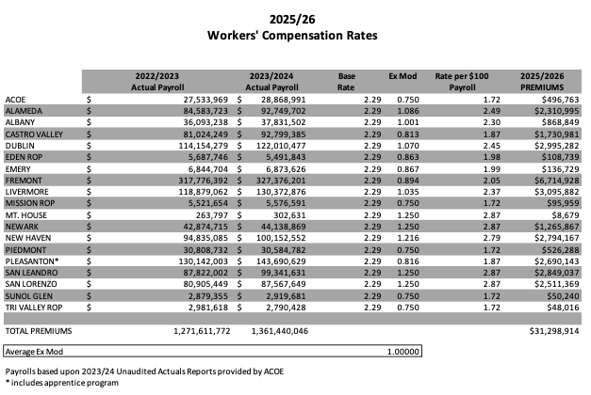

Property & Liability

- Preliminary Property & Liability Rates 2025-26
The Executive Director provided details on the Property & Liability Rates for the 2025-26 year. It’s early in the budget development process, but early indications are that the program is going to see another year of significant increases. This item was to inform the Executive Committee about the market condition and the preliminary Property & Liability rates.

Dental

- Preferred Benefit Insurance Administrators (PBIA) Agreement
The Executive Committee reviewed the agreement with PBIA.
It was moved by Ruth Alahydoian and seconded by Leigh Ann Blessing to approve the PBIA Agreement.
Ayes: Collins, Krueger, Hobbs, Blessing, Wakefield, Alahydoian, Sheikholeslami
Nays: None
Abstain: None

General

- Second Quarter Financial Report
Laurena Grabert from SETECH presented the 2024/2025 Second Quarter Financial Report.
It was moved by Dani Krueger and seconded by Ruth Alahydoian to approve the second quarter financial report.
Ayes: Collins, Krueger, Hobbs, Blessing, Wakefield, Alahydoian, Sheikholeslami
Nays: None
Abstain: None

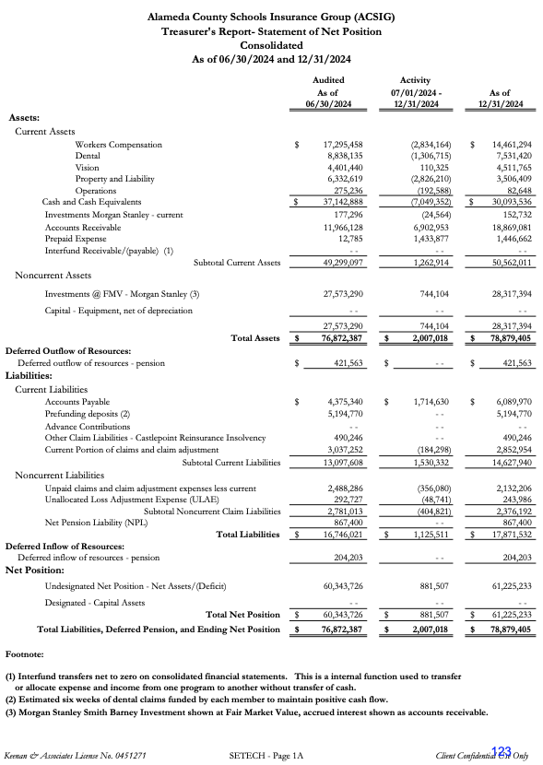
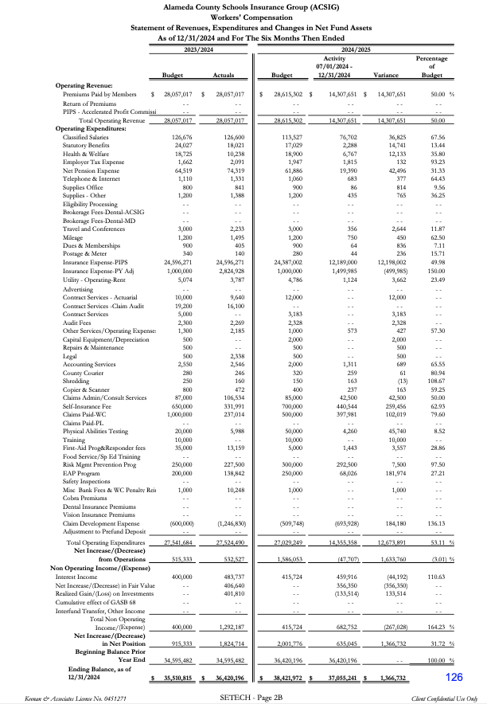
- Second Quarter Investment Report
Mark Payne presented the 2024/25 Second Quarter Investment Report.
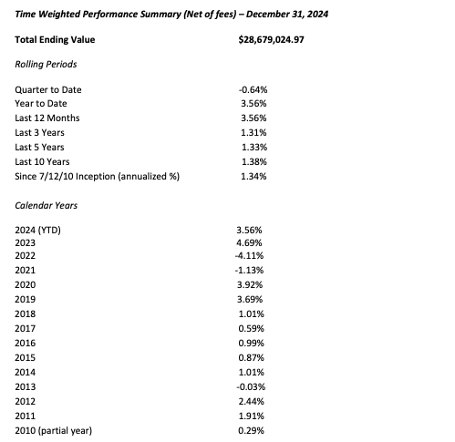

It was moved by Bryan Wakefield and seconded by Ruth Alahydoian to approve the second quarter investment report.
Ayes: Collins, Krueger, Hobbs, Blessing, Wakefield, Alahydoian, Sheikholeslami
Nays: None
Abstain: None

- 2025-26 Budget
This budget was developed using year- to-date 2024-25 data and preliminary estimates for 2025-26 rates and costs. Because all rates are not firm at this time, estimates were used for this report.
It was moved by Chris Hobbs and seconded by Ahmad Sheikholeslami to approve the budget.
Ayes: Collins, Krueger, Hobbs, Blessing, Wakefield, Alahydoian, Sheikholeslami
Nays: None
Abstain: None

- Conflict of Interest Amendment
The Executive Director reviewed the revision to the Conflict of Interest.
It was moved by Leigh Ann Blessing and seconded by Dani Krueger to approve the Conflict of Interest Amendment.
Ayes: Collins, Krueger, Hobbs, Blessing, Wakefield, Alahydoian, Sheikholeslami
Nays: None
Abstain: None

- Executive Committee Meeting Scheduling
The Executive Committee discussed a meeting time and location for the next Executive Committee meeting.

- Future Planning

- This meeting was adjourned by Dr. Kevin Collins at 11:09 AM


LOCATION CALL- IN SHEET
ALAMEDA COUNTY SCHOOLS INSURANCE GROUP
EXECUTIVE COMMITTEE MEETING February 13, 2025 9:30 AM
Join Zoom Meeting
https://us02web.zoom.us/j/7358807014?pwd=SzJEa1BUSzNNMzBYN3VzajB2UEVPQT09
Meeting ID: 735 880 7014 Passcode: acsig24

This meeting will be conducted by teleconferencing in accordance with Government Code Section 54953(b). Members of the public may address the Committee from any teleconference location shown below:

Alameda County Office of Education 313 W Winton Ave. Hayward, CA 94544 Leigh Ann Blessing (510) 670-4187

Alameda Unified School District 2060 Challenger Drive #100 Alameda, CA 94501 Danielle Krueger (510) 337-7066

Dublin Unified School District 7471 Lakedale Avenue Dublin, CA 94568 Chris Hobbs (925) 828-2551 ext 8041

Mission Valley ROP 5019 Stevenson Blvd. Fremont, CA 94538 Bryan Wakefield (510) 492-5145

Piedmont Unified School District 760 Magnolia Ave Piedmont, CA 94611 Ruth Alahydoian (510) 594-2608

Pleasanton Unified School District 5758 W Las Positas Blvd Pleasanton, CA 94588 Ahmad Sheikholeslami (925) 426-4307

San Leandro Unified School District 835 E 14th Street, Suite 200
San Leandro, CA 94577 Kevin Collins (510) 667-3504

