

Alameda County Schools Insurance Group (ACSIG)
5776 Stoneridge Mall Rd., Suite 130 Pleasanton, CA 94588

MINUTES
Full Board

Date: Thursday, November 14, 2024
Time: 12:00PM
Location: Alameda County Office of Education
313 W. Winton Ave.
Hayward, CA 94544

- This meeting was called to order at 12:04 PM

- Roll call

Full Board
Dr. Kevin Collins President San Leandro Unified School District
Danielle Krueger Vice President Alameda Unified School District
Leigh Ann Blessing Board Member Alameda County Office of Education
Suzy Chan Board Member Castro Valley USD
Chris Hobbs Board Member Dublin Unified School District
Anthony Oum Board Member Eden Area ROP
Rowena Cowan Board Member Fremont USD
Bryan Wakefield Board Member Mission Valley ROP
Annette Heldman Board Member New Haven Unified School District
Jenilee Penaflor Board Member Newark Unified School District
Jose Quintana Board Member Newark Unified School District
Ruth Alahydoian Board Member Piedmont Unified School District
Ahmad Sheikholeslami Board Member Pleasanton Unified School District

Jackie Kim Executive Director ACSIG
Celina Flotte Executive Assistant ACSIG

Heather Rubio Guest Christy White

Patrice Grant Guest Keenan & Associates
Kyle Mckibbin Guest Keenan & Associates
Bridgett Jordan Guest Keenan & Associates
Veronica Riglick Guest Keenan & Associates
Julio Villegas Guest Keenan & Associates
Dan Tichenor Guest Morgan Stanley
Hesam Fayaz Guest SETECH

- Acceptance of the Agenda
It was moved by Annette Heldman and seconded by Anthony Oum to approve the agenda as presented.
Ayes: Collins, Krueger, Blessing, Chan, Hobbs, Oum, Cowan, Wakefield, Heldman, Penaflor, Quintana, Alahydoain, Sheikholeslami
Nays: None.
Abstain: None.

- Public Comment on Open Session Agenda Items
Pursuant to the Brown Act, each public agency must provide the public with an opportunity to speak on any matter within the subject matter jurisdiction of the agency and which is on the agency’s agenda for that meeting. The Board of Directors allows speakers to speak on agendized and non-agendized matters under public comment. Comments are limited to no more than 3 minutes per speaker. By law, no action may be taken on any item raised during the public comment periods and matters may be referred to staff for placement on a future agenda of the Board of Directors

Consent Calendar
Review Items listed on the consent agenda for any adjustments and adoptions.

- Executive Committee Minutes from May 16, 2024
- Full Board Minutes from May 23, 2024
- 2023/24 Fourth Quarter Financials
- 2023/24 Fourth Quarter Investment Report
- Resolution 2024/25-1 Approving the adoption of CalPERS 457 Plan
- Resolution 2024/25-2 Approving the adoption of Section 125 Plan

It was moved by Leigh Ann Blessing and seconded by Annette Heldman to accept the consent calendar.
Ayes: Collins, Krueger, Blessing, Chan, Hobbs, Oum, Cowan, Wakefield, Heldman, Penaflor, Quintana
Nays: None.
Abstain: None.

Jose Quintana joined the meeting @ 12.08pm

General Business

- Annual Report
The Executive Director presented the 2023/24 Annual Report.
Ayes: Collins, Krueger, Blessing, Chan, Hobbs, Oum, Cowan, Wakefield, Heldman, Penaflor, Quintana
Nays: None.
Abstain: None.

Ahmad Sheikholeslami joined the meeting @ 12.11pm

- 2023/24 Audit
Heather Rubio from Christy White presented the 2023/24 Audit with the Full Board.
It was moved by Danielle Krueger and seconded by Suzy Chan to approve the Audit.
Ayes: Collins, Krueger, Blessing, Chan, Hobbs, Oum, Cowan, Wakefield, Heldman, Penaflor, Quintana, Sheikholeslami
Nays: None.
Abstain: None.

Ruth Alahydoain joined the meeting @ 12.16pm

- 2024/25 First Quarter Financials
Hesam Fayaz from SETECH presented the 2024/25 1st Quarter Financials.
It was moved by Danielle Krueger and seconded by Ahmad Sheikholeslami to approve the 1st Quarter Financials.
Ayes: Collins, Krueger, Blessing, Chan, Hobbs, Oum, Cowan, Wakefield, Heldman, Penaflor, Quintana, Alahydoain, Sheikholeslami
Nays: None.
Abstain: None.

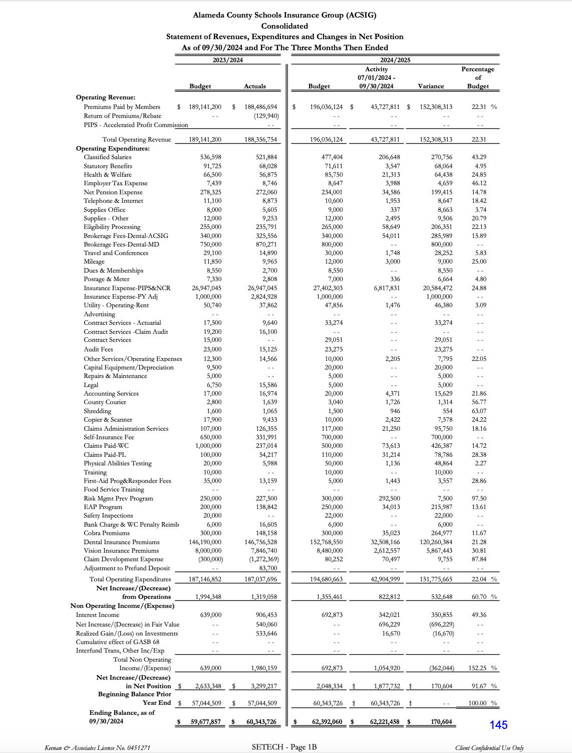

- 2024/25 First Quarter Investment Report
Dan Tichenor from Morgan Stanley presented the 2024/25 1st Quarter Investment Report.
It was moved by Annette Heldman and seconded by Bryan Wakefield to approve the 1st Quarter Investment Report.
Ayes: Collins, Krueger, Blessing, Chan, Hobbs, Oum, Cowan, Wakefield, Heldman, Penaflor, Quintana, Alahydoain, Sheikholeslami
Nays: None.
Abstain: None.

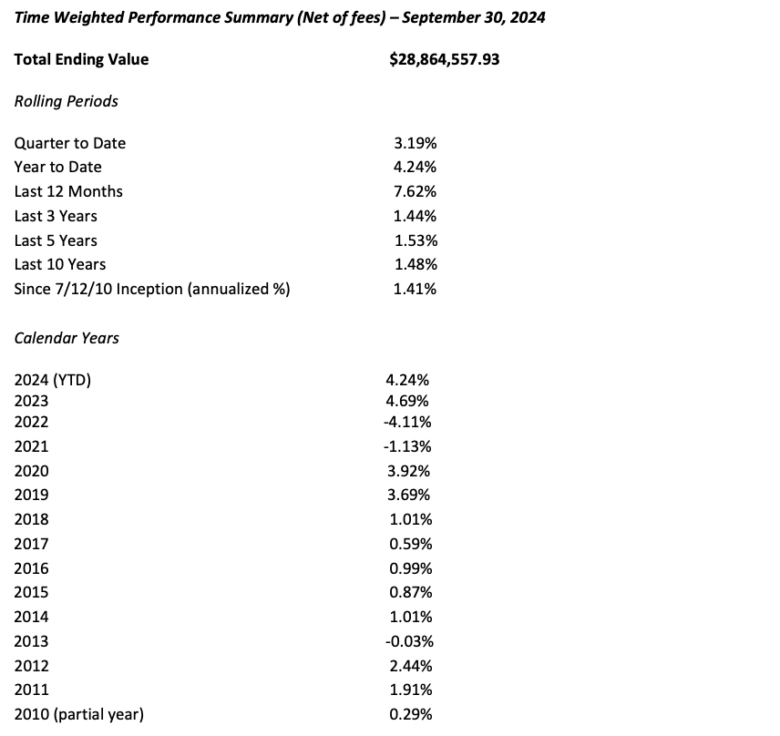

- Dental Network Updates
The Executive Director discussed the Delta Dental providers with the Board. Delta Dental is still the primary network in California, however ACSIG now offers Ameritas dental program as a dual network to meet the members’ needs.

Workers Compensation

- Service Plan 2024/25
Kyle Mckibbin from Keenan Associates reviewed the 2024/25 Service Plan with the Executive Committee. The Service Plan is a tool to show what the service team goals to complete within the upcoming year.

- Workers Compensation Claims History
Bridgett Jordan from Keenan Associates reviewed a 3-year claims history report. As resources are dedicated to improving frequency and severity of injuries within ACSIG, it is important to review claims data to evaluate the effectiveness of programs. Through analysis, we can identify trends within the districts.

- EAP Update
Current participating districts are ACOE, Albany, Dublin, Fremont, Mission Valley ROP, New Haven, Piedmont, Pleasanton, San Leandro, San Lorenzo, Sunol Glen and Tri Valley ROP. Utilization is still low but has had a slight increase to 2.5%. Implementation has been smooth for Castro Valley USD.

- Future Planning

- This meeting was adjourned by Dr. Kevin Collins at 12:50 PM

