

Alameda County Schools Insurance Group (ACSIG)
5776 Stoneridge Mall Rd., Suite 130 Pleasanton, CA 94588

MINUTES
Full Board

Date: Thursday, May 23, 2024
Time: 12:00PM
Location: Video Meeting
Join Zoom Meeting
https://us02web.zoom.us/j/7358807014?pwd=WW9PcGZvV2ZSY2hxWXI4WVJPTWVWUT09&omn=81999610238

Meeting ID: 735 880 7014
Passcode: acsig24

- Dr. Kevin Collins called the meeting to order at 12:02PM

- Roll call

Board Members
Dr. Kevin Collins President San Leandro USD
Danielle Krueger Vice President Alameda USD
Jackie Kim Secretary Albany USD
Leigh Ann Blessing Board Member Alameda County Office of Education
Suzy Chan Board Member Castro Valley USD
Chris Hobbs Board Member Dublin USD
Dora Siu Board Member Emery USD
Bryan Wakefield Board Member Mission Valley ROP
Ruth Alahydoian Board Member Piedmont USD
Ahmad Sheikholeslami Board Member Pleasanton USD
Julie Duncan Board Member Tri-Valley ROP

Kimberly Dennis Executive Director ACSIG
Celina Flotte Executive Assistant ACSIG

Ron Martin Guest Keenan & Associates
Tara Cooper-Salaiz Guest Keenan & Associates
Patrice Grant Guest Keenan & Associates
Margot Bringas Guest Keenan & Associates
Michael Clark Guest Keenan & Associates

- Acceptance of the Agenda
It was moved by Ruth Alahydoain and seconded by Julie Duncan to approve the agenda as presented.
Ayes: Collins, Krueger, Kim, Blessing, Chan, Hobbs, Siu, Wakefield, Alahydoain, Sheikholeslami, Duncan
Nays: None
Abstain: None

- Public Comment on Closed Session Agenda Items

No public present to comment.

Closed Session
Closed session began at 12:03pm

Open Session
Open session began at 12:03pm

- Public Comment on Open Session Agenda Items
No public present to comment.

- Report of Action Taken in Closed Session
No action was taken in closed session.

Consent Calendar

- Items for consent
The below listed routine items are presented by staff for acceptance under a single vote.

- Executive Committee Minutes from February 8, 2024
- Executive Committee Minutes from March 20, 2024
- Executive Committee Minutes from May 3, 2024
- 2nd Quarter Financials
- 2nd Quarter Investment Report
- 3rd Quarter Financials
- 3rd Quarter Investment Report
- Investment Policy
- ACSIG Holiday Calendar
- DWK Agreement
- Actuarial Study – Ultimate Loss
- PLCA Agreement Renewal
- AP 218 PLCA Agreement Renewal
- Loss Control – ReLief Inspection Agreement
- Workers’ Compensation Claims Audit
- Dispute Resolution Policy
- Underwriting Policy
- Conflict of Interest Code
- Authorization of Signatures
- Posting and Mailing Address

It was moved by Ruth Alahydoain and seconded by Julie Duncan to approve the consent calendar as presented.
Ayes: Collins, Krueger, Kim, Blessing, Chan, Hobbs, Siu, Wakefield, Alahydoain, Sheikholeslami, Duncan
Nays: None
Abstain: None

General

- Announcement of New Executive Director
The Board President announced the newly appointed Executive Director to the Board. Please welcome Jackie Kim as the new Executive Director for ACSIG.

- Executive Committee Membership
The Executive Committee has suggested recruiting Dublin USD and Mission Valley ROP to the Executive Committee. Alameda USD agreed to continue sitting on the committee.
It was moved by Leigh Ann Blessing and seconded by Ruth Alahydoian to appoint Dublin USD, Mission Valley ROP and approve the continuance of Alameda USD to serve on the Executive Committee.
Ayes: Collins, Krueger, Kim, Blessing, Chan, Hobbs, Siu, Wakefield, Alahydoain, Sheikholeslami, Duncan
Nays: None
Abstain: None

- Budget 2024/2025
The Executive Director reviewed the Budget with the Full Board.

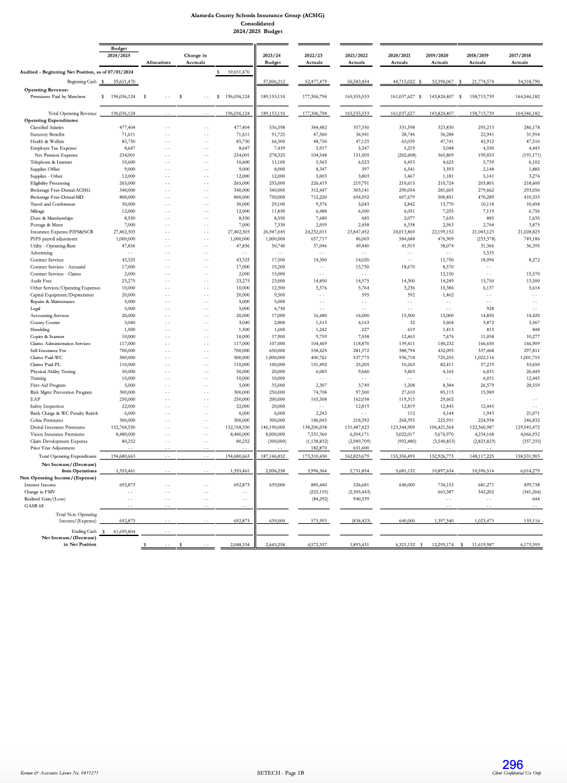

It was moved by Jackie Kim and seconded by Ruth Alahydoain to approve the budget as presented.
Ayes: Collins, Krueger, Kim, Blessing, Chan, Hobbs, Siu, Wakefield, Alahydoain, Sheikholeslami
Nays: None
Abstain: Duncan

- ACSIG Salaries & Benefits
The Governor’s 2023-2024 budget funded COLA at 8.22%.1 ACSIG increased its 2023- 2024 salary schedule by 4.07% on July 1, 2024, except for the Executive Assistant Schedule, which was raised by 10% to conclude a series of superseding adjustments dictated by a 21/22 classification study. The member’s weighted average was 7.06% as calculated by the Alameda County Office of Education. Based on those numbers, ACSIG Staff recommends 7.06% increase.
It was moved by Danielle Krueger and seconded by Jackie Kim to approve ACSIG salaries as presented.
Ayes: Collins, Krueger, Kim, Blessing, Chan, Hobbs, Siu, Wakefield, Alahydoain, Sheikholeslami, Duncan
Nays: None
Abstain: None

- Meeting Calendar
The Board reviewed the draft 2024/25 meeting calendar.

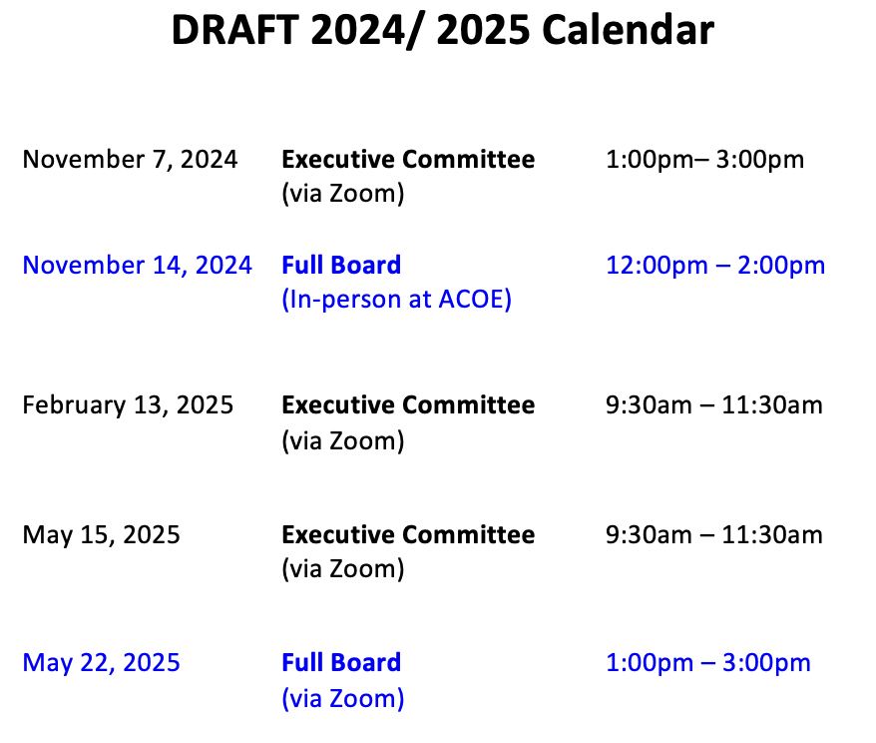
Workers’ Compensation

- Actuarial Study – Ex-Mods
Historically, ACSIG experience modification factors were not “re-benched” to 1.00. The result was program underfunding. In 2008, the Executive Committee and Board agreed to begin a multi-year funding model to begin “re-benching” ex-mods to 1.00. Program year 2009/2010 was the first year of this process. It was the expectation that the rates would become more consistent due to the use of actuarially determined experience-modification rates. Prior to 2013/2014, the ACSIG Board imposed a cap in the amount an ex-mod could increase/decrease in any one program year. Beginning in 2013/14 the actuarially determined ex-mod will be used with no maximum change cap. The assumption that all ex-mods will remain between 0.75 – 1.25 will continue.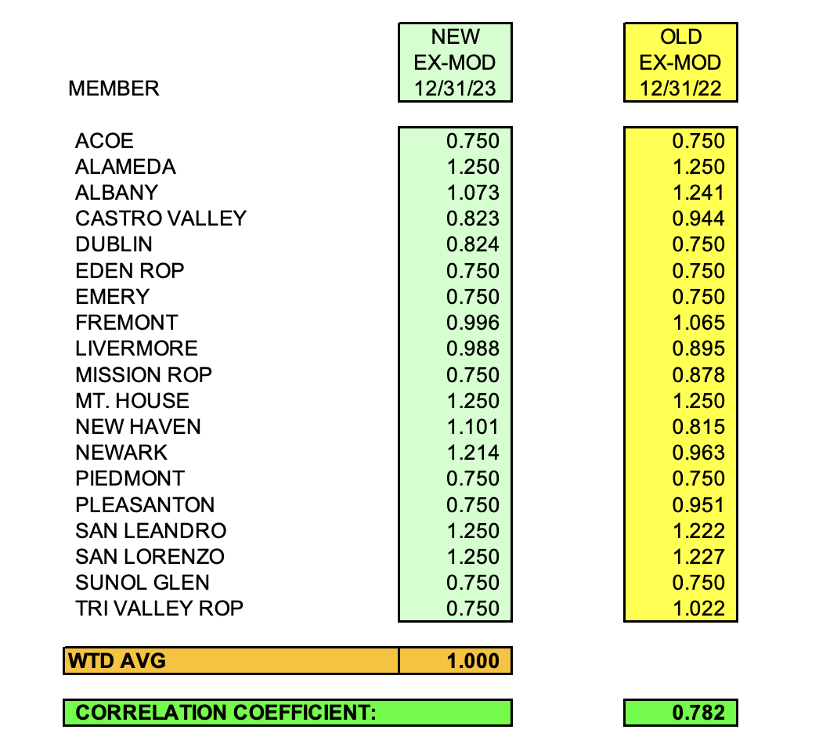

It was moved by Ruth Alahydoain and seconded by Ahmad Sheikholeslami to approve the Ex-Mods as presented.
Ayes: Collins, Krueger, Kim, Blessing, Chan, Hobbs, Siu, Wakefield, Alahydoain, Sheikholeslami, Duncan
Nays: None
Abstain: None
- Workers’ Compensation Rates 2024/2025
The Executive Director presented 2024/25 Workers Compensation rates.
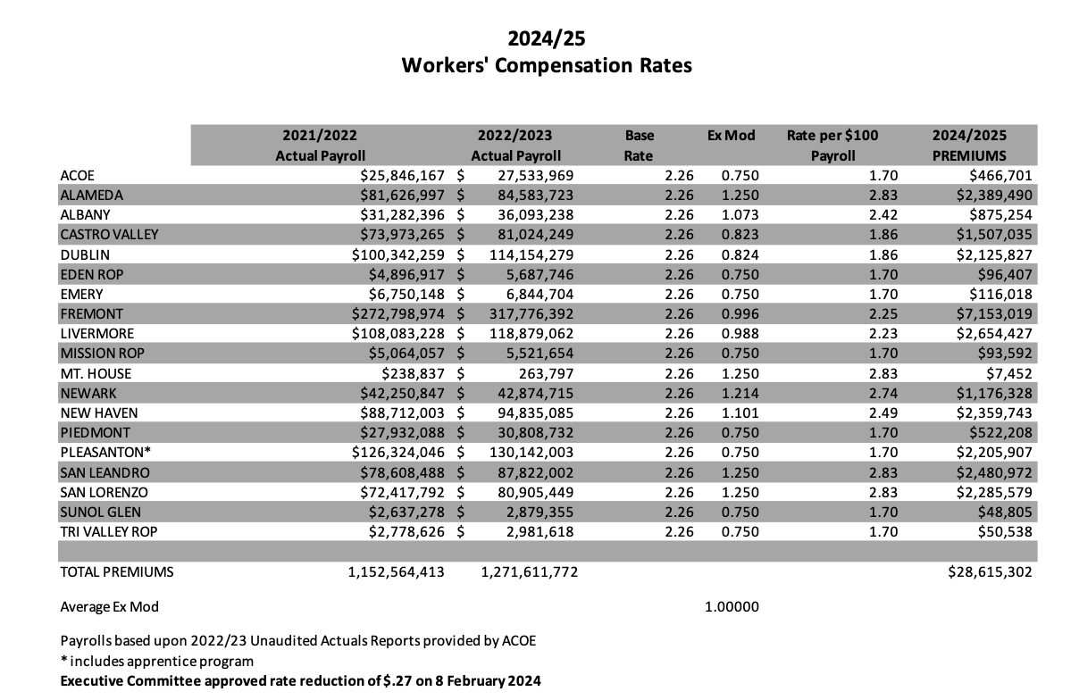

It was moved by Chris Hobbs and seconded by Ruth Alahydoain to approve the Workers Compensation rates with the corrected rate sheet above (base rate of 2.26).

- EAP Update
Current participating members are Alameda County Office of Education, Alameda USD, Albany, Dublin, Fremont, Mission Valley ROP, New Haven, Piedmont, Pleasanton, San Leandro, San Lorenzo, Sunol Glen, and Tri-Valley ROP. Current utilization within the EAP program is 2.3%.

- Claims Trends – 5 year Point in Time
The Risk Management Analyst reviewed the current claim trends by Job Classification, Age and Month with the Executive Committee.

Dental

- Dental Program & Rates 2024/ 2025
The Executive Director presented the Dental Rate recommendations with the Full Board. There is a motion of approval to add 2 additional enhancements: increase to 3 cleaning and 3 exams and to add implant services covered under annual maximum and paid at same coverage level as prosthodontics.
It was moved by Danielle Krueger and seconded by Ruth Alahydoain to approve the Dental Rates with enhancements.
Ayes: Collins, Krueger, Kim, Blessing, Chan, Hobbs, Siu, Wakefield, Alahydoain, Sheikholeslami, Duncan
Nays: None
Abstain: None

- Dental Network Expansion
The Executive Director presented options for expanding the Dental Program’s network partners. Customers are experiencing out-of-network utilizatioin which has resulted in some negative customer expriences. To address these concerns it was recommended to approve a proposal from Ameritas to prevent members paying upfront costs to providers who are no longer in-network with Delta Dental.
It was moved by Danielle Krueger and seconded by Ruth Alahydoain to recommend approval of the Dental Network expansion.
Ayes: Collins, Krueger, Kim, Blessing, Chan, Hobbs, Siu, Wakefield, Alahydoain, Sheikholeslami, Duncan
Nays: None
Abstain: None

Vision

- Vision Program & Rates 2024/ 2025
The Executive Director presented the Vision Rate recommendations with the Full Board. The recommendation is to add 2 additional enhancements: increase allowances to $200 frame and $200 ECL and to add polycarbonate lenses.
It was moved by Ruth Alahydoain and seconded by Julie Duncan to recommend approval of Vision Rates.
Ayes: Collins, Krueger, Kim, Blessing, Chan, Hobbs, Siu, Wakefield, Alahydoain, Sheikholeslami, Duncan
Nays: None
Abstain: None

Property & Liability

- Property & Liability Rates 2024/2025
The Executive Director presented the Property and Liability rates.
It was moved by Leigh Ann Blessing and seconded by Chris Hobbs to approve the Property & Liability rates.
Ayes: Collins, Krueger, Kim, Blessing, Chan, Hobbs, Siu, Wakefield, Alahydoain, Sheikholeslami, Duncan
Nays: None
Abstain: None

- Future Planning

- This meeting was adjourned by Dr. Kevin Collins at 1:24PM


LOCATION CALL- IN SHEET
ALAMEDA COUNTY SCHOOLS INSURANCE GROUP
FULL BOARD MEETING
May 23, 2024
12:00 PM
Join Zoom Meeting
https://us02web.zoom.us/j/7358807014?pwd=WW9PcGZvV2ZSY2hxWXI4WVJPTWVWUT09&omn=81999610238
Meeting ID: 735 880 7014 Passcode: acsig24

This meeting will be conducted by teleconferencing in accordance with Government Code Section 54953(b). Members of the public may address the Committee from any teleconference location shown below:

Alameda County Office of Education
313 W Winton Ave.
Hayward, CA 94544
Leigh Ann Blessing (510) 670-4187

Alameda Unified School District
2060 Challenger Drive #100
Alameda, CA 94501
Danielle Kruger (510) 337-7066

Albany Unified School District
819 Bancroft Way
Berkeley, CA 94710
Jackie Kim (510) 558-3751

Castro Valley Unified School District
4400 Alma Avenue
Castro Valley, CA 94546
Suzy Chan (510) 537-3000ext 1230

Dublin Unified School District
7471 Lakedale Avenue
Dublin, CA 94568
Chris Hobbs (925) 828-2551 ext 8041

Eden Area ROP
26316 Hesperian Blvd.
Hayward, CA 94545
Anthony Oum (510) 293-2906

Emery Unified School District
4727 San Pablo Ave.
Emeryville, CA 94608
Dora Siu (510) 601-4902

Fremont Unified School District
4210 Technology Drive
Fremont, CA 94539
Daniel Hillman (510) 659-2350

Livermore Unified School District
685 East Jack London Blvd.
Livermore, CA 94501
Teresa Fiscus (925) 606-3253

Mission Valley ROP
5019 Stevenson Blvd.
Fremont, CA 94538
Bryan Wakefield (510) 492-5145

Mountain House School District
3950 Mountain House Road
Byron, CA 94546
Gay Costa (209) 835-2283

New Haven Unified School District
34200 Alvarado-Niles Rd.
Union City, CA 94587
Annette Heldman (510) 471-1100 ext 60413

Newark Unified School District
5715 Musick Avenue
Newark, CA 94560
Tracey Vackar (510) 818-4115

Piedmont Unified School District
760 Magnolia Ave
Piedmont, CA 94611
Ruth Alahydoian (510) 594-2608

Pleasanton Unified School District
5758 W Las Positas Blvd
Pleasanton, CA 94566
Ahmad Sheikholeslami (925) 426-4307

San Leandro Unified School District
835 E 14th St
San Leandro, CA 94577
Dr. Kevin Collins (510) 667-3504

San Lorenzo Unified School District
15510 Usher Street
San Lorenzo, CA 94580
Dr. Roberto Perez Jr (510) 317-4641

Sunol Glen School District
11601 Main Street
Sunol, CA 94586
Molleen Barnes (925) 670-4277

Tri-Valley ROP
1040 Florence Road
Livermore, CA 94550
Julie Duncan (925) 455-4800 ext 104

