

Alameda County Schools Insurance Group (ACSIG)
5776 Stoneridge Mall Rd., Suite 130 Pleasanton, CA 94588

MINUTES
Executive Committee

Date: Thursday, May 16, 2024
Time: 9:30 AM
Location: Video Meeting
Join Zoom Meeting
https://us02web.zoom.us/j/7358807014?pwd=WW9PcGZvV2ZSY2hxWXI4WVJPTWVWUT09&omn=81999610238

Meeting ID: 735 880 7014
Passcode: acsig24

- Kevin Collins called the meeting to order 9:31AM

- Roll call

Executive Committee Members
Dr. Kevin Collins President San Leandro USD
Danielle Krueger Vice President Alameda USD
Jackie Kim Secretary Albany USD
Leigh Ann Blessing Board Member ACOE
Annette Heldman Board Member New Haven USD
Ruth Alahydoain Board Member Piedmont USD
Ahmad Sheikholeslami Board Member Pleasanton USD

Kimberly Dennis Executive Director ACSIG
Celina Flotte Executive Assistant ACSIG

Ron Martin Guest Keenan & Associates
Tara Cooper-Salaiz Guest Keenan & Associates
Patrice Grant Guest Keenan & Associates
Hesam Fayaz Guest SETECH
Mark Payne Guest Morgan Stanley

Ruth Alahydoain joined the meeting at 9:32am

- Acceptance of the Agenda
It was moved by Annette Heldman and seconded by Leigh Ann Blessing to approve the agenda as presented.
Ayes: Collins, Krueger, Kim, Blessing, Heldman, Alahydoain, Sheikholeslami
Nays: None
Abstain: None

- Public Comment on Closed Session Agenda Items

No public present to comment.

Closed Session
Closed session began at 9:33am

- Settlement Notification
- Claim Numbers:

574196 | Bentley
587022 | Janko
590712 | Barto
593657 | Byrd
594276 | Norton
601246 | Reardon
609199 | Jackson
614493 | Driouch Walker

- Settlement Authorization
- Claims Numbers: None

- Personnel Matter - Executive Director

- Executive Director Applicant Review

Open Session
Open session began at 9:54am

- Public Comment on Open Session Agenda Items
No public present to comment.

- Report of Action Taken in Closed Session
- It was moved by Dani Krueger and seconded by Annette Heldman to accept the resignation of Andrew Lathrop with administrative leave pay until August 2024.
- It was moved by Dani Krueger and seconded by Ruth Alahydoain to appoint the new Executive Director.
Ayes: Collins, Krueger, Kim, Blessing, Heldman, Alahydoain, Sheikholeslami
Nays: None
Abstain: None

- Approval of Minutes
It was moved by Ruth Alahydoian and seconded by Annette Heldman to approve the meeting minutes from February 8, 2024, March 20, 2024 and May 3, 2024.
Ayes: Collins, Krueger, Kim, Blessing, Heldman, Alahydoain, Sheikholeslami
Nays: None
Abstain: None

General

- Executive Director Appointment
Executive Committee discussed appointing a candidate for the Executive Director vacancy.
It was moved by Ruth Alahydoain and seconded by Dani Krueger to appoint Jackie Kim as the new Executive Director.
Ayes: Collins, Krueger, Blessing, Heldman, Alahydoain, Sheikholeslami
Nays: None
Abstain: Kim

- Executive Committee Membership
The Executive Committee has suggested recruiting Dublin USD, Eden ROP or Mission Valley ROP to the Executive Committee. Alameda USD has agreed to continue sitting on the committee.

- Third Quarter Investment Report
Mark Payne from Morgan Stanley reviewed the 2023/24 third quarter investment report with the Executive Committee.
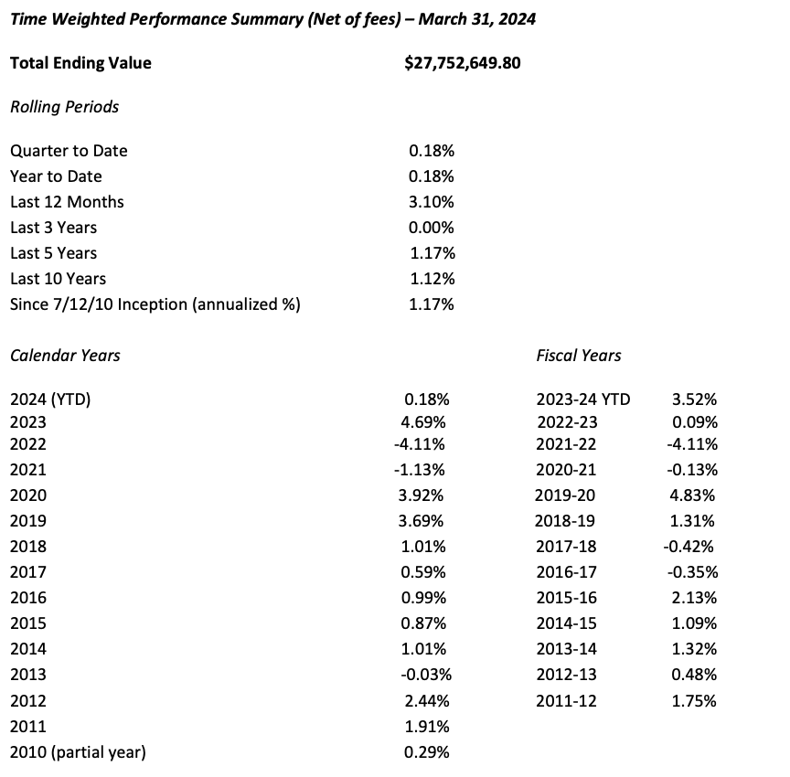
It was moved by Ahmad Sheikholeslami and seconded by Jackie Kim to recommend approval of the third quarter investment report as presented to the Full Board.
Ayes: Collins, Krueger, Kim, Blessing, Heldman, Alahydoain, Sheikholeslami
Nays: None
Abstain: None

- Investment Policy
The Executive Committee conducted the annual review of the written Investment Policy and found no changes necessary.
It was moved by Ruth Alahydoian and seconded by Jackie Kim to recommend approval of the Investment Policy as presented to the Full Board.
Ayes: Collins, Krueger, Kim, Blessing, Heldman, Alahydoain, Sheikholeslami
Nays: None
Abstain: None

- Third Quarter Financial Report
Hesam Fayez from SETECH presented the 2023/2024 third quarter financial report.
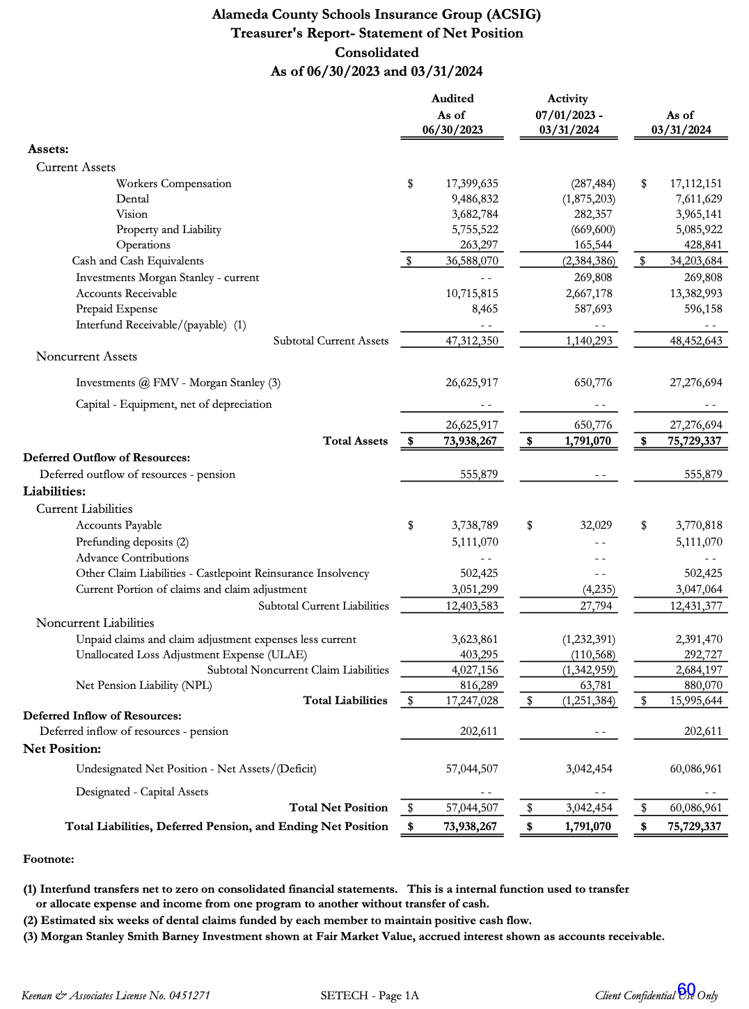
It was moved by Leigh Ann Blessing and seconded by Ruth Alahydoain to recommend approval of the third quarter financial report as presented to the Full Board.
Ayes: Collins, Krueger, Kim, Blessing, Heldman, Alahydoain, Sheikholeslami
Nays: None
Abstain: None

- Budget 2024/2025
The Executive Director reviewed the Budget with the Executive Committee. The budget contains a list of major contracts and service providers, assumptions and calculations with a detailed budget for each major program. The budget incorporates the $.27 WC rate reduction that was approved by the Executive Committee on February 8, 2024.
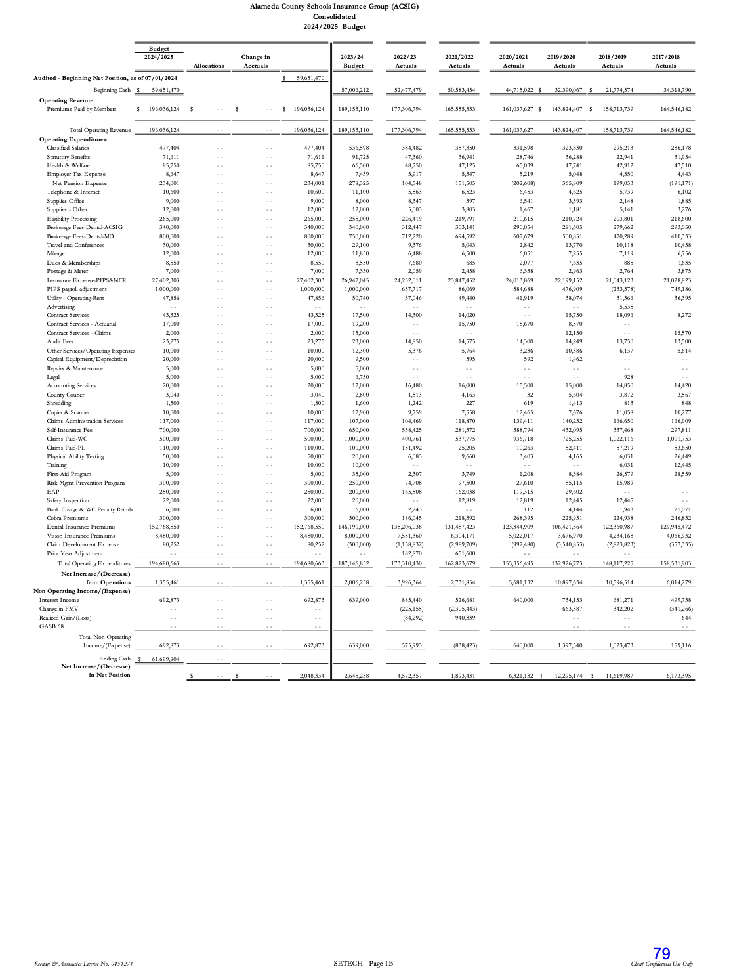
It was moved by Annette Heldman and seconded by Dani Krueger to recommend approval of the budget to the Full Board.
Ayes: Collins, Krueger, Kim, Blessing, Heldman, Alahydoain, Sheikholeslami
Nays: None
Abstain: None

- ACSIG Salaries & Benefits
The Governor’s 2023-2024 budget funded COLA at 8.22%. ACSIG increased its 2023-2024 salary schedule by 4.07% on July 1, 2024, except for the Executive Assistant Schedule, which was raised by 10% to conclude a series of superseding adjustments dictated by a 21/22 classification study. The member’s weighted average was 7.06% as calculated by the Alameda County Office of Education. Based on those numbers, ACSIG Staff recommends a 7.06% increase.
It was moved by Ahmad Sheikholesalmi and seconded by Annette Heldman to recommend approval of the salary increase and all updated salary schedules to the Full Board.
Ayes: Collins, Krueger, Kim, Blessing, Heldman, Alahydoain, Sheikholeslami
Nays: None
Abstain: None

- Meeting Calendar
The Executive Committee reviewed the 2024/25 draft meeting calendar with reccomendations to change meeting durations from 3 to 2 hour blocks.
It was moved by Dani Krueger and seconded by Leigh Ann Blessing to recommend approval of the meeting calendar to the Full Board.
Ayes: Collins, Krueger, Kim, Blessing, Heldman, Alahydoain, Sheikholeslami
Nays: None
Abstain: None

- ACSIG Holiday Calendar
The Executive Director presented a proposed ACSIG 2024/25 calendar with one change to add the Friday after Thanksgiving as a holiday.
It was moved by Annette Heldman and seconded by Jackie Kim to recommend approval of the meeting calendar to the Full Board.
Ayes: Collins, Krueger, Kim, Blessing, Heldman, Alahydoain, Sheikholeslami
Nays: None
Abstain: None

- CAJPA Fall Conference 2024
2024 CAJPA Fall Conference held September 10 -13, 2024 in South Lake Tahoe. This will be the last conference at this location, future conferences will be in Monterey, Ca.

Workers’ Compensation

- EAP Update
The Executive Director reviewed the utilization of the EAP with the Executive Committee.
Uprise was able to provide support to Albany USD, with skilled clinicians on site and provided outstanding service.

- Claims Trends – 5 year Point in Time
The Executive Director updated the Committee regarding current claim trends by Job Classification, Age and Month. Claims have been higher due to medical costs increasing significantly.

- Workers’ Compensation Claims Audit
The Executive Director presented a 2024 Workers’ Compensation Claims Audit of Keenan & Associates.
It was moved by Ruth Alahydoian and seconded by Dani Krueger to recommend approval of the workers compensation claims audit to the Full Board.
Ayes: Collins, Krueger, Kim, Blessing, Heldman, Alahydoain, Sheikholeslami
Nays: None
Abstain: None

Dental

- Dental Program & Rates 2024/2025
The Executive Director presented the Dental Rate recommendations with the Executive Committee. The recommendation is to add 2 additional enhancements: increase to 3 cleaning and 3 exams and to add implant services covered under annual maximum and paid at same coverage level as prosthodontics.
It was moved by Ahmad Sheikholeslami and seconded by Annette Heldman to recommend approval of Dental Rates to the Full Board.
Ayes: Collins, Krueger, Kim, Blessing, Heldman, Alahydoain, Sheikholeslami
Nays: None
Abstain: None

- Dental Network Expansion
The Executive Director presented options for expanding the Dental Program’s network partners. Customers are experiencing out-of-network utilizatioin which has resulted in some negative customer expriences. To address these concerns it was recommended to approve a proposal from Ameritas to prevent members paying upfront costs to providers who are no longer in-network with Delta Dental.
It was moved by Ruth Alahydoain and seconded by Danielle Krueger to recommend approval of the Dental Network expansion to the Full Board.
Ayes: Collins, Krueger, Kim, Blessing, Heldman, Alahydoain, Sheikholeslami
Nays: None
Abstain: None

Vision

- Vision Program & Rates 2024/2025
The Executive Director presented the Vision Rate recommendations with the Executive Committee. The recommendation is to add 2 additional enhancements: increase allowances to $200 frame and $200 ECL and to add polycarbonate lenses.
It was moved by Ruth Alahydoain and seconded by Annette Heldman to recommend approval of Vision Rates to the Full Board.
Ayes: Collins, Krueger, Kim, Blessing, Heldman, Alahydoain, Sheikholeslami
Nays: None
Abstain: None

Property & Liability

- Property & Liability Rates 2024/2025
The Executive Director presented the Property and Liability rates.
It was moved by Jackie Kim and seconded by Leigh Ann Blessing to recommend approval of the Property & Liability rates as presented to the Full Board.
Ayes: Collins, Krueger, Kim, Blessing, Heldman, Alahydoain, Sheikholeslami
Nays: None
Abstain: None

- PLCA Agreement Renewal
The Executive Director reviewed the amendment for Property and Casualty Claims Administration Services ,there was a 3% increase from our previous agreement.
It was moved by Annette Heldman and seconded by Ruth Alahydoian to recommend approval of the PLCA Amendment to the Full Board.
Ayes: Collins, Krueger, Kim, Blessing, Heldman, Alahydoain, Sheikholeslami
Nays: None
Abstain: None

- AB 218 PLCA Agreement Renewal
The Executive Director presented the renewal contract for AB218 Claims Administrative Services.
It was moved by Annette Heldman and seconded by Leigh Ann Blessing to recommend approval of the AB 218 PLCA Amendment to the Full Board.
Ayes: Collins, Krueger, Kim, Blessing, Heldman, Alahydoain, Sheikholeslami
Nays: None
Abstain: None

- Loss Control – ReLief Inspection Agreement Renewal
The Executive Director reviewed the renewal contract for school inspection services, there was a 3% increase frim the previous agreement.
It was moved by Annette Heldman and seconded by Jackie Kim to recommend approval of the Loss Control Agreement Renewal to the Full Board.
Ayes: Collins, Krueger, Kim, Blessing, Heldman, Alahydoain, Sheikholeslami
Nays: None
Abstain: None

Administrative

- Dispute Resolution Policy
The Executive Committee conducted the annual review of the Dispute Resolution policy and found no changes necessary.
It was moved by Leigh Ann Blessing and seconded by Annette Heldman to recommend approval the Dispute Resolution policy as presented to the Full Board.
Ayes: Collins, Krueger, Kim, Blessing, Heldman, Alahydoain, Sheikholeslami
Nays: None
Abstain: None

- Underwriting Policy
The Executive Committee conducted the annual review of the Underwriting Policy and found no changes necessary.
It was moved by Leigh Ann Blessing and seconded by Annette Heldman to recommend approval the Underwriting Policy as presented to the Full Board.
Ayes: Collins, Krueger, Kim, Blessing, Heldman, Alahydoain, Sheikholeslami
Nays: None
Abstain: None

- Conflict of Interest Code
The Executive Committee conducted the annual review of the Conflict of Interest Code and found no changes necessary.
It was moved by Leigh Ann Blessing and seconded by Annette Heldman to recommend approval of the Conflict of Interest Code as presented to the Full Board.
Ayes: Collins, Krueger, Kim, Blessing, Heldman, Alahydoain, Sheikholeslami
Nays: None
Abstain: None

- Authorization of Signatures
The Executive Committee conducted the annual review of the Authorization of Signatures and found no changes necessary.
It was moved by Leigh Ann Blessing and seconded by Annette Heldman to recommend approval the Authorization of Signatures as presented to the Full Board.
Ayes: Collins, Krueger, Kim, Blessing, Heldman, Alahydoain, Sheikholeslami
Nays: None
Abstain: None

- Posting and Mailing Address
The Executive Committee conducted the annual review of the Posting and Mailing Address for ACSIG and found no changes necessary.
It was moved by Leigh Ann Blessing and seconded by Annette Heldman to recommend approval the Posting and Mailing address to the Full Board.
Ayes: Collins, Krueger, Kim, Blessing, Heldman, Alahydoain, Sheikholeslami
Nays: None
Abstain: None

- Future Planning

- This meeting was adjourned by Annette Heldman at 11:38AM

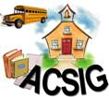
LOCATION CALL- IN SHEET
ALAMEDA COUNTY SCHOOLS INSURANCE GROUP
EXECUTIVE COMMITTEE MEETING
May 16, 2024
9:30 AM
Join Zoom Meeting
https://us02web.zoom.us/j/7358807014?pwd=WW9PcGZvV2ZSY2hxWXI4WVJPTWVWUT09&omn=81999610238

Meeting ID: 735 880 7014 Passcode: acsig24

This meeting will be conducted by teleconferencing in accordance with Government Code Section 54953(b). Members of the public may address the Committee from any teleconference location shown below:

Alameda County Office of Education
313 W Winton Ave.
Hayward, CA 94544
Leigh Ann Blessing (510) 670-4218

Albany Unified School District
819 Bancroft Way
Berkeley, CA 94710
Jackie Kim (510) 558-3751

New Haven Unified School District
34200 Alvarado-Niles Rd.
Union City, CA 94587
Annette Heldman (510) 471-1100 ext 60413

Piedmont Unified School District
760 Magnolia Ave
Piedmont, CA 94611
Ruth Alahydoian (510) 594-2608

Pleasanton Unified School District
5758 W Las Positas Blvd
Pleasanton, CA 94566
Ahmad Sheikholeslami (925) 426-4307

San Leandro Unified School District
835 E 14th St
San Leandro, CA 94577
Dr. Kevin Collins (510) 667-3504

