

Alameda County Schools Insurance Group (ACSIG)
5776 Stoneridge Mall Rd., Suite 130 Pleasanton, CA 94588

MINUTES
Executive Committee

Date: Thursday, February 8, 2024
Time: 9:30AM
Location: Alameda County Office of Education
313 W. Winton Ave.
Hayward, CA 94544

- Kevin Collins called the meeting to order at 9:33 AM

- Roll call

Executive Committee Members
Dr. Kevin Collins President San Leandro USD
Danielle Krueger Vice President Alameda USD
Jackie Kim Secretary Albany USD
Leigh Ann Blessing Board Member Alameda COE
Ruth Alahydoian Board Member Piedmont USD
Ahmad Sheikholelami Board Member Pleasanton USD

Kimberly Dennis Executive Director Alameda County Schools Insurance
Andrew Lathrop Transitional ED Alameda County Schools Insurance
Celina Flotte Executive Assistant Alameda County Schools Insurance

Ron Martin Guest Keenan & Associates
Patrice Grant Guest Keenan & Associates

Brian Sharpes Guest Morgan Stanley
Laurena Grabert Guest SETECH

- Acceptance of the Agenda
It was moved by Ahmad Sheikholeslami and seconded by Dani Krueger to approve the agenda as presented.
Ayes: Collins, Kinder, Krueger, Kim, Blessing, Sheikholeslami
Nays: None
Abstain: None

Ruth Alahydoian joined the meeting at 9:34am

- Public Comment on Closed Session Agenda Items
No public present to comment.

Closed Session
Closed session began at 9:34am

- Settlement Authorization
- Claim Numbers: None

- Settlement Notification

- Claim Numbers:

Ramirez | 533380
Varne | 540086
Boggs | 559398
Morgan | 578051
Mangini | 581967
Pagan | 590820
Garcia de Monge | 597496
Dillon-Lundie | 598429
Torres | 609026
Dixon | 614637
Villalta | 623710

Open Session
Open session began at 9:35am

- Public Comment on Open Session Agenda Items
No public present to comment

- Report of Action Taken in Closed Session
There was no action taken in closed session

- Approval of Minutes
It was moved by Kevin Collins and seconded by Jackie Kim to approve the meeting minutes from the October 25, 2023 Executive Committee Meeting and November 2, 2023 Full Board Meeting.
It was moved by Ruth Alahydoain and seconded by Leigh Ann Blessing to approve the agenda as presented.
Ayes: Collins, Kinder, Krueger, Kim, Blessing, Alahydoain, Sheikholeslami
Nays: None
Abstain: None

Workers Compensation

- Actuarial Study – Ex Mods
The Executive Director presented the Ex-Mods as determined by the Actuarial by Jack Joyce.
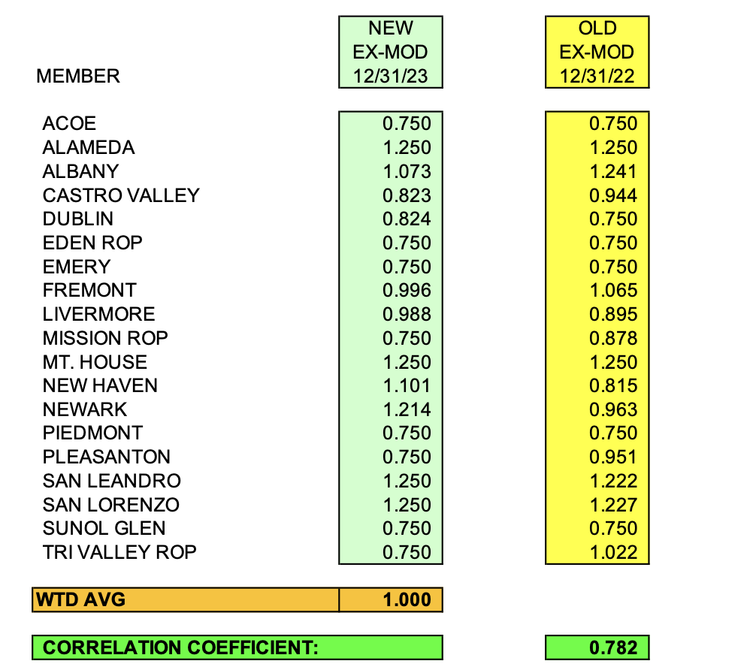
It was moved by Ahmad Sheikholeslami and seconded by Dani Krueger to approve the Ex-Mods as presented.
Ayes: Collins, Kinder, Krueger, Kim, Blessing, Alahydoain, Sheikholeslami
Nays: None
Abstain: None

- Actuarial Study – Ultimate Loss
The Executive Director presented Actuarial study of the ultimate loss of the self-insured portion of the ACSIG Workers Compensation program. Bay Actuarial estimates that ACSIG’s liability for unpaid losses were $3.7M on December 31, 2023. This report reflects claim payments in the amount of $329,959 and a reduction in reserves of $1,393,320.
It was moved by Dani Krueger and seconded by Jackie Kim to approve the Ultimate Loss Actuarial Study as presented.
Ayes: Collins, Kinder, Krueger, Kim, Blessing, Alahydoain, Sheikholeslami
Nays: None
Abstain: None

- EAP Update
The Executive Director discussed an update on the EAP Program with the Executive Committee. Claremont EAP is now Uprise Health and there have been some bumps in the road as they have transitioned from a local company to a national company. Due to recent staffing changes, we are looking forward to improved services.

- Workers Compensation Program Decisions for 2024/25
ACSIG workers’ compensation program has transitioned into a surplus position, we open the discussion with the Executive Committee to have the opportunity to review existing programs and explore new ones for the 2024-2025 year. The committee has no changes to the Skechers, EAP, post offer-pre placement program or trainings and no action was taken.

- Preliminary Workers Compensation Rates 2024/25
The Executive Director reviewed 2024/25 preliminary worker’s compensation rates with the base rate of 2.53. The workers compensation program continues to maintain a positive fund balance, therefore the committee recommends that the base rate be lowered by .27 to 2.26.

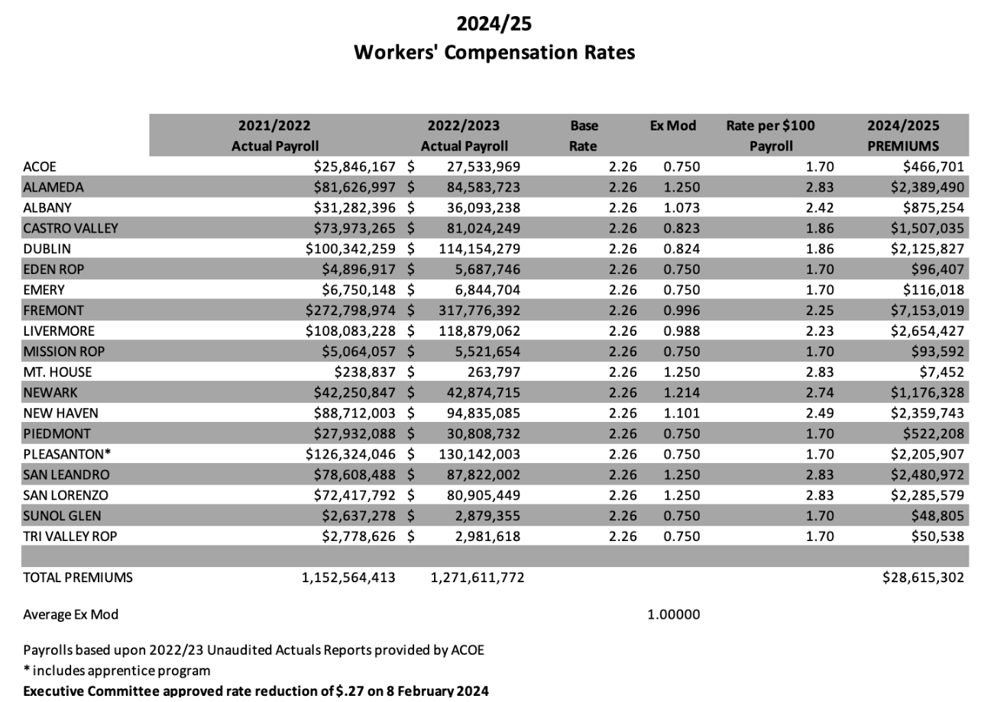

It was moved by Ruth Alahydoain and seconded by Ahmad Sheikholeslami to approve the motion of buying down the WC base rate by $.27.
Ayes: Collins, Kinder, Krueger, Kim, Blessing, Alahydoain, Sheikholeslami
Nays: None
Abstain: None

General

- Second Quarter Financial Report
Laurena Grabert from SETECH presented the 2023/2024 Second Quarter Financial Report.
It was moved by Leigh Ann Blessing and seconded by Ahmad Sheikholeslami to approve the second quarter financial report.
Ayes: Collins, Kinder, Krueger, Kim, Blessing, Alahydoain, Sheikholeslami
Nays: None
Abstain: None
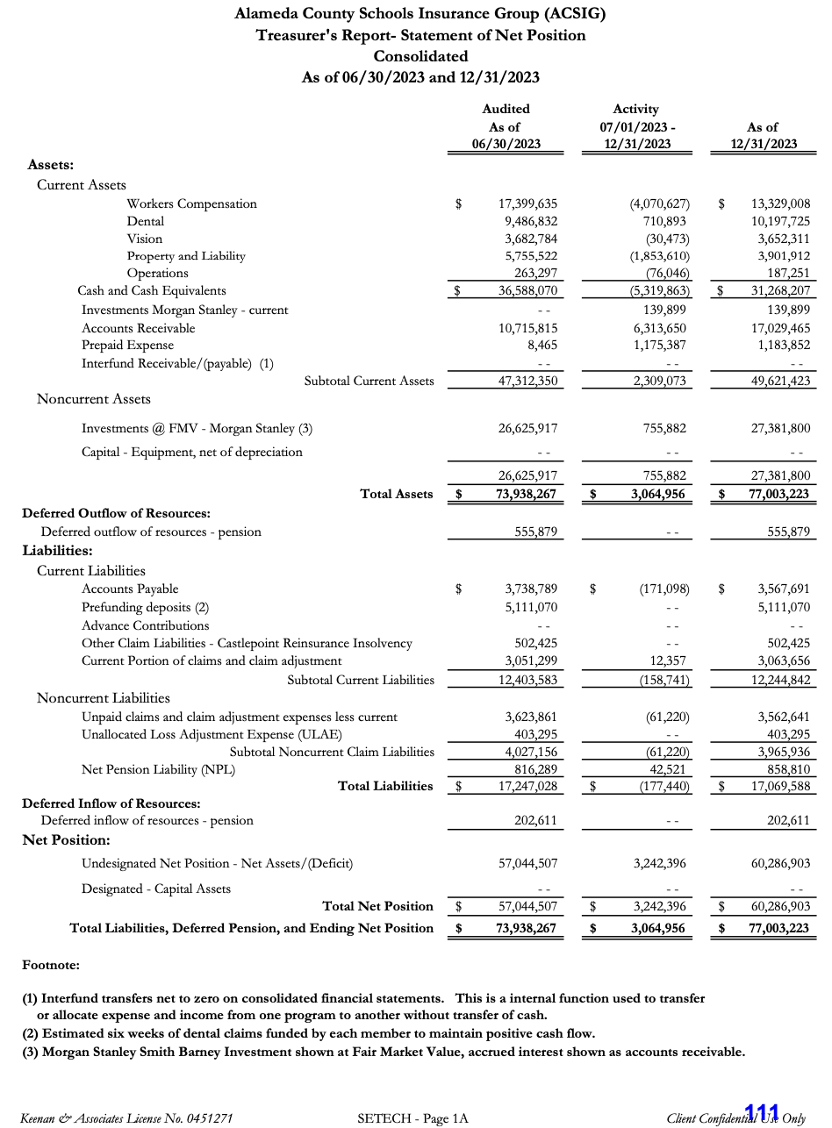

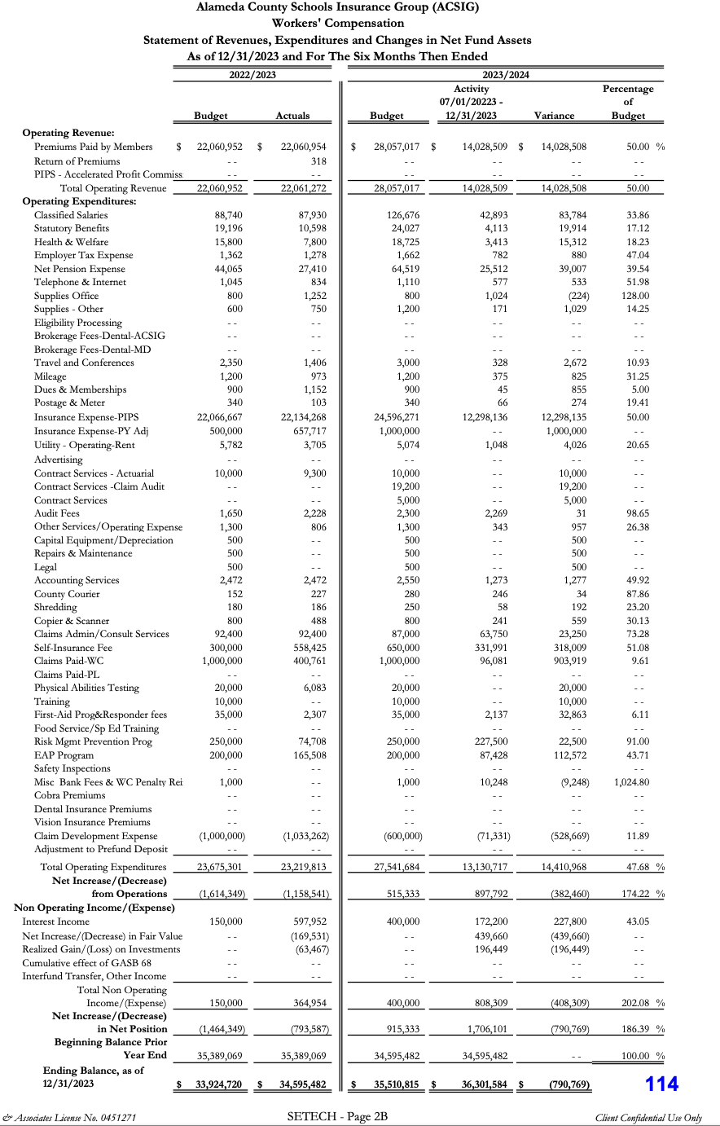

- Second Quarter Investment Report
Cary Allison presented the 2023/24 Second Quarter Investment Report.

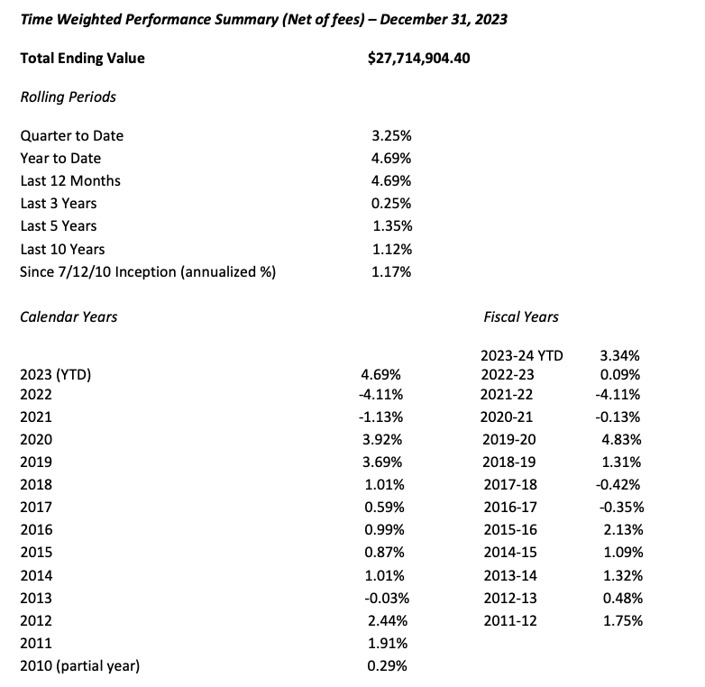

It was moved by Ahmad Sheikholeslami and seconded by Ruth Alahydoain to approve the second quarter investment report.
Ayes: Collins, Kinder, Krueger, Kim, Blessing, Alahydoain, Sheikholeslami
Nays: None
Abstain: None

- Budget 2024/25
This budget was developed using year- to-date 2023/2024 data and preliminary estimates for 2024/2025 rates and costs. Because all rates are not firm at this time, estimates were used for this report.
It was moved by Ahmad Sheikholeslami and seconded by Leigh Ann Blessing to approve the budget.
Ayes: Collins, Kinder, Krueger, Kim, Blessing, Alahydoain, Sheikholeslami
Nays: None
Abstain: None

- Approval of 2023/ 24 Salary Schedule
In preparation for retirement, it came to our attention that the salary schedules utilized by ACSIG are not in compliance with CalPERS requirements. While the Executive Committee and Full Board have always approved any salary augmentations, the actual salary schedule was not brought as an action item.
Additionally, there is some concern from PERS that there is only 1 position on the management salary schedule that provides longevity. PERS deems that longevity as not creditable. Kimberly will continue to work with PERS to get everything into compliance prior to the May Board meeting. It should be noted that the higher salaried amount has been reported to PERS all along and both the employee and employer have been paying the appropriate percentages on that higher amount.

- Cyber Breach
In the Fall of 2023, ACSIG began experiencing interruptions in services such as our telephone system and internet. ACSIG also had a fraud alert from our bank indicating that someone was trying to cash checks against our accounts. Because we have dual signatures on our checks, no money was stolen.
In late November, our systems were accessed and email was spoofed. Correspondence was sent out that to dental members from our COBRA/Dental technician indicating that ACSIG had changed it’s bank and to wire money to a new bank with account numbers. Because we are all operating in the environment of cyber breaches, our dental clients promptly alerted us to this request and we were able to prevent any erroneous wire transfers. That seemed to anger the hackers who then overloaded our emails and outgoing emails were restricted by Microsoft.
ACSIG contracted with counsel recommended by SAFER, Capriani & Werner, and Charles River Associates who are forensic investigators. Medical information is very sensitive. An extensive, forensic investigation was performed. The breach was only to our email system and no sensitive information was accessed.

- Strategic Planning
The Executive Director discussed updates and action plans for the 2024-25 year with the Committee that includes Post Offer/ Preplacement Program expansion, Human Resources connection highlighting the EAP services available, and ACSIG Board meeting electronic agenda changes.

- Future Planning

- This meeting was adjourned by Dr. Kevin Collins at 12:25 PM

