Alameda County Schools Insurance Group (ACSIG)
5776 Stoneridge Mall Rd., Suite 130 Pleasanton, CA 94588

MINUTES
Full Board

Date: Thursday, November 2, 2023
Time: 12:00PM
Location: Dublin Unified School District – Large Board Room
7471 Larkdale Ave, Dublin CA 94568

- This meeting was called to order at 12:15 PM

- Roll call

Full Board
Dr. Kevin Collins President San Leandro Unified School District
Danielle Krueger Vice President Alameda Unified School District
Suzy Chan Board Member Castro Valley USD
Chris Hobbs Board Member Dublin Unified School District
Anthony Oum Board Member Eden Area ROP
Bryan Wakefield Board Member Mission Valley ROP
Kimberly Jokela Board Member Mountain House Unified School District
Annette Heldman Board Member New Haven Unified School District
Ahmad Sheikholeslami Board Member Pleasanton Unified School District
Dr. Roberto Perez Jr. Board Member San Lorenzo Unified School District
Kimberly Jokela Board Member Sunol Glen Unified School District
Julie Duncan Board Member Tri-Valley ROP

Kimberly Dennis Executive Director Alameda County Schools Insurance
Celina Flotte Executive Assistant Alameda County Schools Insurance

Christy White Guest Christy White
Ron Martin Guest Keenan & Associates
Michael Clark Guest Keenan & Associates
Margot Bringas Guest Keenan & Associates
Heidi Richardson Guest Morgan Stanley
Laurena Grabert Guest SETECH

- Acceptance of the Agenda
It was moved by Annette Heldman and seconded by Suzy Chan to approve the agenda as presented.
Ayes: Collins, Heldman, Krueger, Chan, Hobbs, Oum, Wakefield, Sheikholeslami, Perez, Duncan
Nays: None.
Abstain: None.

- Public Comment on Open Session Agenda Items
Pursuant to the Brown Act, each public agency must provide the public with an opportunity to speak on any matter within the subject matter jurisdiction of the agency and which is on the agency’s agenda for that meeting. The Board of Directors allows speakers to speak on agendized and non-agendized matters under public comment. Comments are limited to no more than 3 minutes per speaker. By law, no action may be taken on any item raised during the public comment periods and matters may be referred to staff for placement on a future agenda of the Board of Directors

Consent Calendar
Review Items listed on the consent agenda for any adjustments and adoptions.

- Executive Committee Minutes from May 16, 2023
- Full Board Minutes from May 25, 2023
- 2022/23 Fourth Quarter Financials
- 2022/23 Fourth Quarter Investment Report

It was moved by Dr. Kevin Collins and seconded by Dani Krueger to accept the consent calendar.
Ayes: Collins, Heldman, Krueger, Chan, Hobbs, Oum, Wakefield, Sheikholeslami, Perez, Duncan
Nays: None.
Abstain: None.

General Business

- Annual Report
The Executive Director presented the 2022/23 Annual Report.

- 2022/ 23 Audit
Christy White presented the 2022/23 Audit with the Full Board.
It was moved by Annette Heldman and seconded by Suzy Chan to approve the Audit.
Ayes: Collins, Heldman, Krueger, Chan, Hobbs, Oum, Wakefield, Sheikholeslami, Perez, Duncan
Nays: None.
Abstain: None.

- 2023/ 24 First Quarter Financials
Laurena from SETECH presented the 2023/24 1st Quarter Financials.
It was moved by Bryan Wakefield and seconded by Ahmad Sheikholeslami to approve the 1st Quarter Financials.
Ayes: Collins, Heldman, Krueger, Chan, Hobbs, Oum, Wakefield, Sheikholeslami, Perez, Duncan
Nays: None.
Abstain: None.

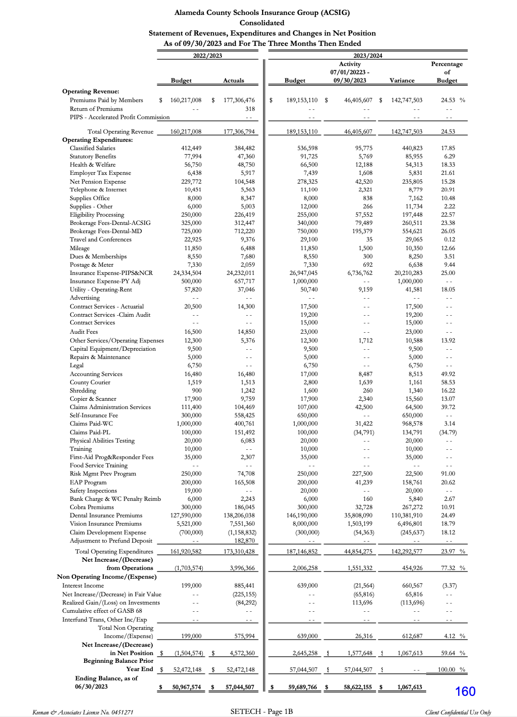

Terah Studges-Owens joined the meeting at 12:35pm

- 2023/ 24 First Quarter Investment Report
Heidi Richardson from Morgan Stanley presented the 2023/24 1st Quarter investment report.

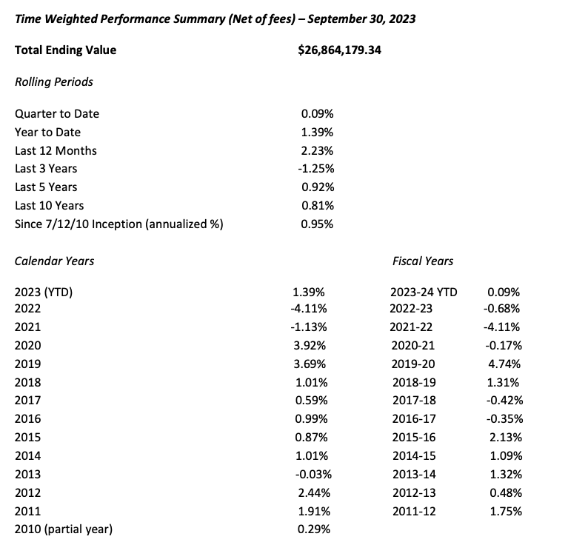

It was moved by Annette Heldman and seconded by Anthony Oum to approve the1st Quarter Investment Report.
Ayes: Collins, Heldman, Krueger, Chan, Hobbs, Oum, Wakefield, Sheikholeslami, Perez, Duncan, Studges-Owen
Nays: None.
Abstain: None.

- Budget Revision
The Executive Director presented a revision for the 2023/24 budget.
It was moved by Suzy Chan and seconded by Annette Heldman to approve the Budget Revision.
Ayes: Collins, Heldman, Krueger, Chan, Hobbs, Oum, Wakefield, Sheikholeslami, Perez, Duncan, Studges-Owens
Nays: None.
Abstain: None.

- CAJPA Accreditation Report
The Executive Director presented the Accreditation Report with the Board.
It was moved by Julie Duncan and seconded by Suzy Chan to approve the Accreditation Report.
Ayes: Collins, Heldman, Krueger, Chan, Hobbs, Oum, Wakefield, Sheikholeslami, Perez, Duncan, Studges-Owens
Nays: None.
Abstain: None.

- Delta Dental Network Review
The Executive Director discussed the Delta Dental providers with the Board. Delta Dental is still the primary network in California. Since the pandemic, there have been several dental groups who have chosen to leave the network in an effort to increase revenue. The JPA will look into having a secondary coverage.

- Cyber Backup Policy
The Executive Director discussed an update to data backup policy with the Board. It was moved by Chris Hobbs and seconded by Suzy Chan to approve the Cyber Backup Policy with a motion for the IT backup policy to include an adjustment to remove “Exchange server” from the policy.
Ayes: Collins, Heldman, Krueger, Chan, Hobbs, Oum, Wakefield, Sheikholeslami, Perez, Duncan, Studges-Owens
Nays: None.
Abstain: None.

- Update on Executive Director Transition
The Executive Committee discussed that the new executive director will start the position on January 2024, shadowing the current executive director until July 2024 until the full transition.

Workers Compensation

- Workers Compensation Rates 2023/24
The Executive Director presented the 2023/24 Workers Compensation rates.
It was moved by Anthony Oum and seconded by Ahmad Sheikholeslami to approve the Workers Compensation Rates.
Ayes: Collins, Heldman, Krueger, Chan, Hobbs, Oum, Wakefield, Sheikholeslami, Perez, Duncan, Studges-Owens
Nays: None.
Abstain: None.

- Workers Compensation Claims History
Michael Clark of Keenan Associates reviewed a 3-year claims history report. As resources are dedicated to improving frequency and severity of injuries within ACSIG, it is important to review claims data to evaluate the effectiveness of programs. Through analysis, we can identify trends within the districts.

- EAP Update
The Executive Director discussed with the Committee how implementation has been bumpy for Alameda USD as Claremont has had some staffing changes during their implementation of the EAP. We are working diligently to address the programs and keep the lines of communication open with the District. Utilization has gone up within the JPA to 3.5%.

- Future Planning

- This meeting was adjourned by Kevin Collins at 1:22 PM

