Alameda County Schools Insurance Group (ACSIG)
5776 Stoneridge Mall Rd., Suite 130 Pleasanton, CA 94588

MINUTES
Full Board

Date: Thursday, November 3, 2022
Time: 12:00PM
Location: Alameda County Office of Education
313 W. Winton Ave.
Hayward, CA 94544

- This meeting was called to order at 12:00 PM

- Roll call

Full Board
Annette Heldman President New Haven Unified School District
Dr. Kevin Collins Vice President San Leandro Unified School District
Jackie Kim Secretary Albany Unified School District
Leigh Ann Blessing Board Member Alameda County Office of Education
Dani Krueger Board Member Alameda Unified School District
Suzy Chan Board Member Castro Valley USD
Chris Hobbs Board Member Dublin Unified School District
Anthony Oum Board Member Eden Area ROP
Susan Kinder Board Member Livermore Valley Joint USD
Bryan Wakefield Board Member Mission Valley ROP
Shirene Moreira Board Member Mountain House Unified School District
Marie Dela Cruz Board Member Newark Unified School District
Ruth Alahydoian Board Member Piedmont Unified School District
Shirene Moreira Board Member Sunol Glen Unified School District
Julie Duncan Board Member Tri-Valley ROP

Kimberly Dennis Executive Director Alameda County Schools Insurance
Celina Flotte Executive Assistant Alameda County Schools Insurance

Tara Cooper-Salaiz Guest Keenan & Associates
Patrice Grant Guest Keenan & Associates
Ron Martin Guest Keenan & Associates
Michael Clark Guest Keenan & Associates
Margot Bringas Guest Keenan & Associates
Hesam Fayaz Guest SETECH
Mark Payne Guest Morgan Stanley

- Acceptance of the Agenda
It was moved by Dr. Kevin Collins and seconded by Susan Kinder to approve the agenda as presented.
Ayes: Heldman, Collins, Kim, Blessing, Krueger, Chan, Hobbs, Kinder, Wakefield, Moreira, Dela Cruz, Alahydoain, Duncan
Nays: None
Abstain: None

- Public Comment on Open Session Agenda Items
Pursuant to the Brown Act, each public agency must provide the public with an opportunity to speak on any matter within the subject matter jurisdiction of the agency and which is on the agency’s agenda for that meeting. The Board of Directors allows speakers to speak on agendized and non-agendized matters under public comment. Comments are limited to no more than 3 minutes per speaker. By law, no action may be taken on any item raised during the public comment periods and matters may be referred to staff for placement on a future agenda of the Board of Directors

Consent Calendar
Reviewed Items listed on the consent agenda for any adjustments and adoptions.

- Executive Committee Minutes from May 19, 2022
- Full Board Minutes from May 26, 2022
- 2021/22 Fourth Quarter Financials
- 2021/22 Fourth Quarter Investment Report

It was moved by Dr. Kevin Collins and seconded by Dani Krueger to accept the consent calendar.
Ayes: Heldman, Collins, Kim, Blessing, Krueger, Chan, Hobbs, Oum, Kinder, Wakefield, Moreira, Dela Cruz, Alahydoain, Duncan
Nays: None
Abstain: None

General Business

- Annual Report
The Executive Director presented the 2021/22 Annual Report.

- 2021/ 22 Audit
The Executive Director presented the 2021/22 Audit with the Full Board.
It was moved by Dr. Kevin Collins and seconded by Suzy Chan to approve the Audit.
Ayes: Heldman, Collins, Kim, Blessing, Krueger, Chan, Hobbs, Oum, Kinder, Wakefield, Moreira, Dela Cruz, Alahydoain, Duncan
Nays: None
Abstain: None

- 2022/ 23 First Quarter Financials
Hesam Fayaz from SETECH presented the 2022/23 1st Quarter Financials.
It was moved by Suzy Chan and seconded by Ruth Anthony Oum to approve the 4th Quarter Financials.
Ayes: Heldman, Collins, Kim, Blessing, Krueger, Chan, Hobbs, Oum, Kinder, Wakefield, Moreira, Dela Cruz, Alahydoain, Duncan
Nays: None
Abstain: None

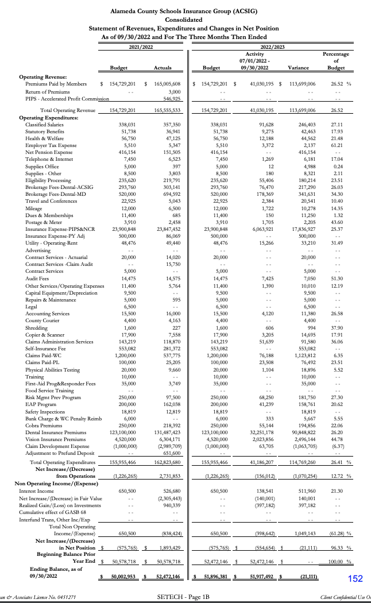

- 2022/ 23 First Quarter Investment Report
Mark Payne presented the 2022/23 1st Quarter investment report.

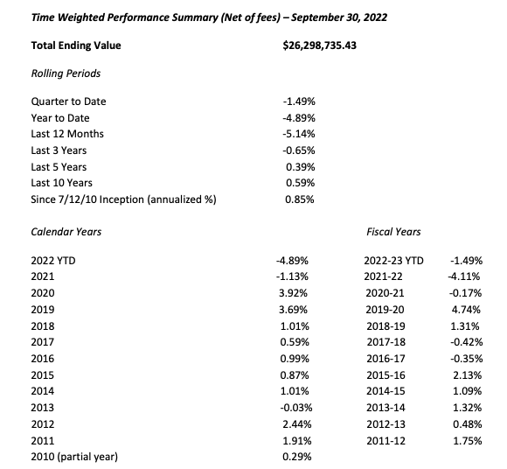

It was moved by Julie Duncan and seconded by Dani Krueger to approve the1st Quarter Investment Report.
Ayes: Heldman, Collins, Kim, Blessing, Krueger, Chan, Hobbs, Oum, Kinder, Wakefield, Moreira, Dela Cruz, Alahydoain, Duncan
Nays: None
Abstain: None

Workers Compensation

- Service Plan 2022/ 2023
The service team reviewed the 2022/23 Service Plan, this year the service team developed a service plan to better document responsibilities and timelines.

- Current Trends in Claims – Aged Injury Workforce
The Executive Director and Michael Clark of Keenan Associates reviewed a 3-year claims history report. As resources are dedicated to improving frequency and severity of injuries within ACSIG, it is important to review claims data to evaluate the effectiveness of programs. Through analysis, we can identify trends within the districts.

- Sketchers Update
ACSIG has seen a reduction of injuries since the implementation of the shoe program. The shoe program has now been expanded to include Food Service/ Maintenance/ Custodial/ Warehouse employees. Skechers automatically gives a 30% discount to all employees so that can purchase shoes with a retail value of $90 or less. Michael Clark distributes $65 gift cards directly to the districts for their employees.

- EAP Update
The Executive Director discussed with the committee how implementation has been slow due to the current remote working environment and direct access to employees for the program introduction. Those who have utilized the services have given very positive feedback. The JPA has budget funded this program through June 2023 and will conduct research to seek other EAP’s that charge a fee per service to be more cost efficient.

- Special Education – Additional Protective Equipment
The Executive Director discussed having additional protective equipment for workers within the Special Education program. The Executive Director will research protective equipment for Aids to help with future injuries.

- State PAR Audit Results
The Executive Director reviewed the audit results performed by the State Department of Workers’ Compensation. This audit is extensive and thorough. The Pleasanton, Keenan team ranked #6 in the entire state.

- Future Planning

- This meeting was adjourned by Annette Heldman at 12:56 PM

