Alameda County Schools Insurance Group (ACSIG)
5776 Stoneridge Mall Rd., Suite 130 Pleasanton, CA 94588

MINUTES
Full Board

Date: Thursday, May 14, 2020
Time: 2:00PM
Location: Video Meeting
Join Zoom Meeting
https://us04web.zoom.us/j/232470722
Meeting ID: 232 470 722

- The meeting was called to order by Annette Heldman at 2:03 PM

- Roll call

Board Members
Annette Heldman President New Haven USD
Susan Kinder Vice President Livermore Valley Joint USD
Dani Krueger Board Member Alameda USD
Jackie Kim Board Member Albany USD
Dora Siu Board Member Emery USD
Marcus Battle Board Member Fremont USD
Bryan Wakefield Board Member Mission Valley ROP
Teresa Santamaria Board Member Mountain House USD
Ruth Alahydoian Board Member Piedmont USD
Ahmad Shiekholeslami Board Member Pleasanton USD
Dr. Kevin Collins Board Member San Leandro USD

Kimberly Dennis Executive Director ACSIG
Celina Flotte Executive Assistant ACSIG

Ron Martin Guest Keenan & Associates
Tara Cooper-Salaiz Guest Keenan & Associates
Patrice Grant Guest Keenan & Associates

Michael Clark Guest Keenan & Associates
Laurena Grabert Guest SETECH
Steve Spigarelli Guest Delta Dental
Ryan Neese Guest Delta Dental
Cary Allison Guest Morgan Stanley

- Acceptance of the Agenda
It was moved by Kevin Collins and seconded by Ahmad Shiekholeslami to accept the agenda as presented.
Ayes: Heldman, Kinder, Krueger, Kim, Siu, Battle, Wakefield, Santamaria, Alahydoian, Shiekholeslami, Collins
Nays: None
Abstain: None

- Public Comment on Open Session Agenda Items
Pursuant to the Brown Act, each public agency must provide the public with an opportunity to speak on any matter within the subject matter jurisdiction of the agency and which is on the agency’s agenda for that meeting. The Board of Directors allows speakers to speak on agendized and non-agendized matters under public comment. Comments are limited to no more than 3 minutes per speaker. By law, no action may be taken on any item raised during the public comment periods and matters may be referred to staff for placement on a future agenda of the Board of Directors

Consent Calendar
Review Items listed on the consent agenda for any adjustments and adoptions.

- Executive Committee Minutes from February 6, 2020
- Strategic Planning Minutes from December 19, 2019
- 2nd Quarter Financials
- 2nd Quarter Investment Report
- Informational Report for Fiscal Year End
- PLCA Agreement Renewal
- Investment Policy
- Conflict of Interest Code
- Authorization of Signatures
- Posting and Mailing Address

It was moved by Susan Kinder and seconded by Dora Siu to approve the consent calendar as presented.
Ayes: Heldman, Kinder, Krueger, Kim, Siu, Battle, Wakefield, Santamaria, Alahydoian, Shiekholeslami, Collins
Nays: None
Abstain: None
General

- Third Quarter Investment Report
Cary Allison of Morgan Stanley reviewed the 2019/20 third quarter investment report with the Board.

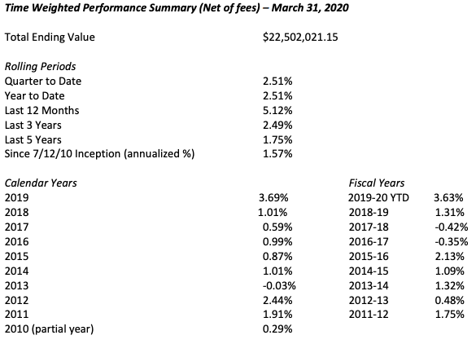

It was moved by Marcus Battle and seconded by Kevin Collins to approve the third quarter investment report as presented.
Ayes: Heldman, Kinder, Krueger, Kim, Siu, Battle, Wakefield, Santamaria, Alahydoian, Shiekholeslami, Collins
Nays: None
Abstain: None

- Third Quarter Financials
Laurena Grabert from SETECH presented the 2019/2020 third quarter financial report.
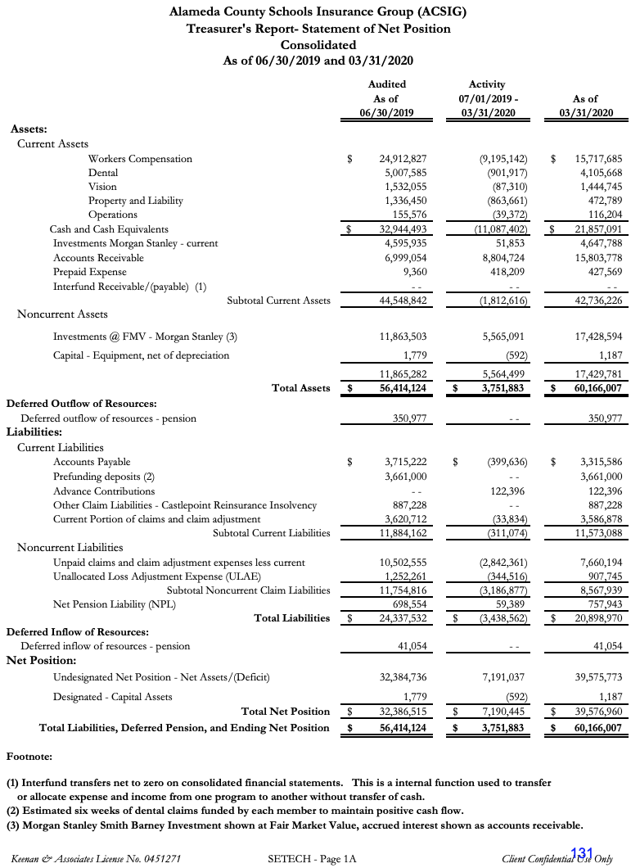
It was moved by Teresa Santamarie and seconded by Ruth Alahydoian to approve the third quarter financial report as presented.
Ayes: Heldman, Kinder, Krueger, Kim, Siu, Battle, Wakefield, Santamaria, Alahydoian, Shiekholeslami, Collins
Nays: None
Abstain: None

- Budget 2020/2021
The Executive Director reviewed the 2020/21 Budget with the Board.
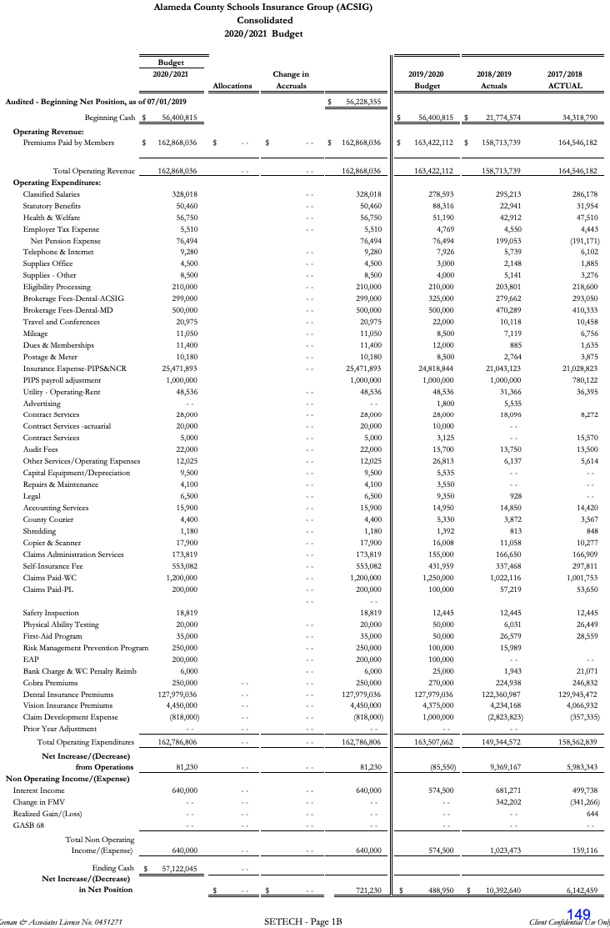
It was moved by Ahmad Shiekholeslami and seconded by Dani Krueger to approve of the budget to as presented.
Ayes: Heldman, Kinder, Krueger, Kim, Siu, Battle, Wakefield, Santamaria, Alahydoian, Shiekholeslami, Collins
Nays: None
Abstain: None

- ACSIG Salaries & Benefits
The Executive Director presented a schedule increase proposal for the ACSIG staff of 2.14% off the salary schedule. The overall cost for this increase would total $7,911.93.
It was moved by Kevin Collins and seconded by Ruth Alahydoian to approve ACSIG salaries and benefits as presented.
Ayes: Heldman, Kinder, Krueger, Kim, Siu, Battle, Wakefield, Santamaria, Alahydoian, Shiekholeslami, Collins
Nays: None
Abstain: None

Dental

- Delta Dental Presentation
Steve Spigarelli and Ryan Neese from Delta Dental presented claims data to the Full Board.

- Dental Rates 2020/2021
The Executive Director presented the 2020/2021 Dental Rate recommendations to the Board. The program has continued to perform well. The recommendation is for a flat renewal for 2020/21.
It was moved by Kevin Collins and seconded by Jackie Kim to approve of the Dental Rates.
Ayes: Heldman, Kinder, Krueger, Kim, Siu, Battle, Wakefield, Santamaria, Alahydoian, Shiekholeslami, Collins
Nays: None
Abstain: None

Vision

- Vision Rates 2020/2021
The Executive Director presented the 2020/21 Vision rates with a recommendation as a flat renewal.
It was moved by Teresa Santamaria and seconded by Ruth Alahydoian to approve the Vision rates as presented.
Ayes: Heldman, Kinder, Krueger, Kim, Siu, Battle, Wakefield, Santamaria, Alahydoian, Shiekholeslami, Collins
Nays: None
Abstain: None

Property & Liability

- Property & Liability Rates 2020/2021
The Executive Director presented the 2020/21 Property and Liability rates. NCR Property rates and Liability rates have firmer numbers for renewal at this time and have been able to decrease the ‘worst case scenario’ rates we published in February.
It was moved by Kevin Collins and seconded by Jackie Kim to approve the Property & Liability rates as presented.
Ayes: Heldman, Kinder, Krueger, Kim, Siu, Battle, Wakefield, Santamaria, Alahydoian, Shiekholeslami, Collins
Nays: None
Abstain: None

Workers Compensation

- Actuarial Study – Ultimate Loss
The Executive Director presented Actuarial study of the ultimate loss of the self-insured portion of the ACSIG Workers Compensation program. Bay Actuarial estimates that ACSIG’s liability for unpaid losses were $10M on December 31, 2019 and project that it will be $9.5M on June 30, 2020.
It was moved by Ruth Alahydoian and seconded by Kevin Collins to approve the Ultimate Loss Actuarial Study as presented.
Ayes: Heldman, Kinder, Krueger, Kim, Siu, Battle, Wakefield, Santamaria, Alahydoian, Shiekholeslami, Collins
Nays: None
Abstain: None

- Actuarial Study – Ex-Mods
Historically, ACSIG experience modification factors were not “re-benched” to 1.00. The result was program underfunding. In 2008, the Executive Committee and Board agreed to begin a multi-year funding model to begin “re-benching” ex-mods to 1.00. Program year 2009/2010 was the first year of this process. It was the expectation that the rates would become more consistent due to the use of actuarially determined experience-modification rates. Prior to 2013/2014, the ACSIG Board imposed a cap in the amount an ex-mod could increase/decrease in any one program year. Beginning in 2013/14 the actuarially determined ex-mod will be used with no maximum change cap. The assumption that all exmods will remain between 0.75 – 1.25 will continue.

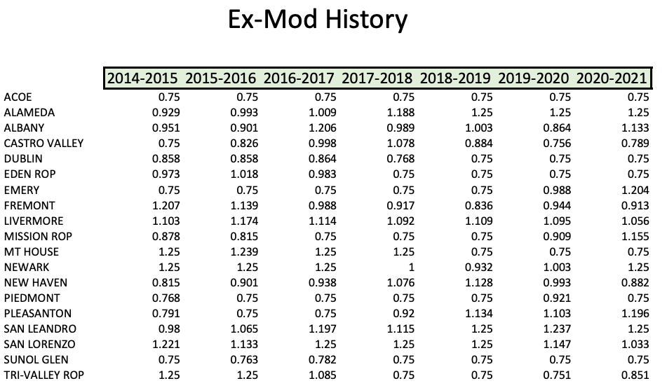

It was moved Dani Krueger and seconded by Teresa Santamaria to approve the Ex-Mods as presented.
Ayes: Heldman, Kinder, Krueger, Kim, Siu, Battle, Wakefield, Santamaria, Alahydoian, Shiekholeslami, Collins
Nays: None
Abstain: None

- Workers Compensation Rates 2020/2021
The Executive Director presented 2020/21 Workers Compensation rates.
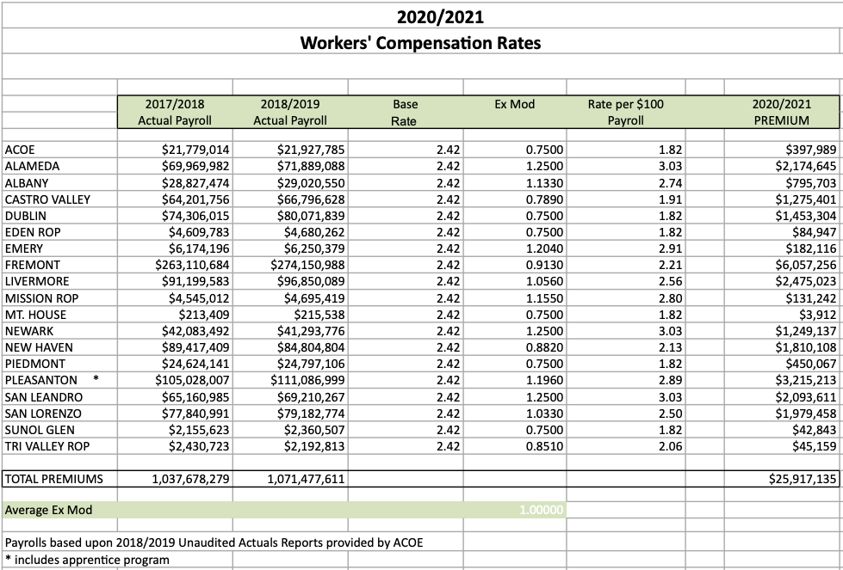

It was moved by Kevin Collins and seconded by Dora Siu to approve the Workers Compensation rates.
Ayes: Heldman, Kinder, Krueger, Kim, Siu, Battle, Wakefield, Santamaria, Alahydoian, Shiekholeslami, Collins
Nays: None
Abstain: None

- 5-year Point in Time Comparison
Michael Clark from Keenan and Associates discussed the 5-year workers compensation claim trend. As resources are dedicated to improve frequency and severity of injuries within ACSIG, it is important to review claims data to evaluate the effectiveness of programs. Through analysis, we can identify trends within Districts. Additionally, we can identify if there are any abnormalities between program years within Districts so resources can be targeted when necessary. The JPA is trending well.

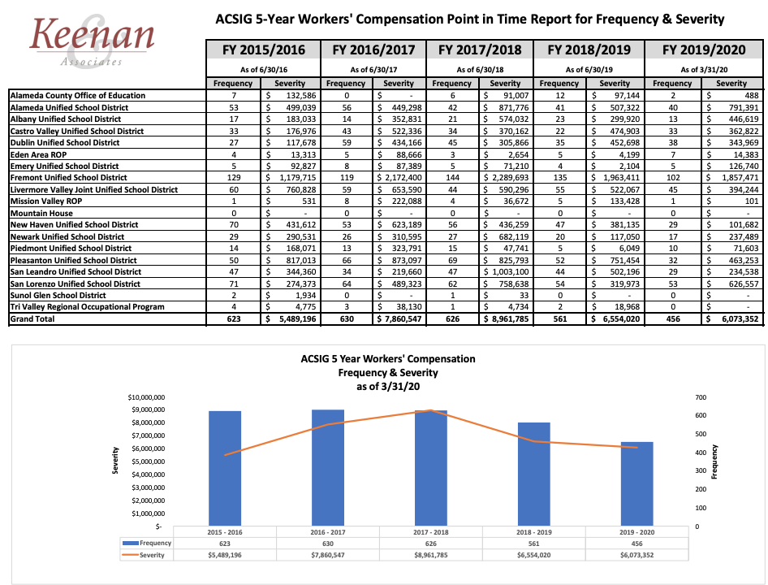

Administrative

- Election of Executive Committee
Due to Annette Heldman, Susan Kinder, Jackie Kim and Suzy Chan’s terms expiring, all but Suzy Chan has agreed to serve another 2 year term. Additionally, the Board nominated Madeline Gabel to the Executive Committee.
It was moved by Kevin Collins and seconded Ruth Alahydoian to approve the Executive Committee serving another 2-year term, with an addition to Madeline Gabel.
Ayes: Heldman, Kinder, Krueger, Kim, Siu, Battle, Wakefield, Santamaria, Alahydoian, Shiekholeslami, Collins
Nays: None
Abstain: None

- Meeting Calendar
The Executive Committee reviewed the 2020/21 draft calendar.

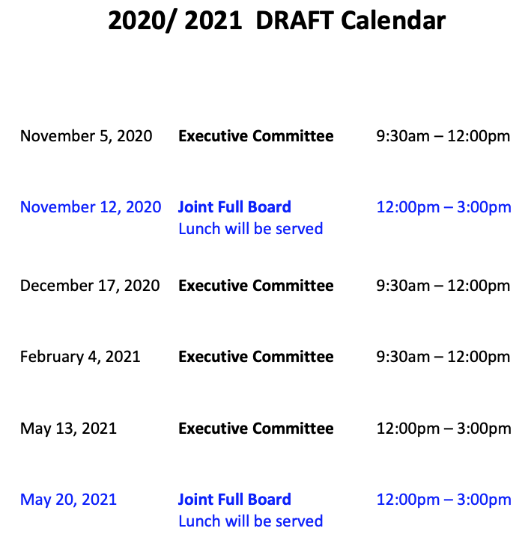

It was moved by Jackie Kim and seconded by Kevin Collins to approve of the draft meeting calendar.
Ayes: Heldman, Kinder, Krueger, Kim, Siu, Battle, Wakefield, Santamaria, Alahydoian, Shiekholeslami, Collins
Nays: None
Abstain: None

- Future Planning

- This meeting was adjourned at 3:33pm.

