Alameda County Schools Insurance Group (ACSIG)
5776 Stoneridge Mall Rd., Suite 130 Pleasanton, CA 94588

MINUTES
Executive Committee

Date: Thursday, May 14, 2020
Time: 12:00 PM
Location: Video Meeting
Join Zoom Meeting
https://us04web.zoom.us/j/232470722
Meeting ID: 232 470 722

- Annette Heldman called the meeting to order at 12:02 PM

- Roll call

Executive Committee Members
Annette Heldman President New Haven USD
Susan Kinder Vice President Livermore USD
Jackie Kim Board Member Albany USD
Marcus Battle Board Member Fremont USD
Dr. Kevin Collins Board Member San Leandro USD

Kimberly Dennis Executive Director ACSIG
Celina Flotte Executive Assistant ACSIG

Ron Martin Guest Keenan & Associates
Tara Cooper-Salaiz Guest Keenan & Associates
Patrice Grant Guest Keenan & Associates
Michael Clark Guest Keenan & Associates
Laurena Grabert Guest SETECH
Cary Allison Guest Morgan Stanley
Jack Joyce Guest Bay Actuarials

- Acceptance of the Agenda
It was moved by Kevin Collins and seconded by Susan Kinder to approve the agenda as presented.
Ayes: Heldman, Kinder, Kim, Battle, Collins
Nays: None
Abstain: None

- Public Comment on Closed Session Agenda Items

No public present to comment.

Closed Session
Closed session began at 12:07pm

- Settlement Notification
- Claim Numbers:
Howard | 471036 | Pintal | 535328 | Wooden | 553001 | Gomez | 563691
Dahl | 478543 | Lal | 538939 | Lembesis | 553740 | Green | 564207
Dahl | 490927 | Pasillas | 541429 | Bower | 555222 | Crisologo | 567942
Dahl | 490928 | Sierras | 543279 | Bower | 555222 | Subramanian | 568128
Barros | 509777 | Turner | 545257 | Bravo | 558951 | Manrique | 568467
Sierras | 511034 | Stewart | 547061 | DeGuzman | 560376 | Chakrabarti | 573980
Stewart | 515512 | Ferrier | 548793 | Vaccaro | 560764 | Dahl | 2206171
Gilroy | 530955 | Segundo | 550405 | Singh | 563419

- Settlement Authorization
- Claims Numbers: None

- CastlePoint Memo
Ron Martin from Keenan and Associates discussed the CastlePoint Memo and Loss Run with the Executive Committee.

Open Session
Open session began at 12:30pm.

- Public Comment on Open Session Agenda Items
No public present to comment.

- Report of Action Taken in Closed Session
None

- Approval of Minutes
It was moved by Kevin Collins and seconded by Jackie Kim to approve the February 6, 2020 Executive Committee Meeting minutes.
Ayes: Heldman, Kinder, Kim, Battle, Collins
Nays: None
Abstain: None

General

- Third Quarter Investment Report
Cary Allison of Morgan Stanley reviewed the 2019/20 third quarter investment report with the Executive Committee.
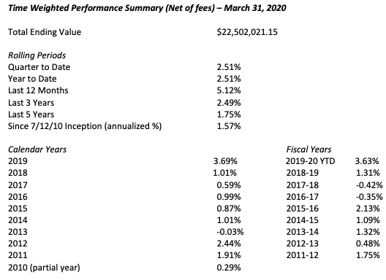

It was moved by Marcus Battle and seconded by Kevin Collins to recommend approval of the third quarter investment report as presented to the Full Board.
Ayes: Heldman, Kinder, Kim, Battle, Collins
Nays: None
Abstain: None

- Third Quarter Financial Report
Laurena Grabert from SETECH presented the 2019/2020 third quarter financial report.
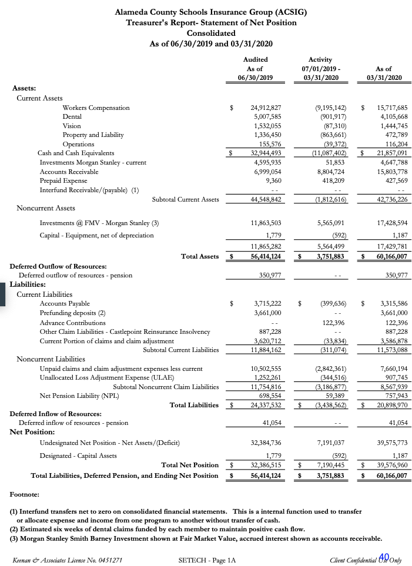
It was moved by Kevin Collins and seconded by Susan Kinder to recommend approval of the third quarter financial report as presented to the Full Board.
Ayes: Heldman, Kinder, Kim, Battle, Collins
Nays: None
Abstain: None

- Budget 2020/2021
The Executive Director reviewed the 2020/21 Budget with the Executive Committee.
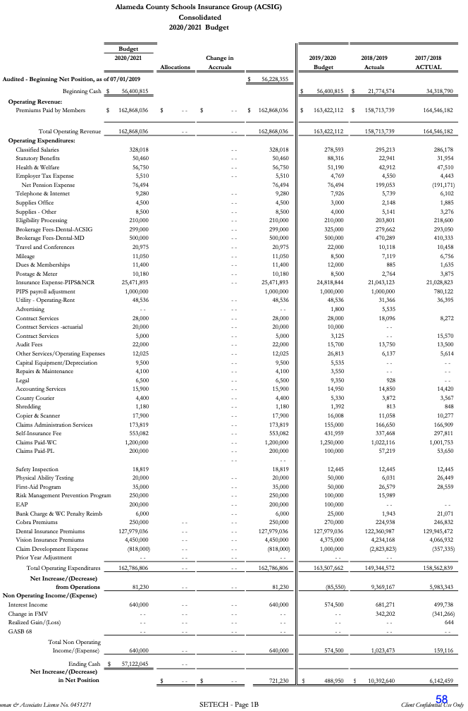
It was moved by Kevin Collins and seconded by Jackie Kim to recommend approval of the budget to the Full Board.
Ayes: Heldman, Kinder, Kim, Battle, Collins
Nays: None
Abstain: None

- ACSIG Salaries & Benefits
The Executive Director presented a schedule increase proposal for the ACSIG staff of 2.14% off the salary schedule. The overall cost for this increase would total $7911.93.
It was moved by Kevin Collins and seconded by Jackie Kim to approve ACSIG salaries and benefits as presented.
Ayes: Heldman, Kinder, Kim, Battle, Collins
Nays: None
Abstain: None

Workers Compensation

- Actuarial Study – Ultimate Loss
Jack Joyce of Bay Actuarials presented Actuarial study of the ultimate loss of the self-insured portion of the ACSIG Workers Compensation program. Bay Actuarial estimates that ACSIG’s liability for unpaid losses were $10M on December 31, 2019 and project that it will be $9.5M on June 30, 2020.
It was moved by Susan Kinder and seconded by Kevin Collins to approve the Ultimate Loss Actuarial Study as presented.
Ayes: Heldman, Kinder, Kim, Battle, Collins
Nays: None
Abstain: None

- Workers Compensation Premium Modification
The Executive Director discussed moving ACSIG Workers Compensation premium to be billed biannually in November and April with due dates being December and May.
It was moved by Kevin Collins and seconded by Susan Kinder to approve the WC Premiums to be billed in November and May.
Ayes: Heldman, Kinder, Kim, Battle, Collins
Nays: None
Abstain: None

Dental

- Dental Rates 2020/2021
The Executive Director presented the 2020/2021 Dental Rate recommendations to the Executive Committee. The recommendation is for a rate pass for 2020/21.
It was moved by Kevin Collins and seconded by Marcus Battle to recommend approval of Dental Rates to the Full Board.
Ayes: Heldman, Kinder, Kim, Battle, Collins
Nays: None
Abstain: None

Vision

- Vision Rates 2020/2021
The Executive Director presented the 2020/21 Vision rates with a recommendation as a flat renewal with an increase of frame allowance to a minimum of $150.
It was moved by Marcus Battle and seconded by Kevin Collins to recommend approval of the Vision rates as presented to the Full Board.
Ayes: Heldman, Kinder, Kim, Battle, Collins
Nays: None
Abstain: None

Property & Liability

- Property & Liability Rates 2020/2021
The Executive Director presented the 2020/21 Property and Liability rates. We have firmer numbers for renewal at this time and have been able to decrease the “worst case scenario” rates that we published in February.
It was moved by Kevin Collins and seconded by Jackie Kim to recommend approval of the Property & Liability rates as presented to the Full Board.
Ayes: Heldman, Kinder, Kim, Battle, Collins
Nays: None
Abstain: None

- PLCA Agreement Renewal
The Executive Director reviewed the amendment for Property and Casualty Claims Administration Services.
It was moved by Kevin Collins and seconded by Jackie Kim to recommend approval of the PLCA Amendment to the Full Board.
Ayes: Heldman, Kinder, Kim, Battle, Collins
Nays: None
Abstain: None

Administrative

- Investment Policy
The Executive Committee conducted the annual review of the written investment policy and found no changes necessary.
It was moved by Susan Kinder and seconded by Marcus Battle to recommend approval the Investment Policy as presented to the Full Board.
Ayes: Heldman, Kinder, Kim, Battle, Collins
Nays: None
Abstain: None

- Conflict of Interest Code
The Executive Committee conducted the annual review of the Conflict of Interest Code and found no changes necessary.
It was moved by Susan Kinder and seconded by Marcus Battle to recommend approval the Conflict of Interest Code as presented to the Full Board.
Ayes: Heldman, Kinder, Kim, Battle, Collins
Nays: None
Abstain: None

- Authorization of Signatures
The Executive Committee conducted the annual review of the Authorization of Signatures and found no changes necessary.
It was moved by Susan Kinder and seconded by Marcus Battle to recommend approval the Authorization of Signatures as presented to the Full Board.
Ayes: Heldman, Kinder, Kim, Battle, Collins
Nays: None
Abstain: None

- Meeting Calendar
The Executive Committee reviewed the 2020/21 calendar.
It was moved by Kevin Collins and seconded by Jackie Kim to recommend approval of the draft meeting calendar as presented to the Full Board.
Ayes: Heldman, Kinder, Kim, Battle, Collins
Nays: None
Abstain: None

- Posting and Mailing Address
The Executive Committee conducted the annual review of the Posting and Mailing Address for ACSIG and found no changes necessary.
It was moved by Susan Kinder and seconded by Marcus Battle to recommend approval the Posting and Mailing address as presented to the Full Board.
Ayes: Heldman, Kinder, Kim, Battle, Collins
Nays: None
Abstain: None

- Future Planning

- This meeting was adjourned at 1:53pm.

