Alameda County Schools Insurance Group (ACSIG)
5776 Stoneridge Mall Rd., Suite 130 Pleasanton, CA 94588

MINUTES
Full Board

Date: Thursday, November 7, 2019
Time: 12:00PM
Location: Alameda County Office of Education
313 W. Winton Ave.
Hayward, CA 94544

- The meeting was called to order by Susan Kinder at 12:06pm.

- Roll call

Full Board
Susan Kinder Vice President Livermore Valley Joint USD
Raul Parungao Secretary Alameda County Office of Education
Dani Krueger Board Member Alameda Unified School District
Jackie Kim Board Member Albany Unified School District
Dora Siu Board Member Emery Unified School District
Marcus Battle Board Member Fremont USD
Teresea Santamaria Board Member Mountain House Unified School District
Marie Dela Cruz Board Member Newark Unified School District
Ruth Alahydoian Board Member Piedmont Unified School District
Ahmad Sheikholeslami Board Member Pleasanton Unified School District
Dr. Kevin Collins Board Member San Leandro Unified School District
Madeline Gabel Board Member San Lorenzo Unified School District

Kimberly Dennis Executive Director Alameda County Schools Insurance
Celina Flotte Executive Assistant Alameda County Schools Insurance

Tara Cooper-Salaiz Guest Keenan & Associates
Patrice Grant Guest Keenan & Associates
Ron Martin Guest Keenan & Associates
Michael Clark Guest Keenan & Associates
Dave Kundert Guest Keenan & Associates
Hesam Fayaz Guest SETECH
Heather Daud Rubio Guest Christy White & Associates
Cary Allison Guest Morgan Stanley

- Acceptance of the Agenda
It was moved by Kevin Collins and seconded by Raul Parungao to accept the agenda as presented.

- Public Comment on Closed Session Agenda Items
No public present to comment.

- Closed Session
Closed session began at 12:11 PM.

Open Session
Open session began at 12:37 PM.

- Public Comment on Open Session Agenda Items
No public present to comment.

- Report of Action Taken in Closed Session
The Board took action to approve settlement authority for claim numbers 2503013, 99001125, 9901861, 2510407, 2202377, and 2202360.

- Settlement Authorization
- Claim Numbers:
 | Murcia | 2503013 |  | Jackson | 2510407
 | Ali-Sullivan | 99001125 |  | Parker | 2202377
 | Murphy | 9901861 |  | Nese-Forte | 2202360

- Settlement Notification
- Claim Numbers:
Taylor | 478029 |  | Texeira | 517274 |  | Fallon | 536413 |  | Guzman | 555537
Supnet | 482303 |  | Johnson | 522455 |  | Pagni | 536821 |  | Keesee | 557531
Goulet | 487607 |  | Villanueva | 523695 |  | Edwards | 538692 |  | Javeed | 561424
Hunter | 487985 |  | Cheung | 523869 |  | Dawn | 540240 |  | Cheng | 561561
Martins | 491308 |  | Guzman | 528284 |  | Anaya | 541956 |  | Morett | 562971
Velazquez | 498313 |  | Gordon | 529062 |  | Ibarra | 542339 |  | Carpenter | 563512
Pence | 503237 |  | Idris | 533424 |  | Baker | 543756 |  | Delgado | 564034
Middleton | 505313 |  | Ostlund | 534669 |  | Holthe | 545445
Johnson | 505638 |  | Reynado | 535263 |  | Grier | 547829
Hanford | 514309 |  | Carone | 536209 |  | Shadd | 554040

- CastlePoint/ Reinsurance Update
Ron Martin of Keenan discussed the status summary memo, loss run and calculation of ACSIG potential exposure.

- Approval of Minutes
The Board reviewed the Executive Committee meeting minutes from May 9, 2019 and the Full Board minutes from May 16, 2019.
It was moved by Dani Krueger and seconded by Jackie Kim to approve the minutes with fixed typos on page 8 and 9 of the agenda packet.
Ayes: Parungao, Krueger, Kim, Siu, Battle, Santamaria, Cruz, Alahydoian, Collins, Gabel, Gabel
Nays: None
Abstain: None

Consent Calendar
Review Items listed on the consent agenda for any adjustments and adoptions.

- 2018/19 Fourth Quarter Financials
- 2018/19 Fourth Quarter Investment Report

It was moved by Ruth Alahydoian and seconded by Madeline Gabel to accept the consent calendar.
Ayes: Parungao, Krueger, Kim, Siu, Battle, Santamaria, Cruz, Alahydoian, Collins, Gabel, Gabel
Nays: None
Abstain: None

General Business

- Members to Executive Committee
The Board has suggested recruiting Fremont USD to the Executive Committee.
It was moved by Susan Kinder and seconded by Madeline Gabel to recruit Fremont USD to the Executive Committee.
Ayes: Parungao, Krueger, Kim, Siu, Battle, Santamaria, Cruz, Alahydoian, Collins, Gabel, Gabel
Nays: None
Abstain: None

- Annual Report
The Executive Director reviewed the annual report with the Full Board.

- 2018/ 19 Audit
Heather Daud of Christy White reviewed the 2018/19 Audit with the Board. This was the 7th year with Christy White Associates and the audit went very smoothly with no findings.
It was moved by Raul Parungao and seconded by Kevin Collins to approve the Audit.
Ayes: Parungao, Krueger, Kim, Siu, Battle, Santamaria, Cruz, Alahydoian, Collins, Gabel, Gabel
Nays: None
Abstain: None

- 2019/ 20 First Quarter Financials
Laurena Grabert from SETECH presented the 2019/20 1st Quarter Financials.
It was moved by Kevin Collins and seconded by Teresa Santamaria to approve the 1st Quarter Financials with a motion to move $5M to investments.
Ayes: Parungao, Krueger, Kim, Siu, Battle, Santamaria, Cruz, Alahydoian, Collins, Gabel, Gabel
Nays: None
Abstain: None
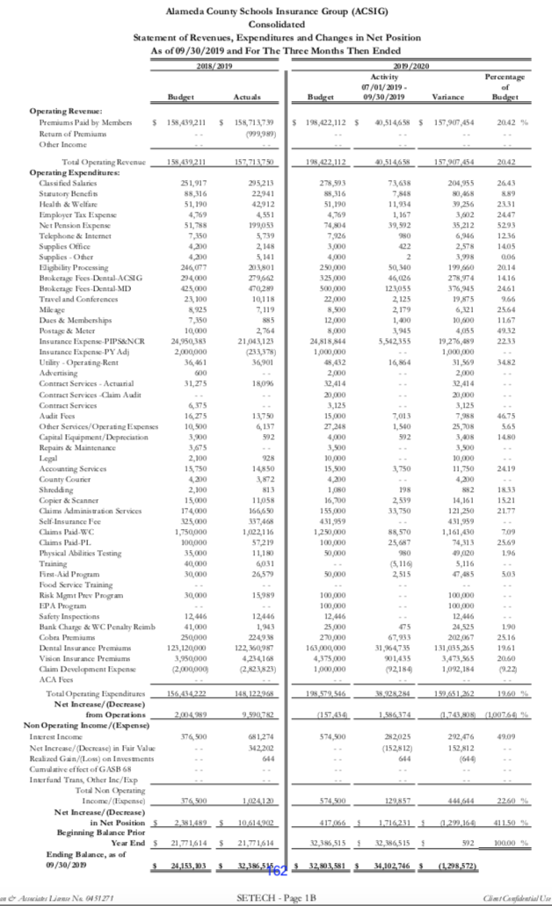

- 2019/ 20 First Quarter Investment Report
Cary Allison presented the 2019/20 1st Quarter investment report.
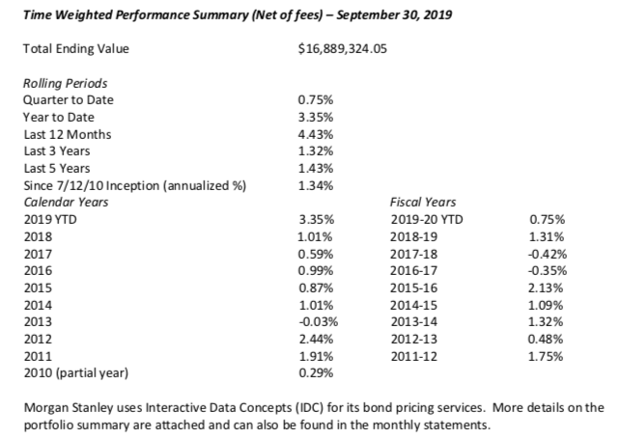
It was moved by Raul Parungao and seconded by Dora Siu to approve the 1st Quarter Investment Report.
Ayes: Parungao, Krueger, Kim, Siu, Battle, Santamaria, Cruz, Alahydoian, Collins, Gabel, Gabel
Nays: None
Abstain: None

- FBC Contract
The Executive Director presented the new contract with FBC for the dental coalition.
It was moved by Kevin Collins and seconded by Marcus Battle to approve the contract.
Ayes: Parungao, Krueger, Kim, Siu, Battle, Santamaria, Cruz, Alahydoian, Collins, Gabel, Gabel
Nays: None
Abstain: None

- Strategic Planning
The strategic planning meeting will take place on Decemeber 17, 2019 at 5776 Stoneridge Mall Rd. in Pleasanton CA.

Workers Compensation

- Workers Compensation Rates 2019/ 2020
The Executive Director reviewed the 2019/ 2020 Workers Compensation Rates with the Board.
It was moved by Kevin Collins and seconded by Ruth Alahydoain to approve the workers compensation rates.
Ayes: Parungao, Krueger, Kim, Siu, Battle, Santamaria, Cruz, Alahydoian, Collins, Gabel, Gabel
Nays: None
Abstain: None

- Service Plan 2019/ 2020
The Executive Director reviewed the 2019/20 Service Plan with the Board. The service team consists of Tara Cooper-Salaiz as Account Manager, Michael Clark as Claims Analyst, Dave Kundert as Loss Control Consultant, Patrice Grant as Claims Manager, and Ron Martin as Account Executive. The Service Plan is a tool to show what the team wants to complete within the upcoming year.

- EAP Update
The Executive Director discussed the EAP Program with the Board.

- Workers Compensation Claims History
Michael Clark of Kennan and Associates reviewed the Workers Compensation Claims History with Board. As resources are dedicated to improve frequency and severity of injuries within ACSIG, it is important to review claims data to evaluate the effectiveness of programs. Through analysis, we can identify trends within the districts.

- Future Planning

- The meeting was adjourned at 1:38pm by Susan Kinder.

