Alameda County Schools Insurance Group (ACSIG)
5776 Stoneridge Mall Rd., Suite 130 Pleasanton, CA 94588

MINUTES
Executive Committee

Date: Thursday, February 7, 2019
Time: 9:30AM
Location: Alameda County Office of Education
313 W. Winton Ave.
Hayward, CA 94544

- Annette Heldman called the meeting to order at 9:33am

- Roll call

Executive Committee Members

Annette Heldman President New Haven USD
Susan Kinder Vice President Livermore USD
Jackie Kim Board Member Albany USD
Suzy Chan Board Member Castro Valley USD
Kevin Collins Board Member San Leandro USD

Kimberly Dennis Executive Director Alameda County Schools Insurance Group
Celina Flotte Executive Assistant Alameda County Schools Insurance Group

Ron Martin Guest Keenan & Associates
Tara Cooper-Salaiz Guest Keenan & Associates
Patrice Grant Guest Keenan & Associates
Michael Clark Guest Keenan & Associates
Dave Kundert Guest Keenan & Associates
Cary Allison Guest Morgan Stanley
Mark Payne Guest Morgan Stanley
Laurena Grabert Guest SETECH

- Acceptance of the Agenda
It was moved by Kevin Collins and seconded by Susan Kinder to approve the agenda as presented.
Ayes: Heldman, Kinder, Kim, Chan, Collins
Nays: None
Abstain: None

- Public Comment on Closed Session Agenda Items

No public present to comment.

Closed Session
Closed session began at 9:34am.

- Settlement Authorization
- Claim Numbers:
2205897 | Santucci

- Settlement Notification

- Claim Numbers:
421071 | Tarin
453533 | Barriga
509542 | Medeiros
535017 | Poominathan
539412 | Gatewood
541210 | Santos
542229 | Halol
548896 | Havig
551417 | Rivas

- CastlePoint/ Renisurance Update
The Executive Director and a Keenan representative gave committee an update on the open claims affected by the receivership of Castlepoint Reinsurance.

- Executive Director Contract
The Executive Committee discussed the Executive Director’s contract.
Open Session
Open session began at 10:49am.

- Public Comment on Open Session Agenda Items
No public present to comment.

- Report of Action Taken in Closed Session
The Committee approved $110,000 to claim number 2205897 for expenses.
It was moved by Susan Kinder and seconded by Kevin Collins to approve the requested amount.
Ayes: Heldman, Kinder, Kim, Chan, Collins
Nays: None
Abstain: None

- Approval of Minutes
The Executive Committee reviewed the meeting minutes from the November 1, 2018 Executive Committee and November 8, 2018 Full Board Meetings.
It was moved by Kevin Collins and seconded by Suzy Chan to approve the meeting minutes.
Ayes: Heldman, Kinder, Chan, Collins
Nays: None
Abstain: Kim

Workers Compensation

- Actuarial Study – Ex Mod
The Executive Director presented the Ex-Mods as determined by the Actuary, Jack Joyce. The assumption that all Ex-Mods will remain between .75 and 1.25 will continue.
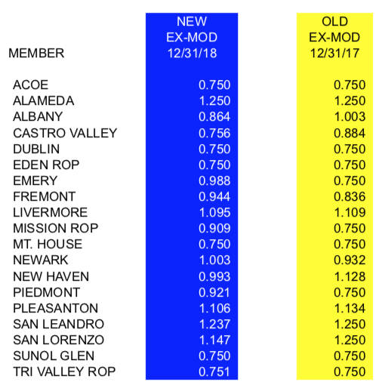

- Preliminary 2019-2020 Workers’ Compensation Rates
The Executive Director reviewed 2019-2020 preliminary worker’s compensation rates with the base rate of 2.65. The workers compensation program continues to maintain a positive fund balance, therefore the committee recommends that the base rate be lowered to 2.60.
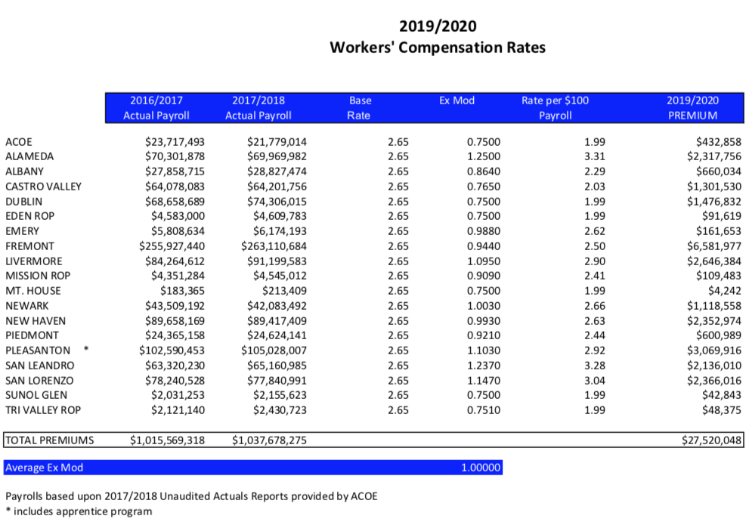
It was moved by Kevin Collins and seconded by Suzy Chan to recommend approval of a 2.60 base rate to the board.
Ayes: Heldman, Kinder, Kim, Chan, Collins
Nays: None
Abstain: None

- Information Report for the Fiscal Year End
Laurena Grabert from SETECH presented the Financial Management Information Report Ended June 30, 2018. The following numbers reflect each member’s portion of the unfunded liability.
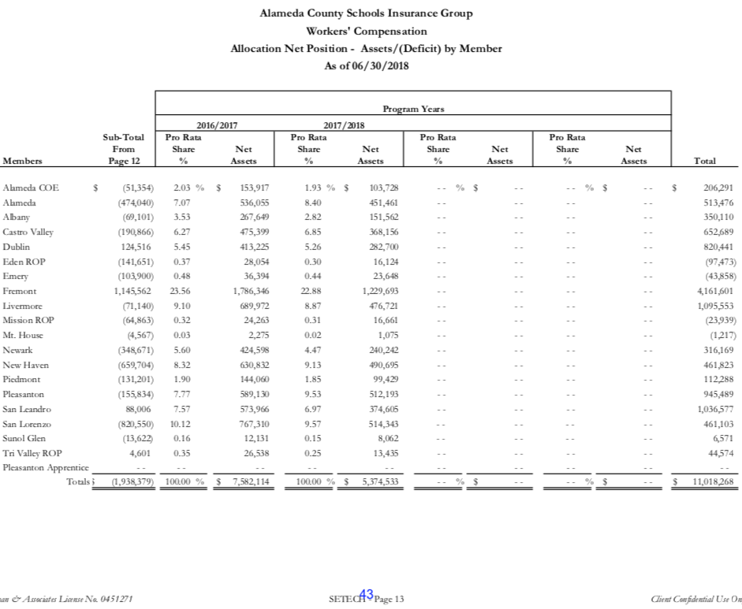

Dental/ Vision

- Actuarial Report Contract
The Executive Director presented the actuarial contract with Healthcare Actuaries for both the Dental and Vision programs.
It was moved by Kevin Collins and seconded by Susan Kinder to recommend approval of the Board.
Ayes: Heldman, Kinder, Kim, Chan, Collins
Nays: None
Abstain: None

General

- Election of Officers
The Executive Committee elected officers for the 2018/19 year.

President: Annette Heldman
Vice President: Susan Kinder
Secretary: Raul Parungao

It was moved by Kevin Collins and seconded by Suzy Chan to approve the officers for 2018/19.
Ayes: Heldman, Kinder, Kim, Chan, Collins
Nays: None
Abstain: None

- Second Quarter Financial Report
Laurena Grabert from SETECH presented the 2018/2019 Second Quarter Financial Report.
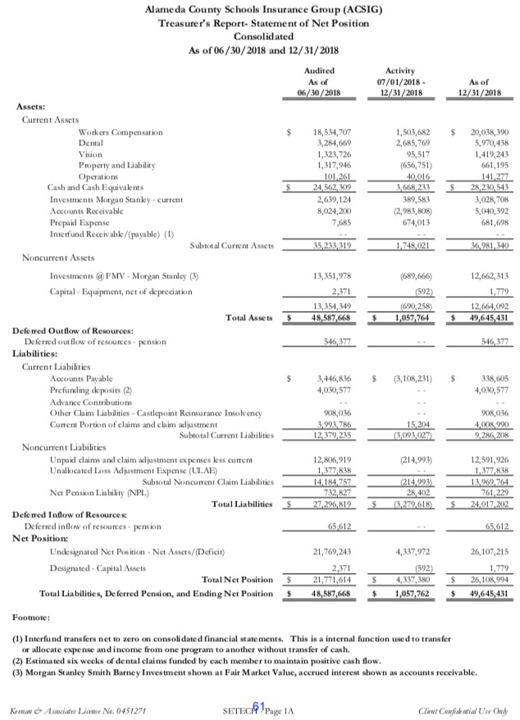
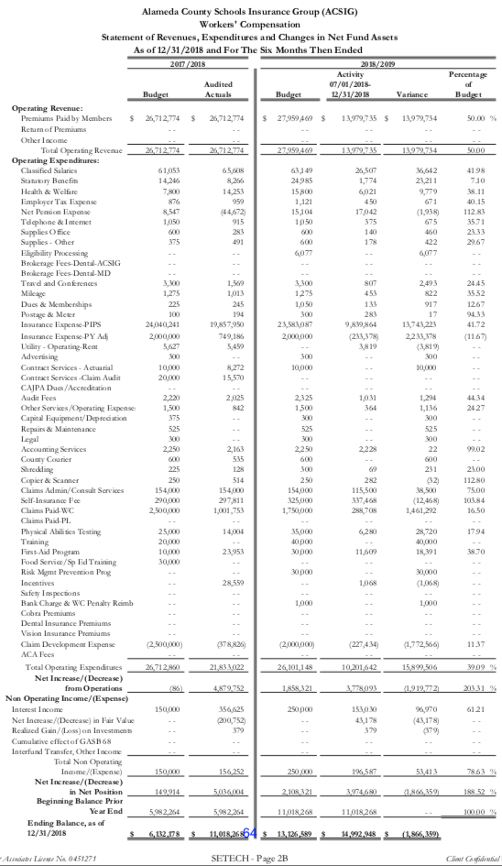
It was moved by Kevin Collins and seconded by Suzy Chan to approve the second quarter financials as amended with a clerical error.
Ayes: Heldman, Kinder, Kim, Chan, Collins
Nays: None
Abstain: None

- Second Quarter Investment Report
Cary Allison presented the 2018/19 Second Quarter Investment Report.
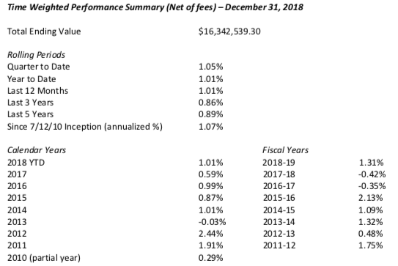

It was moved by Susan Kinder and seconded by Kevin Collins to approve the second quarter investment report.
Ayes: Heldman, Kinder, Kim, Chan, Collins
Nays: None
Abstain: None

- 2019/2020 Budget
The Executive Director reviewed the tentative 2019/20 Budget. The budget was developed using year-to-date 2018/19 data and preliminary estimates for 2019/20 rates and costs. There have been funds allocated to support the release time for regional trainings for Special Education and Food Service staffing as well as Shoes for Crews and County-wide EAP Program.
It was moved by Kevin Collins and seconded by Suzy Chan to approve the budget.
Ayes: Heldman, Kinder, Kim, Chan, Collins
Nays: None
Abstain: None

- SETECH Contract Renewal
The Executive Director presented a renewal contract with SETECH.
It was moved by Kevin Collins and seconded by Susan Kinder to approve the contract renewal.
Ayes: Heldman, Kinder, Kim, Chan, Collins
Nays: None
Abstain: None

- FBC Partnership
The Executive Director discussed that ACSIG may be expanding our dental coalition into San Diego County, which would include a 30,000 school pool to reduce their administrative fees paid to Delta Dental.

- Robin Johnson Law Contract
The Executive Director presented a new contract with Robin Johnson Law to the Executive Committee. With potential partnership with FBC Dental Group, it is necessary to secure legal counsel to review documents necessary to create the cooperative. Any costs associated with this contract will be paid from the dental fund only.
It was moved by Kevin Collins and seconded by Susan Kinder to approve the contract.
Ayes: Heldman, Kinder, Kim, Chan, Collins
Nays: None
Abstain: None

- Audit RFP
The Executive Director has acknowledged that ACSIG has maintained two separate 3-year contracts with Christy White & Associates for our claims audit. The Executive Director want to give the opportunity of the committee the option of a new RFP. The committee decided to continue with Christy White and request a proposal for another year and add that as an agenda item to the May meeting.

- Strategic Planning Update
The Executive Director presented and reviewed the progress to date of strategies established at the 2018-19 strategic planning meeting held in June 2018. There was a typo error that was corrected – The budgeted amount for the JPA-wide EAP Program is $100,000 not $200,000.

- CAJPA Fall Conference 2019
CAJPA Fall Conference will be held in South Lake Tahoe Sept 10- 13, 2019.

- Future Planning

- This meeting was adjourned at 12:08pm.

