Alameda County Schools Insurance Group (ACSIG)
5776 Stoneridge Mall Rd., Suite 130 Pleasanton, CA 94588

MINUTES
Full Board

Date: Thursday, May 17, 2018
Time: 12:00PM
Location: Alameda County Office of Education
313 W. Winton Ave.
Hayward, CA 94544

Conference Call
Dial-in instructions: 888-240-3210, access code 5912465#

- The meeting was called to order by Annette Heldman at 12:06 PM

- Roll call

Board Members
Annette Heldman President New Haven USD
Bryan Richards Secretary Newark USD
Suzy Chan Board Member Castro Valley USD
Marites Fermin Board Member Eden Area ROP
Minh Vu Alternate Fremont USD
Joyce Veasley Board Member Mission Valley ROP
Vicki Hu Alternate Mountain House USD
Micaela Ochoa Board Member Pleasanton Unified School District
Kevin Collins Board Member San Leandro Unified School District
Madeline Gabel Board Member San Lorenzo Unified School District
Anne Spalasso Alternate Tri-Valley ROP

Kimberly Dennis Executive Director ACSIG
Celina Flotte Executive Assistant ACSIG

Ron Martin Guest Keenan & Associates
Tara Cooper-Salaiz Guest Keenan & Associates
Patrice Grant Guest Keenan & Associates
Dave Kundert Guest Keenan & Associates
Michael Clark Guest Keenan & Associates
Laurena Grabert Guest SETECH

- Acceptance of the Agenda
It was moved by Kevin Collins and seconded by Bryan Richards to accept the agenda as presented.
Ayes: Heldman, Richards, Chan, Fermin, Vu, Veasley, Hu, Ochoa, Collins, Gabel, Whetfield, Spalasso
Nays: None
Abstain: None

- Public Comment on Open Session Agenda Items
There was no public present to comment.

Consent Calendar
Review Items listed on the consent agenda for any adjustments and adoptions.

- Executive Committee Minutes from February 8, 2018
- 2nd Quarter Financials
- 2nd Quarter Investment Report
- Investment Policy
- Conflict of Interest Code
- Authorization of Signatures
- Posting and Mailing Address

It was moved by Marites Fermin and seconded by Micaela Ochoa to approve the consent calendar as presented.
Ayes: Heldman, Richards, Chan, Fermin, Vu, Veasley, Hu, Ochoa, Collins, Gabel, Spalasso
Nays: None
Abstain: None

General

- Third Quarter Financials
Laurena Grabert from SETECH presented the 2017/18 Third Quarter Financial statements.
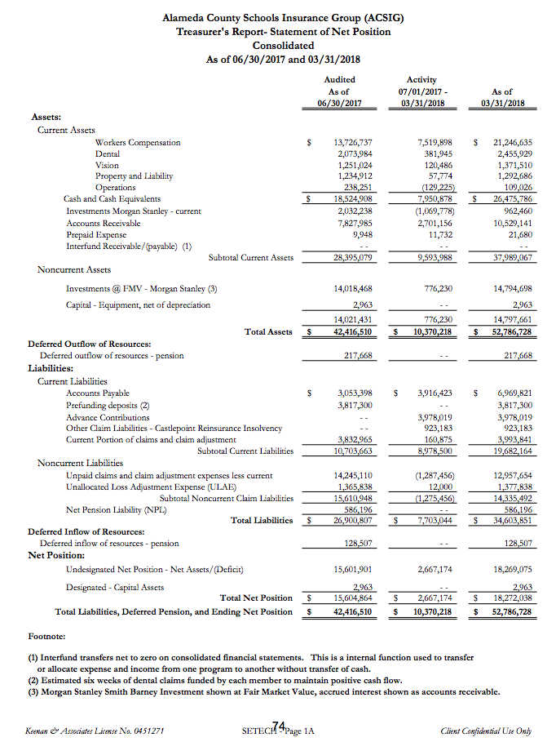
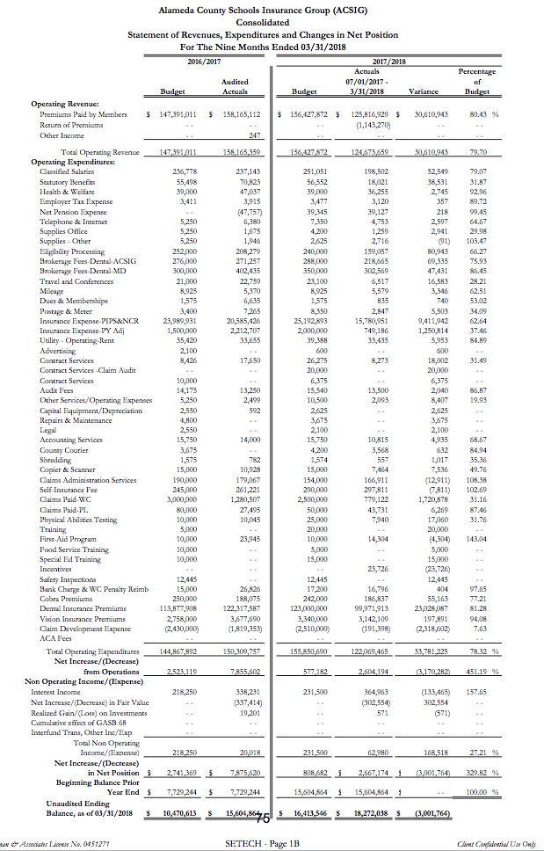
It was moved by Kevin Collins and seconded by Bryan Richards to approve the Third Quarter Financials as presented.
Ayes: Heldman, Richards, Chan, Fermin, Vu, Veasley, Hu, Ochoa, Collins, Gabel, Spalasso
Nays: None
Abstain: None

- Third Quarter Investment Report
The Executive Director reviewed the 2017/18 Third Quarter Investment Report with the Board.
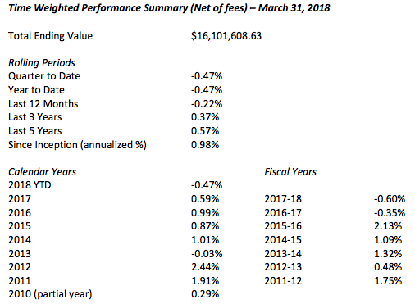

It was moved by Kevin Collins and seconded by Micaela Ochoa to approve the Third Quarter Investment Report as presented.
Ayes: Heldman, Richards, Chan, Fermin, Vu, Veasley, Hu, Ochoa, Collins, Gabel, Spalasso
Nays: None
Abstain: None

- 2018/2019 Budget
The Executive Director presented the 2018/19 Budget to the Board. The budget was developed using year to date 2017/18 data and preliminary estimates for 2018/19 rates and costs. Because all the rates are not firm at this time, estimates were used for this report. Salaries have been distributed to each program based upon a time study.
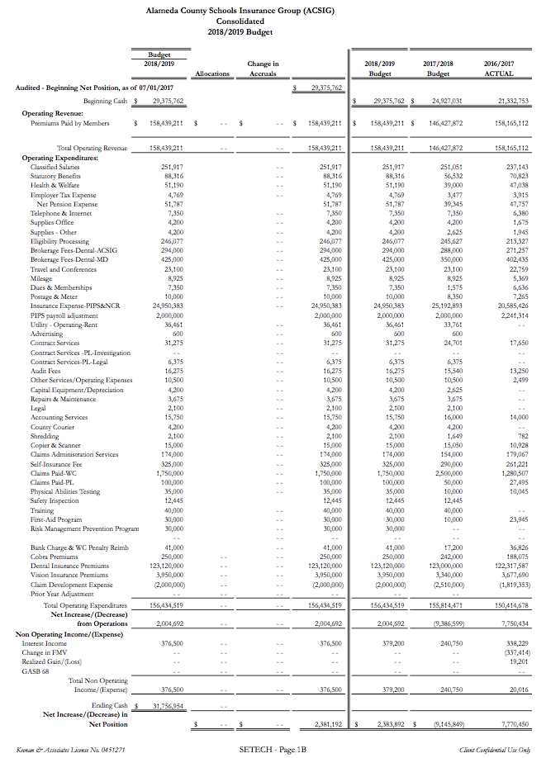
It was moved by Kevin Collins and seconded by Bryan Richards to approve the Budget as presented.
Ayes: Heldman, Richards, Chan, Fermin, Vu, Veasley, Hu, Ochoa, Collins, Gabel, Spalasso
Nays: None
Abstain: None

Dental

- Dental Rates 2018/2019
The Executive Director presented the 2018/19 Dental program proposed rate changes. The program continues to perform well. Last year, ACSIG decreased rates by 2%. The program has leveled off and we are recommending a flat renewal for 2018/19.
It was moved by Bryan Richards and seconded by Micaela Ochoa to approve the Dental Rates as presented.
Ayes: Heldman, Richards, Chan, Fermin, Vu, Veasley, Hu, Ochoa, Collins, Gabel, Spalasso
Nays: None
Abstain: None

Vision

- Vision Rates 2018/2019
The Executive Director presented the 2018/19 Vision program proposed rate changes. The underwriting model shows a slight decrease in claim development within the past several years. Because of the increasing growth within the program, it is our recommendation that rates remain flat for 2018/19.
It was moved by Kevin Collins and seconded by Suzy Chan to approve the Vision Rates as presented.
Ayes: Heldman, Richards, Chan, Fermin, Vu, Veasley, Hu, Ochoa, Collins, Gabel, Spalasso
Nays: None
Abstain: None

Property & Liability

- Property & Liability Rates 2018/2019
The Executive Director presented 2018/19 Property and Liability rates. ACSIG participates in the NCR P/L JPA. The NCR Board met on May 4, 2018 to approve rates. NCR Property rates and Liability rates showed adverse development in the program. ACSIG has higher experience than the NCR average. These negative factors have resulted in an increase to the ACSIG PL rates.
We have included the adjusted valuations and ADA estimates. The rates have been estimated using the latest NCR and SAFER rate estimates.
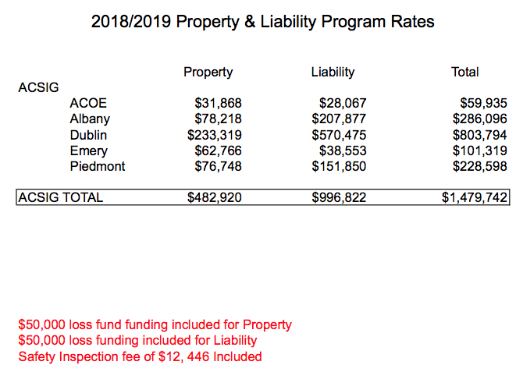

It was moved by Bryan Richards and seconded by Micaela Ochoa to approve the Property and Liability Rates conditionally with adjustments of SAFER final rates.
Ayes: Heldman, Richards, Chan, Fermin, Vu, Veasley, Hu, Ochoa, Collins, Gabel, Spalasso
Nays: None
Abstain: None

- PLCA Agreement Renewal
The Executive Director presented the renewal contract for Property and Casualty Claims Administration Services from Keenan and Associates.
It was moved by Kevin Collins and seconded by Bryan Richards to approve the PLCA Agreement Renewal.
Ayes: Heldman, Richards, Chan, Fermin, Vu, Veasley, Hu, Ochoa, Collins, Gabel, Spalasso
Nays: None
Abstain: None

Workers Compensation

- Claims Audit
The Executive Director presented the results of the USI Claims Audit. The overall score given to the Keenan & Associate claims team was 3.5 out of 5. The total score given was lower than the score of 4.0 received in 2016. Corrective action has been taken and a full-time supervisor has been hired to work with Patrice in the Pleasanton office.
It was moved by Kevin Collins and seconded by Bryan Richards to approve the Claims Audit.
Ayes: Heldman, Richards, Chan, Fermin, Vu, Veasley, Hu, Ochoa, Collins, Gabel, Spalasso
Nays: None
Abstain: None

- Actuarial Study – Ultimate Loss
The Executive Director presented the February 2018 Actuarial study of the ultimate loss of the self-insured portion of the ACSIG Workers Compensation program. Bay Actuarial estimates that ACSIG’s liability for unpaid losses were $18.5M on December 31, 2016 and project that it will be $17.8M on June 30, 2017.The corresponding discounted values (at 1.5% interest) are $16.4M and $15.7M.
It was moved by Bryan Richards and seconded by Suzy Chan to approve the Ultimate Loss Actuarial Study as presented.
Ayes: Heldman, Richards, Chan, Fermin, Vu, Veasley, Hu, Ochoa, Collins, Gabel, Spalasso
Nays: None
Abstain: None

- Actuarial Study – Ex-Mods
The Executive Director presented the Ex-Mods to the Board. Historically, ACSIG experience modification factors were not “re-benched” to 1.00. The result was program underfunding. In 2008, the Executive Committee and Board agreed to begin a multi-year funding model to begin “re-benching” ex-mods to 1.00. Program year 2009/2010 was the first year of this process. It was the expectation that the rates would become more consistent due to the use of actuarially determined experience-modification rates. Prior to 2013/2014, the ACSIG Board imposed a cap in the amount an ex-mod could increase/decrease in any one program year. Beginning in 2013/14 the actuarially determined ex-mod will be used with no maximum change cap. The assumption that all ex-mods will remain between 0.75 – 1.25 continues.
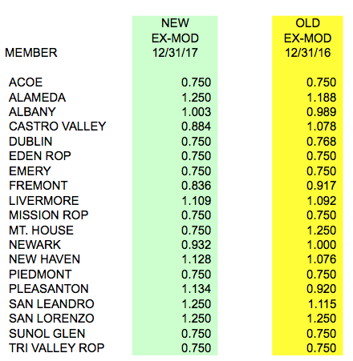

It was moved by Bryan Richards and seconded by Kevin Collins to approve the Ex-Mods as presented.
Ayes: Heldman, Richards, Chan, Fermin, Vu, Veasley, Hu, Ochoa, Collins, Gabel, Spalasso
Nays: None
Abstain: None

- Workers Compensation Rates 2018/2019
The Executive Director presented 2018/19 Workers Compensation rates.
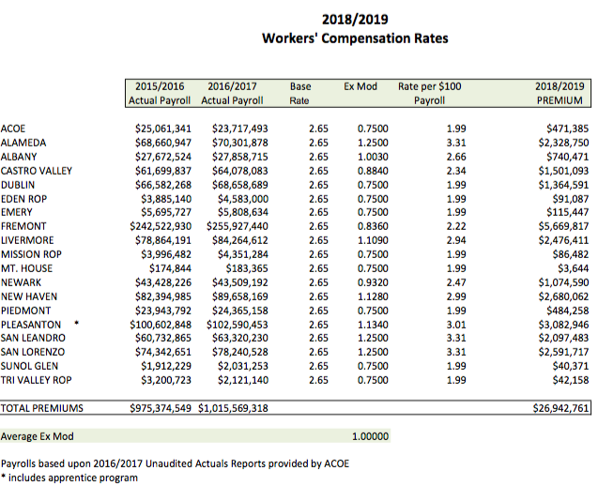

It was moved by Kevin Collins and seconded by Bryan Richards to approve the Workers Compensation rates as presented.
Ayes: Heldman, Richards, Chan, Fermin, Vu, Veasley, Hu, Ochoa, Collins, Gabel, Spalasso
Nays: None
Abstain: None

- Informational Report for Fiscal Year End
Laurena Grabert from SETECH presented the 2016/2017 Informational Report for the Fiscal Year Ended June 30, 2017. The following numbers reflect each member’s portion of the unfunded liability.
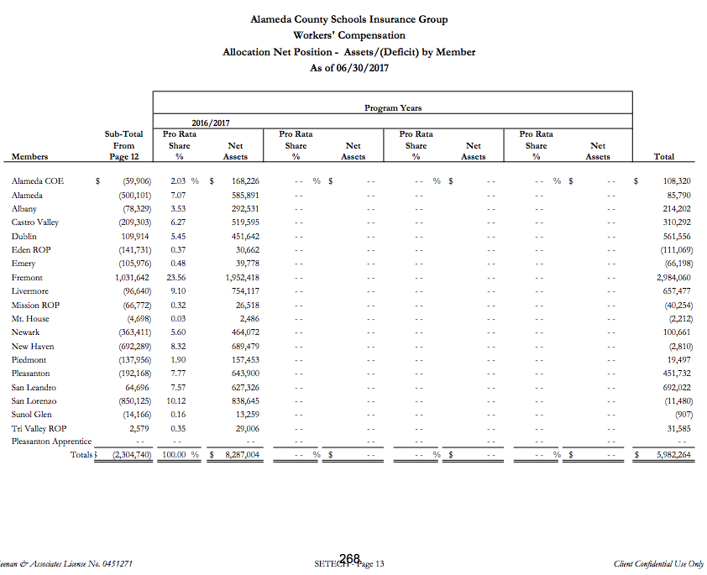

- 5 Year Point in Time Comparison
Michael Clark from Keenan & Associates discussed the 5 year point in time comparison. As resources are dedicated to improve frequency and severity of injuries within ACSIG, it is important to review the claims data to evaluate the effectiveness of the programs.
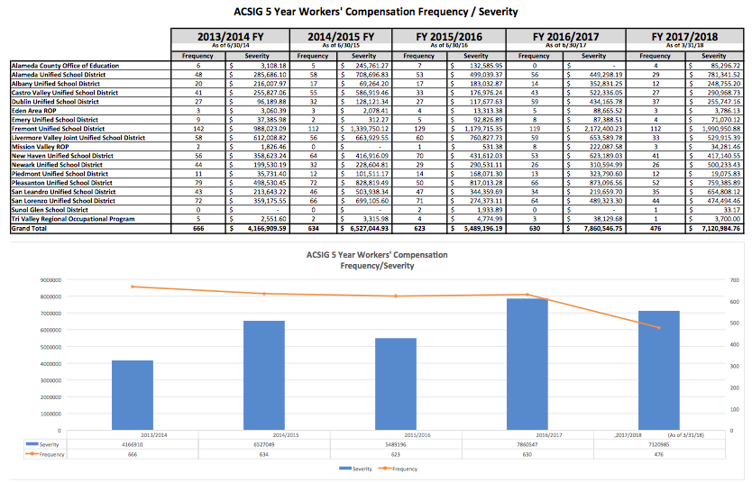

Administrative

- Election of Executive Committee
Due to Allan Garde, Annette Heldman, Susan Kinder, and Bryan Richard’s terms expiring, we have 4 seats available for rotation on the Executive Committee. Annette, Susan, and Bryan have agreed to sit for another 2 years. Suzy Chan will be a new member to our Executive Committee.
It was moved by Micaela Ochoa and seconded by Annette Heldman to approve the Election of Executive Committee as presented.
Ayes: Heldman, Richards, Chan, Fermin, Vu, Veasley, Hu, Ochoa, Collins, Gabel, Spalasso
Nays: None
Abstain: None

- ACSIG Salaries & Benefits
The Executive Director presented a schedule increase proposal for the ACSIG staff of 2% and a 1% off the salary schedule. The average from 10 settled agencies was 2.01%. The overall cost for this increase would total $9757.79.
It was moved by Kevin Collins and seconded by Bryan Richards to approve the ACSIG Salary as presented.
Ayes: Heldman, Richards, Chan, Fermin, Vu, Veasley, Hu, Ochoa, Collins, Gabel, Spalasso
Nays: None
Abstain: None

- Meeting Calendar
The Full Board received the draft 2018/19 Calendar with the following dates.
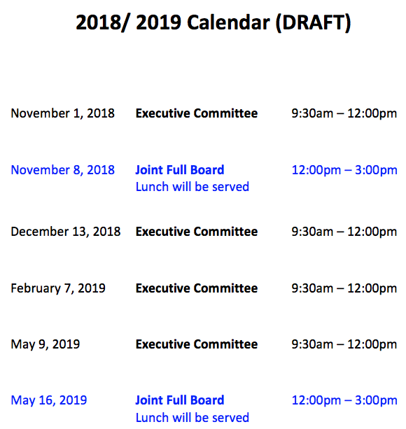

- Future Planning

- This meeting was adjourned at 1:28pm.

LOCATION CALL- IN SHEET
ALAMEDA COUNTY SCHOOLS INSURANCE GROUP
FULL BOARD MEETING May 17, 2018 12:00 PM
1) Enter call-in number (888) 240-3210 2) Enter Participation Code 5912465# 3) State your name.

This meeting will be conducted by teleconferencing in accordance with Government Code Section 54953(b). Members of the public may address the Committee from any teleconference location shown below:

Alameda County Office of Education 313 W Winton Ave. Hayward, CA 94544 Teresea Kapellas (510) 670-4270

Alameda Unified School District 2060 Challenger Drive #100 Alameda, CA 94501 Shariq Khan (510) 337-7066

Albany Unified School District 1051 Monroe Street Albany, CA 94706 Douglas Crancer (510) 558-3751

Castro Valley Unified School District 4400 Alma Avenue Castro Valley, CA 94546 Suzy Chan (510) 537-3000

Dublin Unified School District 7471 Lakedale Avenue Dublin, CA 94568 Joe Sorrera (925) 828-2551

Eden Area ROP 26316 Hesperian Blvd. Hayward, CA 94545 Marites Fermin (510) 293-2906

Emery Unified School District 1275 61st Street Emeryville, CA 94608 Dora Siu (510)601-4905

Fremont Unified School District 4210 Technology Drive Fremont, CA 94539 Raul Parungao (510) 659-2572

Livermore Unified School District 685 East Jack London Blvd. Livermore, CA 94501 Susan Kinder (925) 606-3255

Mission Valley ROP 5019 Stevenson Blvd. Fremont, CA 94538 Joyce Veasley (510) 657-1865

Mountain House School District 3950 Mountain House Road Byron, CA 94546 Vickie Chang (510) 670-4192

New Haven Unified School District 34200 Alvarado-Niles Rd. Union City, CA 94587 Annette Heldman (510) 471-1100

Newark Unified School District 5715 Musick Avenue Newark, CA 94560 Bryan Richards (510) 818-4115

Piedmont Unified School District 760 Magnolia Ave Piedmont, CA 94611 Song Chin-Bendib (510) 594-2608

Pleasanton Unified School District 4665 Bernal Ave Pleasanton, CA 94566 Micaela Ochoa (925) 426-4307

San Leandro Unified School District 835 E 14th St San Leandro, CA 94577 Kevin Collins (510) 667-3504

San Lorenzo Unified School District 15510 Usher Street San Lorenzo, CA 94580 Madeline Gabel (510) 317-4641

Sunol Glen School District 11601 Main Street Sunol, CA 94586 Miki Whetfield (925) 862-2026

Tri-Valley ROP 1040 Florence Road Livermore, CA 94550 Julie Duncan (925) 455-4800

