Alameda County Schools Insurance Group (ACSIG)
5776 Stoneridge Mall Rd., Suite 130 Pleasanton, CA 94588

MINUTES
Executive Committee

Date: Thursday, May 10, 2018
Time: 9:30 AM
Location: Alameda County Office of Education
313 W. Winton Ave.
Hayward, CA 94544

- Annette Heldman called the meeting to order at 9:30am

- Roll call

Executive Committee Members
Annette Heldman President New Haven USD
Susan Kinder Vice President Livermore USD
Bryan Richards Secretary Newark USD
Raul Parungao Board Member Fremont USD
Kevin Collins Board Member San Leandro USD

Madeline Gabel Board Member San Lorenzo USD

Kimberly Dennis Executive Director Alameda County Schools Insurance
Celina Flotte Executive Assistant Alameda County Schools Insurance

Ron Martin Guest Keenan & Associates
Tara Cooper-Salaiz Guest Keenan & Associates
Patrice Grant Guest Keenan & Associates
Michael Clark Guest Keenan & Associates
Laurena Grabert Guest SETECH
Cary Allison Guest Morgan Stanley

- Acceptance of the Agenda
It was moved by Bryan Richards and seconded by Raul Parungao to approve the agenda as presented.
Ayes: Heldman, Kinder, Richards, Parungao, Collins
Nays: None
Abstain: None

- Public Comment on Closed Session Agenda Items

No public present to comment.

Closed Session
Closed session began at 9:31am

- Settlement Notification
- Claim Numbers:

401941 | Rossman, Michael | 484231 | Dean, Clinton | 504935 | Jiran, Steven
407334 | Dean, Clinton | 487007 | Tomcik, Allison | 506176 | Honda, Martin K
417758 | Ellis, April C | 487989 | Arnold, Peggy | 511368 | Tafolla, Leticia
426977 | Rossman, Michael | 496788 | Gilroy, Kadie | 526520 | Alvarez, Roberto
428974 | Dean, Clinton | 498066 | Gozun, Alan P | 529769 | Ariwoola, Vanessa
447335 | Dean, Clinton | 498795 | Alvarez, Roberto | 535832 | Sanchez, Loretta
458309 | Dean, Clinton | 501285 | Gholami, Nahid | 2204320 | Kalany, Hassan
466381 | Perez, Leah | 502115 | Kelley, M'lisa | 2206618 | Dean, Clinton
471869 | Daniello, Kathleen | 504685 | Neves, Joe H | 2206738 | Crosetti, Paula

- Settlement Authorization
- Claims Numbers: N/A

- Executive Director Evaluation
The Executive Committee discussed the Executive Director’s Annual Job Performance Review.
- CastlePoint Memo
Ron Martin from Keenan and Associates discussed the CastlePoint Memo and Loss Run with the Executive Committee.

Open Session
Open session began at 10:25am.

- Public Comment on Open Session Agenda Items
No public present to comment.

- Report of Action Taken in Closed Session
No action was taken.

- Approval of Minutes
It was moved by Bryan Richards and seconded by Kevin Collins to approve the February 8, 2018 Executive Committee Meeting minutes as amended.
Ayes: Heldman, Kinder, Richards, Parungao, Collins
Nays: None
Abstain: None

General

- Third Quarter Investment Report
Cary Allison of Morgan Stanley reviewed the 2017/18 third quarter investment report with the Executive Committee. 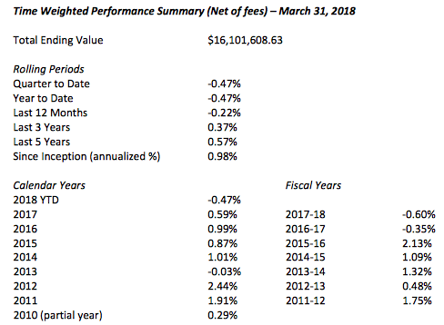
It was moved by Raul Parungao and seconded by Susan Kinder to recommend approval of the third quarter investment report as presented to the Full Board.
Ayes: Heldman, Kinder, Richards, Parungao, Collins
Nays: None
Abstain: None

- Third Quarter Financial Report
Laurena Grabert from SETECH presented the 2017/2018 third quarter financial report.
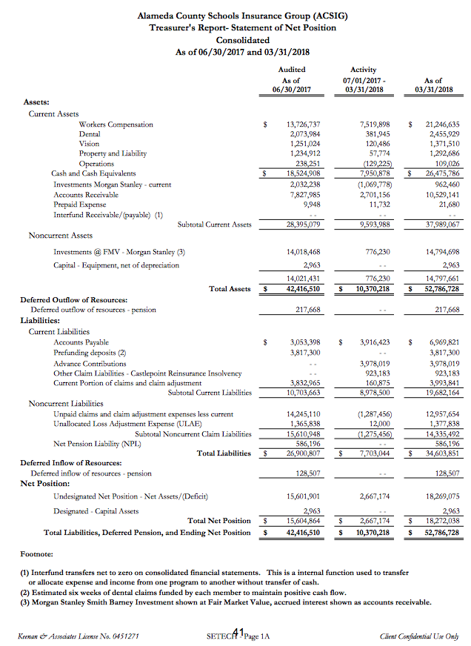
It was moved by Kevin Collins and seconded by Bryan Richards to recommend approval of the third quarter financial report as presented to the Full Board.
Ayes: Heldman, Kinder, Richards, Parungao, Collins
Nays: None
Abstain: None

- 2018/2019 Budget
The Executive Director reviewed the 2017/18 Budget to the Executive Committee. An amendment was made to make corrections to the workers compensation, property and liability and consolidated reports.
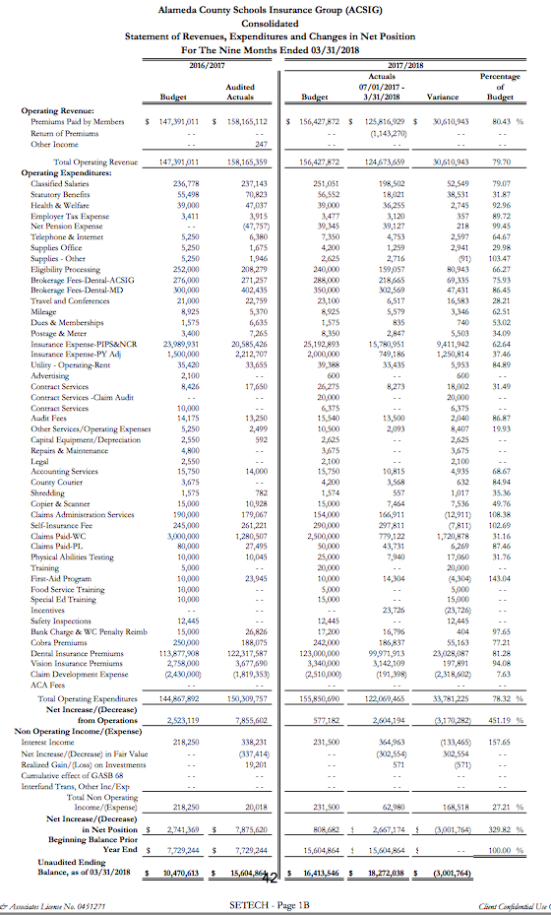
It was moved by Kevin Collins and seconded by Raul Parungao to recommend approval of the budget as amended with changes to the WC, PL and consolidated reports to the Full Board.
Ayes: Heldman, Kinder, Richards, Parungao, Collins
Nays: None
Abstain: None

- ACSIG Salaries & Benefits
The Executive Director presented a schedule increase proposal for the ACSIG staff of 2% and a 1% off the salary schedule. The average from 10 settled agencies was 2.01%. The overall cost for this increase would total $9757.79.
It was moved by Kevin Collins and seconded by Susan Kinder to approve ACSIG salaries and benefits as presented.
Ayes: Heldman, Kinder, Richards, Parungao, Collins
Nays: None
Abstain: None

- Strategic Plan 2018
The Executive Committee will be holding the Strategic Planning meeting on June 28, 2018 at 9:00am at the ACSIG office. They discussed wanting to emphasize/ recognize the strengths of ACSIG at that time.

Workers Compensation

- Claims Audit
The Executive Director presented the results of the USI Claims Audit. The overall score given to the Keenan & Associate claims team was 3.5 out of 5. The total score given was lower than the score of 4.0 received in 2016. Corrective action has been taken and a full-time supervisor has been hired to work with Patrice in the Pleasanton office.
It was moved by Kevin Collins and seconded by Raul Parungao to recommend approval the USI Claims Audit as presented to the Full Board.
Ayes: Heldman, Kinder, Richards, Parungao, Collins
Nays: None
Abstain: None

- 5-year Claim Trend by Member
Michael Clark from Keenan and Associates discussed the 5-year workers compensation claim trend. As resources are dedicated to improve frequency and severity of injuries within ACSIG, it is important to review claims data to evaluate the effectiveness of programs. Through analysis, we can identify trends within the districts.

Dental

- Dental Rates 2018/2019
The Executive Director presented the 2018/2019 Dental Rate recommendations to the Executive Committee. The program has been performing well, rates decreased last year by 2%. The program as leveled off and we are recommending a flat renewal for 2018/19.
It was moved by Kevin Collins and seconded by Raul Parungao to recommend approval of Dental Rates to the Full Board.
Ayes: Heldman, Kinder, Richards, Parungao, Collins
Nays: None
Abstain: None

- Review Dental Overpayment Reimbursement
The Executive Director discussed the dental overpayment reimbursement to Centinela Valley. Centinela Valley has originally been elected and been underwritten as a 10-pay client. Their annual costs were recalculated over 10 months, and due to an oversight, Centinela Valley paid 12 premiums each year – resulting in an overpayment of more than $1 million.

Vision

- Vision Rates 2018/2019
The Executive Director presented the 2017/18 Vision rate recommendation as a flat renewal due to the increasing growth within the program.
It was moved by Bryan Richards and seconded by Raul Parungao to recommend approval of the Vision rates as presented with no increase to the Full Board.
Ayes: Heldman, Kinder, Richards, Parungao, Collins
Nays: None
Abstain: None

Property & Liability

- Property & Liability Rates 2018/2019
The Executive Director presented the 2018/19 Property and Liability rates. ACSIG has 5 members in the Property & Liability pool, which attaches to NCR at the $25,000 SIR. NCR Property rates and Liability rates showed adverse development in the program. ACSIG has higher experience than the NCR average. These negative factors have resulted in an increase to the ACSIG property and liability rates.
It was moved by Kevin Collins and seconded by Raul Parungao to recommend approval of the Property & Liability rates as presented to the Full Board.
Ayes: Heldman, Kinder, Richards, Parungao, Collins
Nays: None
Abstain: None

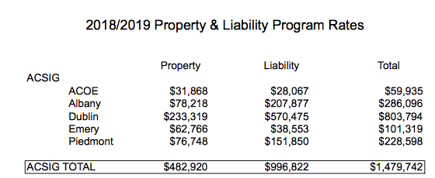

- PLCA Agreement Renewal
The Executive Director presented the extension of terms with no fee increase for the claim administration services with Keenan & Associates. The contract was approved in 2018-2019 and has been in effect for 3 subsequent years.
It was moved by Raul Parungao and seconded by Susan Kinder to recommend approval the PLCA Renewal as presented to the Full Board.
Ayes: Heldman, Kinder, Richards, Parungao, Collins
Nays: None
Abstain: None

Administrative

- Investment Policy
The Executive Committee conducted the annual review of the written investment policy and found no changes necessary.
It was moved by Bryan Richards and seconded by Susan Kinder to recommend approval the Investment Policy as presented to the Full Board.
Ayes: Heldman, Kinder, Richards, Parungao, Collins
Nays: None
Abstain: None

- Conflict of Interest Code
The Executive Committee conducted the annual review of the Conflict of Interest policy and requested a check for any updates.
It was moved by Kevin Collins and seconded by Raul Parungao to recommend approval the Conflict of Interest Code as presented to the Full Board.
Ayes: Heldman, Kinder, Richards, Parungao, Collins
Nays: None
Abstain: None

- Authorization of Signatures
The Executive Committee conducted the annual review of the Authorization of Signatures and found no changes necessary.
It was moved by Bryan Richards and seconded by Raul Parungao to recommend approval the Authorization of Signatures as presented to the Full Board.
Ayes: Heldman, Kinder, Richards, Parungao, Collins
Nays: None
Abstain: None

- Meeting Calendar
The Executive Committee reviewed the 2018/19 draft calendar.
It was moved by Kevin Collins and seconded by Susan Kinder to recommend approval of the draft meeting calendar as presented to the Full Board.
Ayes: Heldman, Kinder, Richards, Parungao, Collins
Nays: None
Abstain: None

- Posting and Mailing Address
The Executive Committee conducted the annual review of the Posting and Mailing Address for ACSIG and found no changes necessary.
It was moved by Bryan Richards and seconded by Kevin Collins to recommend approval the Posting and Mailing address as presented to the Full Board.
Ayes: Heldman, Kinder, Richards, Parungao, Collins
Nays: None
Abstain: None

- Future Planning

- This meeting was adjourned at 11:42am.

