Alameda County Schools Insurance Group (ACSIG)
5776 Stoneridge Mall Rd., Suite 130 Pleasanton, CA 94588

MINUTES
Executive Committee

Date: Thursday, February 8, 2018
Time: 9:30AM
Location: Alameda County Office of Education
313 W. Winton Ave.
Hayward, CA 94544

- Annette Heldman called the meeting to order at 9:28am

- Roll call

Executive Committee Members

Annette Heldman President New Haven USD
Susan Kinder Vice President Livermore USD
Bryan Richards Secretary Newark USD
Joe Sorrera Board Member Dublin USD
Raul Parungao Board Member Fremont USD
Kevin Collins Board Member San Leandro USD
Mei Chan Educator New Haven USD

Kimberly Dennis Executive Director Alameda County Schools Insurance Group
Celina Flotte Executive Assistant Alameda County Schools Insurance Group

Ron Martin Guest Keenan & Associates
Tara Cooper-Salaiz Guest Keenan & Associates
Patrice Grant Guest Keenan & Associates
Michael Clark Guest Keenan & Associates
Dave Kundert Guest Keenan & Associates
Hesam Fayaz Guest SETECH

- Acceptance of the Agenda
It was moved by Kevin Collins and seconded by Bryan Richards to approve the agenda as presented.
Ayes: Heldman, Kinder, Richards, Sorrera Parungao, Collins
Nays: None
Abstain: None

- Public Comment on Closed Session Agenda Items

No public present to comment.

Closed Session
Closed session began at 9:30am.

- Settlement Authorization
- Claim Numbers:
2203078 | Olson

- Settlement Notification

- Claim Numbers:
428895 | VanDenburg | 517263 | Elliott | 527510 | Compton
436007 | Ulloa | 518456 | Henry-Ellis | 529346 | Abuhwaidi
458936 | Carrion | 519257 | Zupo | 529439 | Stanley
487842 | Flores | 520623 | Friend | 530484 | Benzien
501334 | Cunha | 521363 | Spranza | 531352 | North
501349 | Sablan | 522573 | Lockwood w | 536343 | Abuhwaidi
502269 | Navarro | 524581 | Wagner | 539136 | Canlas
509544 | Samson | 525487 | Cilibrasi | 2509361 | Galvan

Open Session
Open session began at 9:42am.

- Public Comment on Open Session Agenda Items
No public present to comment.

- Report of Action Taken in Closed Session
The Committee approved adding an addition $50,000 to claim number 2203078 for negociations — making the total settlement amount up to $200,000.
It was moved by Susan Kinder and seconded by Raul Parungao to approve the new settlement amount.
Ayes: Heldman, Kinder, Richards, Sorrera, Parungao, Collins
Nays: None
Abstain: None

- Approval of Minutes
It was moved by Susan Kinder and Bryan Richards to approve the meeting minutes from the November 2, 2017 Executive Committee and November 9, 2017 Full Board Meetings.
It was moved by Susan Kinder and seconded by Bryan Richards to approve the meeting minutes.
Ayes: Heldman, Kinder, Richards, Parungao, Collins
Nays: None
Abstain: Sorrera

Workers Compensation

- USI Consulting Agreement
The Executive Director presented the USI Agreement to the Executive Committee.
It was moved by Raul Parungao and seconded by Susan Kinder to approve the agreement.
Ayes: Heldman, Kinder, Richards, Sorerra, Parungao, Collins
Nays: None
Abstain: None

- Keenan Loss Control Contract
The Executive Director will presented the Loss Control Contract to the Committee.
It was moved by Raul Parungao and seconded by Bryan Richards to approve the contract.
Ayes: Heldman, Kinder, Richards, Sorerra, Parungao, Collins
Nays: None
Abstain: None

- CastlePoint/ Reinsurance Update
Ron Martin of Keenan discussed the CastlePoint update with the Executive Committee. There are 4 claims that have paid amounts over the SIR. There are 2 claims that have been denied with paid amounts within ACSIGS’s $250,000 SIR and that will exceed the SIR. Additionally there are 3 corresponding claimants that also have open claim files under PIPS for the same body part which could be constructed by CIGA that other coverage exists which may result in denial of coverage. There are 8 claims that are reserved more than the $250,000 SIR for specific injuries and reimbursement is anticipated if the SIR is exceeded. The Committee suggests that names and claim numbers are removed for the public eye.

- Actuarial Study – Ex Mod
The Executive Director presented the Ex-Mods as determined by the Actuary, Jack Joyce. Ex-Mods have a minimum of .75 and a maximum of 1.25. There is not a limit to the amount that a member can change between years. The amounts are averaged to 1.00 and based on a member’s experience within the pool.
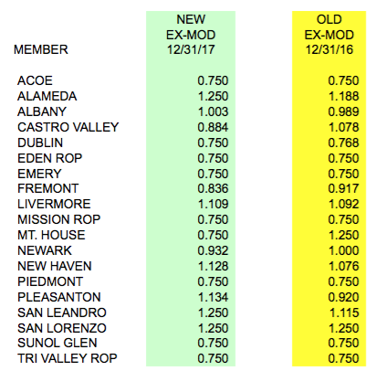

It was moved by Raul Parungao and seconded by Bryan Richards to approve the ex-mods.
Ayes: Heldman, Kinder, Richards, Sorerra, Parungao, Collins
Nays: None
Abstain: None

- Actuarial Study – Ultimate Loss
The Executive Director presented the Ultimate Loss report prepared by Jack Joyce of Bay Actuarial. It was estimated that ACSIG’s liability for unpaid losses are $17,088,000 on December 31, 2017 and project that it will be $16,219,000 on June 30, 2018. The corresponding discounted values (at 1.75% interest) are $14,850,000 and $14,090,000.

It was moved by Bryan Richards and seconded by Kevin Collins to approve actuarial study.
Ayes: Heldman, Kinder, Richards, Sorerra, Parungao, Collins
Nays: None
Abstain: None

- Preliminary 2018-2019 Workers’ Compensation Rates
The Executive Director reviewed the changes proposed to the base rate. 2018-2019 base rate uses a calculation of PIPS rate + Administrative Costs + Self Insurance Fee + an Adjustment of $1,500,000. The Committee recommends that the base rate be changed to 2.65.
This payroll adjustment resulted in a 6.31% increase to the Worker’s Comp rate.
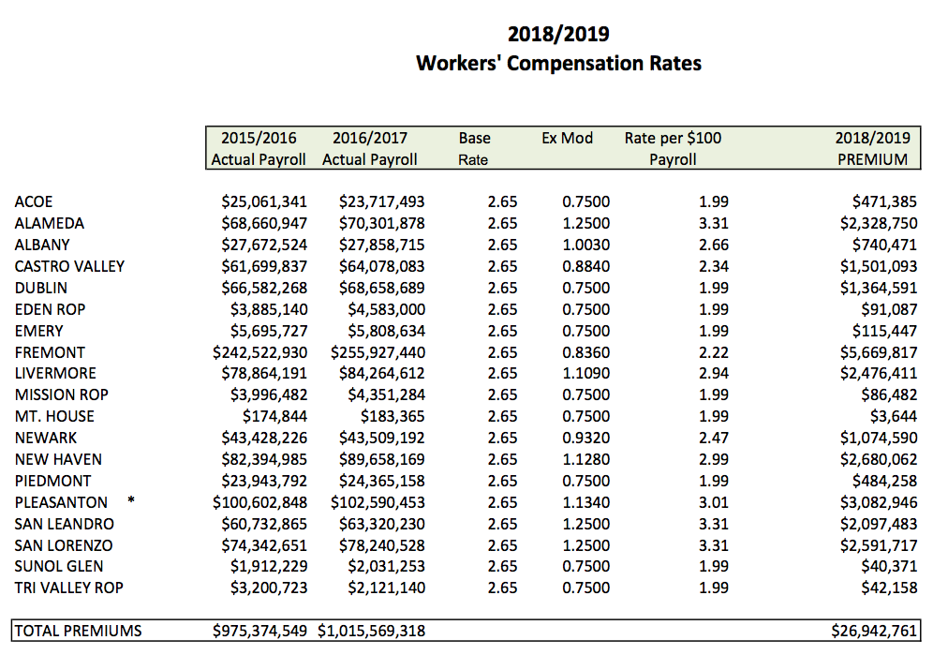
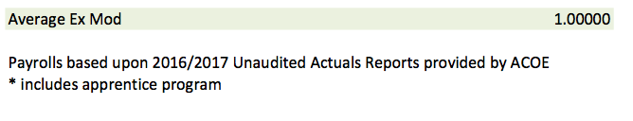

It was moved by Susan Kinder and seconded by Bryan Richards to approve preliminary workers compensation rates.
Ayes: Heldman, Kinder, Richards, Sorerra, Parungao, Collins
Nays: None
Abstain: None

- Information Report for the Fiscal Year End
Hesam Feyaz from SETECH presented the Financial Management Information Report Ended June 30, 2017. The following numbers reflect each member’s portion of the unfunded liability.
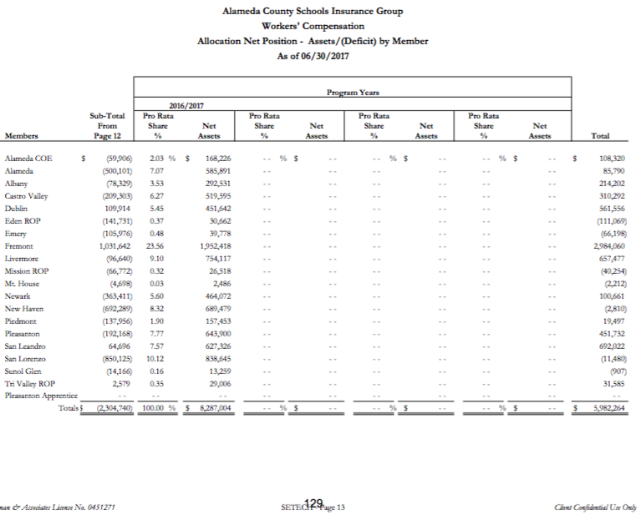

General

- Second Quarter Financial Report
Hesam Fayaz from SETECH presented the 2017/2018 Second Quarter Financial Report.
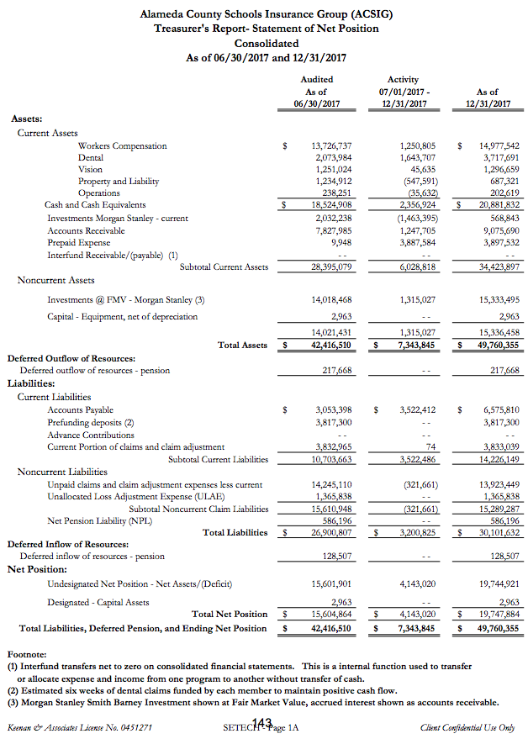
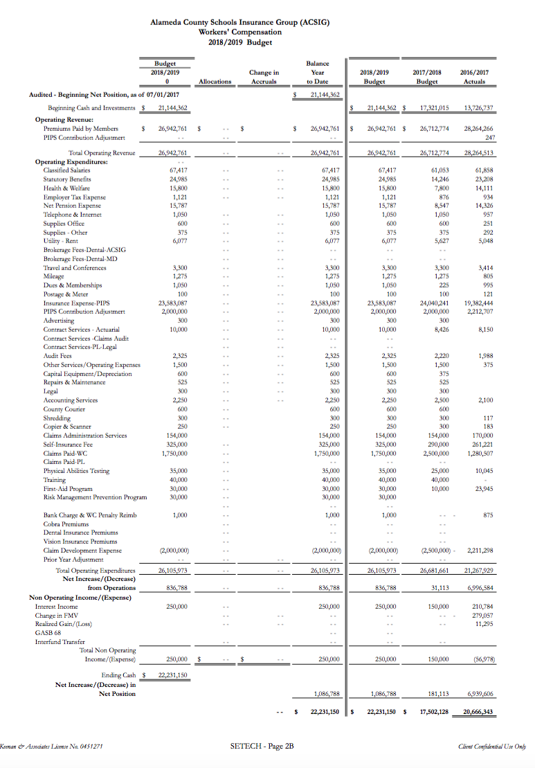
It was moved by Raul Parungao and seconded by Susan Kinder to approve second quarter financials.
Ayes: Heldman, Kinder, Richards, Sorerra, Parungao, Collins
Nays: None
Abstain: None

- Second Quarter Investment Report
The Executive Director presented the 2017/18 Second Quarter Investment Report.
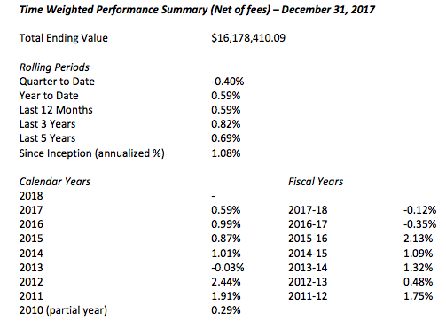

It was moved by Kevin Collins and seconded by Raul Parungao to approve second quarter investment report.
Ayes: Heldman, Kinder, Richards, Sorerra, Parungao, Collins
Nays: None
Abstain: None

- 2018/2019 Budget
The Executive Director reviewed the tentative 2018/19 Budget. The budget was developed using year-to-date 2017/2018 data and preliminary estimates for 2018/2019 rates and costs. There have been funds allocated to support the release time for regional trainings for Special Education and Food Service staffing.
It was moved by Bryan Richards and seconded by Raul Parungao to approve second quarter investment report.
Ayes: Heldman, Kinder, Richards, Sorerra, Parungao, Collins
Nays: None
Abstain: None

- Strategic Planning Update
The Executive Director asked the Committee to surface ideas for strategic planning. The Committee recommends that there is no need for a facilitator, instead to plan a targeted discussion highlighting strengths and weaknesses. Recapping on goals, focusing on opportunities, and getting district participation for a meeting this end of June 2018.

- CAJPA Fall Conference 2018
The dates for the 2017 CAJPA Fall Conference will be September 11 -14 in Lake Tahoe. All Executive Committee Members/ or Designees and new Board Members are invited to attend.

- Future Planning

- This meeting was adjourned at 11:03am.

