Alameda County Schools Insurance Group (ACSIG)
5776 Stoneridge Mall Rd., Suite 130 Pleasanton, CA 94588

MINUTES
Full Board

Date: Thursday, November 9, 2017
Time: 12:00PM
Location: Alameda County Office of Education
313 W. Winton Ave.
Hayward, CA 94544

- The meeting was called to order by Susan Kinder at 12:04pm.

- Roll call

Full Board
Susan Kinder Vice President Livermore Valley Joint USD
Bryan Richards Secretary Newark Unified School District
Teresa Kapellas Board Member Alameda County Office of Education
Daniella Kruger Alternate Alameda Unified School District
Marites Fermin Board Member Eden Area ROP
Dora Siu Board Member Emery Unified School District
Raul Parungao Board Member Fremont USD
Joyce Veasley Board Member Mission Valley ROP
Vicki Hu Alternate Mountain House Unified School District
Amy Robbins Alternate Tri-Valley ROP

Kimberly Dennis Executive Director Alameda County Schools Insurance
Celina Flotte Executive Assistant Alameda County Schools Insurance

Tara Cooper-Salaiz Guest Keenan & Associates
Patrice Grant Guest Keenan & Associates
Ron Martin Guest Keenan & Associates
Michael Clark Guest Keenan & Associates
Dave Kundert Guest Keenan & Associates
Laurena Grabert Guest SETECH
Heather Daud Guest Christy White & Associates

- Acceptance of the Agenda
It was moved by Teresea Kapellas and seconded by Bryan Richards to accept the agenda as presented.
Ayes: Kinder, Ricahrds, Kapellas, Kruger, Fermin, Siu, Parungao, Veasley, Hu, Robbins
Nays: None
Abstain: None

- Approval of Minutes
The Full Board reviewed meeting minutes from the Executive Committee meetings from May 11, 2017 and the Full Board minutes from May 25, 2017.
It was moved by Bryan Richards and seconded by Raul Parungao to approve the Executive Committee Meeting minutes from May 11, 2017 and the Full Board minutes from May 25, 2017.
Ayes: Kinder, Ricahrds, Kapellas, Kruger, Fermin, Siu, Parungao, Veasley, Hu, Robbins
Nays: None
Abstain: None

Consent Calendar
Review Items listed on the consent agenda for any adjustments and adoptions.

- 2016/17 Fourth Quarter Financials
- 2016/17 Fourth Quarter Investment Report
- Annual Report
- Calendar Revision

General Business

- Members to Executive Committee
The Full Board has suggested recruiting Dublin USD and San Leandro USD to the Executive Committee.
It was moved by Bryan Richards and seconded by Raul Parungao to recruit the above members to the Executive Committee.
Ayes: Kinder, Richards, Kapellas, Kruger, Fermin, Siu, Parungao, Veasley, Hu, Robbins
Nays: None
Abstain: None

- ACOE Endorsement
It was moved by Bryan Richards and seconded by Marites Fermin to approve endorsement of the ACOE Charter.
Ayes: Kinder, Richards, Kapellas, Kruger, Fermin, Siu, Parungao, Veasley, Hu, Robbins
Nays: None
Abstain: None

- 2016/ 17 Audit
Heather Daud of Christy White presented the 2016/17 Audit.
It was moved by Bryan Richards and seconded by Marites Fermin to accept the 2016/17 Audit.
Ayes: Kinder, Richards, Kapellas, Kruger, Fermin, Siu, Parungao, Veasley, Hu, Robbins
Nays: None
Abstain: None

- 2017/18 First Quarter Financials
Laurena Grabert from SETECH presented the 2017/18 1st Quarter Financials to the Board.
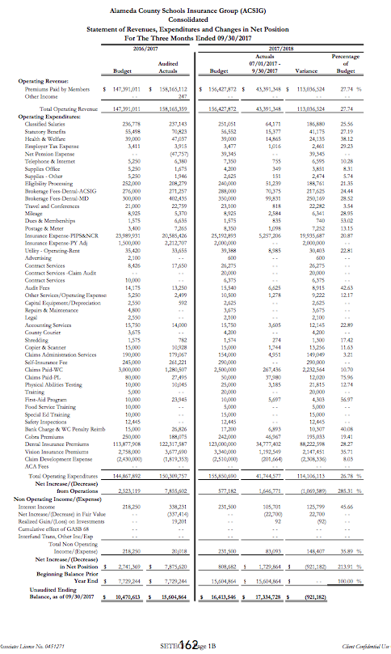
It was moved by Raul Parungao and seconded by Teresea Kapellas to accept the 2017/18 1st Quarter Financials.
Ayes: Kinder, Richards, Kapellas, Kruger, Fermin, Siu, Parungao, Veasley, Hu, Robbins
Nays: None
Abstain: None

- 2017/18 First Quarter Investment Report
The Executive Director presented the 2017/18 1st Quarter Investment Report to the Board.

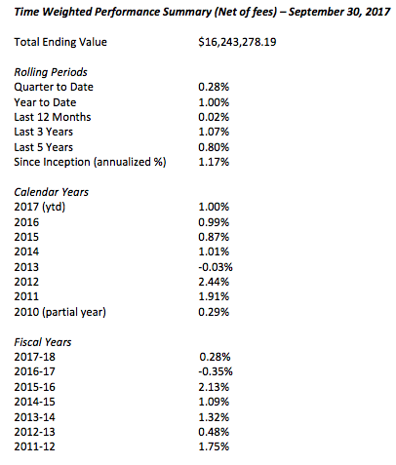

It was moved Marites Fermin and seconded by Raul Parungao to accept the 2017/18 1st Quarter Investment Report.
Ayes: Kinder, Richards, Kapellas, Kruger, Fermin, Siu, Parungao, Veasley, Hu, Robbins
Nays: None
Abstain: None

Workers Compensation

- 2017/18 Service Plan
Tara Salaiz of Keenan reviewed the 2017/18 Service Plan with the Board. The service team consists of Tara Cooper-Salaiz as Account Manager, Michael Clark as Claims Analyst, Dave Kundert as Loss Control Consultant, Patrice Grant as Claims Manager, and Ron Martin as Account Executive. The Service Plan is a tool to show what the team wants to complete within the upcoming year. The team has chosen 5 focus districts, including Alameda USD, Fremont USD, Newark USD, and Dublin USD, and Castro Valley USD.

- Company Nurse Update
Michael Clark of Keenan presented the Executive Committee with an update on the Company Nurse program expansion. Aside from Alameda USD—most of the larger districts have joined the program.

- Workers Compensation Claims History
The Executive Director reviewed the Workers Compensation Claims History with the Executive Committee. As resources are dedicated to improve frequency and severity of injuries within ACSIG, it is important to review claims data to evaluate the effectiveness of programs. Through analysis, we can identify trends within the districts.

- Shoes for Crews
Michael Clark of Keenan Associates informed the Board that ACSIG will be implementing a program that provides shoes for all food service employees. The information for each district should be collected by December, and the shoes should be distributed by January 2018.

- Communication
The Executive Director and service team discussed 3 sample communication instruments to gain better access to the Districts to meet the needs of the member and give timely information in an effort to mitigate injuries.

- Title IX
Ron Martin of Keenan Associates reviewed Title IX and its relevance to school agencies.

- Future Planning

- The meeting was adjourned at 1:18pm by Susan Kinder.

